May Members Meeting & Program
Blair-Caldwell African American Research Library
May 13, 2024

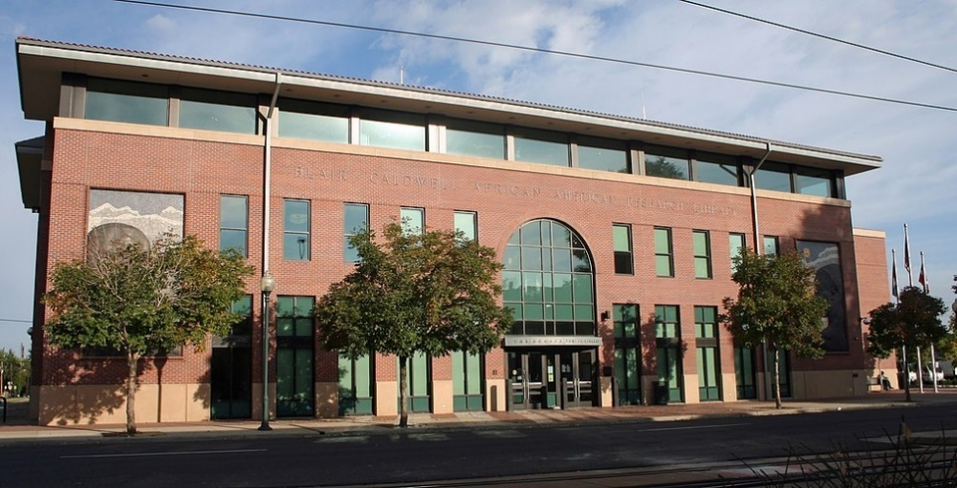
WHAT: May Meeting and Program (Note Starting Time)
PLEASE RSVP to meeting organizer Charles Foster (adventurecharlie03@gmail.com ) by May 7th
WHEN: May 13, 2024
9:30AM | – Networking and mid-morning brunch (see menu below) specially catered for this event of fine remembrance (Colorado Black Chamber of Commerce Foundation Boardroom on First Floor)
10:15AM | – Tour of Blair Caldwell Library by Emanni Butler. Fabulous tour of the facility highlighting the recently completed renovations, updated portraits archival collections, and the Western Legacies Museum of Five Points
11:00AM | - Presentation by Charles Foster on Five Points and some coming changes. Charles works with the Five Point businesses to maintain the Heritage of the neighborhood.  Charles will welcome a selection of five points property owners and businesspeople as well as the RMGA members and guests. (Archive and Research Room on Second Floor)
11:30AM | – Presentation concludes. Revisit the Museum on your own or have lunch at one of the many Five Points restaurants. The museum highlights the historic Five Points neighborhood, African Americans in early Denver (including the city’s earliest arrivals), the Black West, and the African American leadership corridor and gallery. A rotating art gallery featuring local artists and traveling exhibits also share space with the museum.
The Program is organized by Charles Foster.
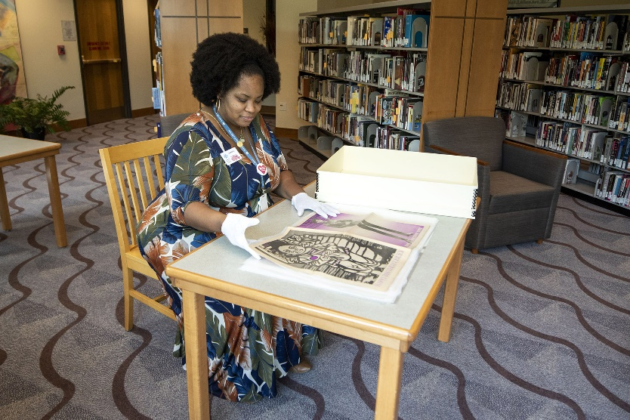
The Archival Room
WHERE: Blair-Caldwell African American Research Library, 2401 Welton St. 80205
Only the Presentation will be available via Zoom: https://us06web.zoom.us/j/82804337501
FOOD: Brunch provided by Charles Foster
PARKING: Adjoining library

Light Rail: 25th & Welton stop is one block from the library.

GUESTS: Members are encouraged to invite potential members as guests to the meeting.

MEETING CONTACT: Mike Pearl (303) 868-0023 voice & text or Tom Jensen (303) 968-0515

Rocky Mountain Guides Assoc. Brunch!

Sun-Shine Fruit Tray
Sliced fresh seasonal fruits

Country Brunch Eggs
made with Cage free pasteurized eggs
Herbs & Spices that are savory

Assorted Breakfast Breads
Assorted muffins,
Mini Danish & Biscuits

Our Original Garden Veggies
seasoned organic Assorted Garden veggies

Our famous
*Collard Green Dip
w/ Tasty Cornbread Sticks

Breakfast Breads
Assorted muffins
Assorted Mini Danish

Fruit Tray
Sliced fresh seasonal fruits

Beverage
*Pineapple Mimosas Non-alcohol
Freshly Brewed Filter Coffee
A Fine Selection of Specialty Teas
*Healthy Sweeteners
Lemons, Reg. Cream & Almond Cream

