PropWash

Next Meeting: Tuesday, September

5th. 7:00 PM @ The Club Field
Next FunFly/Swap Meet: September 16th 9:00am till?

AMA CHARTER #895
August

President:
Gary Esterle

Vice President:
Jim Rippy

Secretary:
Bruce Whatley

Treasurer:
Jerry Hermes

Newsletter:
John Vetter

Website:
John Vetter
www.lrccky.com

Board of Directors:
Bill Crawley
Dan Gibson
Ray Glass
Mike Davis
Dan West
Scotty White
John Vetter

Safety Director
Larry Lowe

Direct correspondence to: Bruce Whatley, 8202 Cheshire Way, Louisville, KY 40222
August Meeting:
The LRCC Club meeting was held on August 1, 2017 at the club field. The meeting was opened up at 7:00 p.m. by Gary Esterle.

Attendance:
The meeting was attended by President: Gary Esterle, Vice President: Jim Rippy, Treasurer Jerry Hermes, with 6 club members present.

The next meeting will be on September 5th at the Club field, at 7:00 pm.
For new members, the Club Web site is http://www.lrccky.com.
The discount after midyear only applies to new members.

Treasurers' Report:
The Treasurer's report was read and was approved. Jerry says we do have money.

Prior Months Meeting Minutes:
The Club’s July meeting minutes were read by Gary and approved.

Old Business:
*We are still planning on paying off the lawnmower this fall after all dues are in and the only payouts will be the port-a-pot and Christmas party.
*Still need to get dirt delivered. Hope to have the time to get it soon. The $200 cost has been approved.
*Jim Rippy cut back the branches on the main road and on the trails. Thanks Jim.

*The old John Deere mower has been sold. Jim Rippy bought it.
*Jim brought up a discussion on the bleachers that the Parks Dept. was going to get for us if we really want them. They are very big and heavy. Parks said it takes 8 men to move them. We discussed the issues this would give us mowing around them, where to put them out of the way of trailers, and do we want our guest sitting in the sun and far away from us. We decided that we want guest joining us under the pavilion and not have the problem of the bleachers. It was voted unanimously to cancel the bleachers.
*Member Fred Breese spoke with the Parks Dept. when they came to the field a while back about cutting the high weeds. Parks said they want to do it in sections because of wildlife. Fred suggested they cut back from the runway 100 feet to start and they later cut the back section.
*Still having issues with people not securing the lock on the gate when it is open. They are leaving the lock open, not secured to the gate post or sitting on our combination. Remember to put the lock on the chain through the gate and scramble the combination.

New Business:
*Reminder this month’s fun fly is Saturday August 19th. Let’s have a great turn out!
*Jim Rippy placed signs on the trash cans to remind people to latch them correctly. When they are left unlatched the animals get into them and we have to pick up a lot of trash. (Thanks again Jim)

*On Monday 8/21/17, there will be the solar eclipse. For our area it will start at 1 pm, end at 3:51 pm with the max being at 2:27 pm. If you are available it would be a good time to get in some strange night flying.

What’s New:
Marty Severance brought a Hobby King Sopwith Camel WW1 Fighter Laser Cut Balsa Kit (1520mm) that he built. It weighs about 8-1/2 lbs. He powers it with aEflight 60 electric motor running on a 6 cell lipo. He covered it with super monokote and did a great job. He replace the wheels with scale units. He has not maiden it yet. He donated the $10 back to the club.

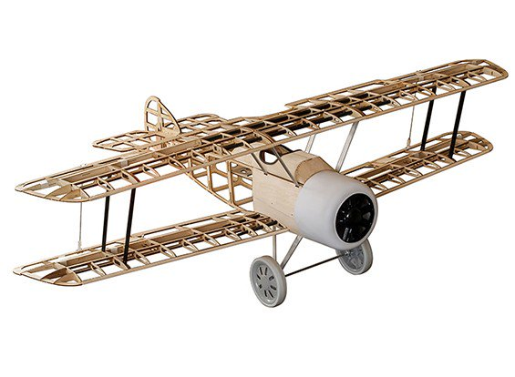

Club Merchandise:
Jerry has hats $10, shirts $12, $16 depending on size for sale at every meeting. If you have specific requests, contact Jerry.
Jerry now has club window decals, made out of vinyl, which his daughter makes. They are really nice! They sell for $12.
50 - 50 Raffle:
N/A
Meeting was adjourned at 7:27 p.m.
NOTE: Please allow right of way when pilots
announce TAKING OFF and LANDING.

Reminder - AMA Cards must be displayed on one's persons while flying at the field, with the club sticker. There are card sleeves in the Club house in the file cabinet second drawer for members to use to pin or clip on. This helps verify AMA insurance and club membership. Thanks you for your compliance.
Key Dates:

2017 Meeting Dates
September 5th. 7:00pm @ LRCC Field
October 3rd. 7:00pm @ LRCC Field
November 7th. 7:30pm The Aero Club
December 5th. 7:30pm The Aero Club

2017 Fun Fly/Swap Meet Dates
September 16th. 9:00am till?
October 21st. 9:00am till

Interesting Picture

