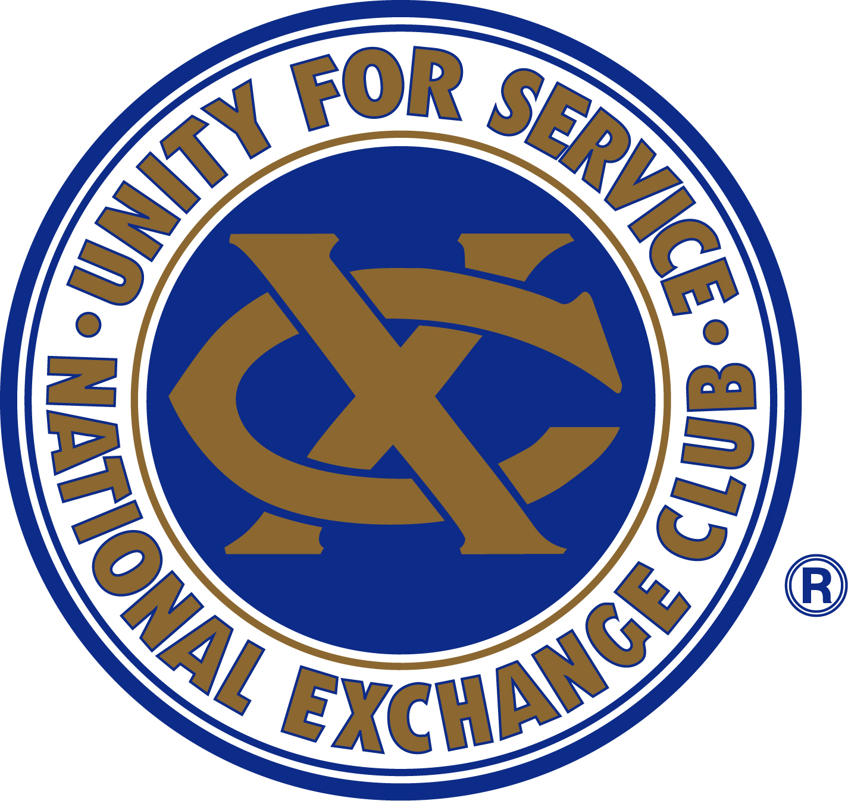
ALL-SERVICE CLUB
GOLF TOURNAMENT

Date: Thursday, May 26, 2016
Time: Shotgun Start 1:30 pm
Place: Three Lakes Golf Course

- Cost: $75.00 per person - $300.00 per team and includes a boxed lunch before tournament and
appetizers afterwards along with range balls and a cart
- Tournament is open to all Service Club members and their guests
- Team or individuals welcome (individuals will be placed on a team)
- Make checks payable to Wenatchee Central Lions and payment is due with registration

ALL ENTRY FORMS NEED TO BE RETURNED BY MAY 19, 2016

NAME: PHONE: SERVICE CLUB:

Golfer 1:

Golfer 2:

Golfer 3:

Golfer 4:

- This is a four-person team scramble event. There will be prizes for 1st and 2nd place Teams plus a Service Club Champion.
- To be eligible to win the Service Club Champion, all golfers must be from the same Service Club.
- Will have a men and women’s longest drive.
- Also, will be selling mulligans for 3 for $20 limit 3 per person
- Please return completed forms to: Cordell and Neher & Company PO Box 3068 Wenatchee, WA 98807 Attn: Phil Blakney.
- If you have any questions, please feel free to contact us through our Facebook page at Wenatchee Central Lions.

