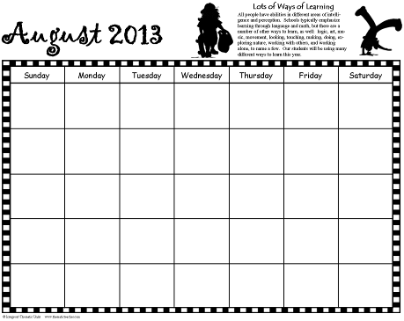
Artful Teaching
Copyright © 2011 Integreat! Thematic Units www.thematicteacher.com
Communication
Calendar
You can use these black and white calendars to communicate with parents during the year. Each month features a learning style to help parents better understand the variety of experiences you are providing for your students. The calendars are blank so that you can fill in the information that’s appropriate for you. They begin with August, but you can begin anywhere. (August has an introductory passage, though.)

You can change the month names and the years—just double click on them and retype what you need. Click in the upper left corner of each box to input numbers. Click in the center of each day to type information there.

I left the holidays from a previous year. Many of them occur on the same days each year. To move a holiday to a different day, click and drag the image to the new space. Click in the new box to type in the holiday name. Highlight the old name and backspace to delete it. To move a holiday icon from one month to another (as in Easter), right click on the image and select copy. Go to the new page. Right click on the place you want to place the image and select paste. Click and drag to move it more precisely, if needed.

I hope you’ll find the calendar easy and fun to use!

Lots of Ways of Learning
All people have abilities in different areas of intelligence and perception. Schools typically emphasize learning through language and math, but there are a number of other ways to learn, as well, including logic, art, music, movement, looking, touching, making, doing, exploring nature, working with others, and working alone. Our students will be using many different ways to learn this year.

August 2013

Copyright ©2011 Integreat! Thematic Units www.thematicteacher.com
Sunday
Monday
Tuesday
Wednesday
Thursday
Friday
Saturday


Body Movement
Some students learn best through body movement. They:
• Think in muscle movements
• Enjoy building, running, jumping, dancing, moving, touching, and making things
• Learn by acting, reenacting, muscle memory, hands on activities, & manipulating things

September 2013



Copyright ©2011 Integreat! Thematic Units www.thematicteacher.com

Sunday
Monday
Tuesday
Wednesday
Thursday
Friday
Saturday

Labor Day

Grandparent’s Day

First Day of Fall


Language
Some students learn best through listening, speaking, reading, and writing. They
• Think in words
• Enjoy words, telling stories, reading, writing, playing with words, second languages
• Learn by books, taking notes, reading, writing, discussion, debates, stories

October 2013


Copyright ©2011 Integreat! Thematic Units www.thematicteacher.com

Sunday
Monday
Tuesday
Wednesday
Thursday
Friday
Saturday

Columbus Day

Halloween




Logic
Some students learn best through logic, numbers, & patterns. They
• Think by reasoning things out
• Enjoy data collection, puzzles, looking for patterns, asking questions, experimenting, math
• Learn by manipulating, experimenting, discovering, charting, analyzing data, data maps

Sunday
Monday
Tuesday
Wednesday
Thursday
Friday
Saturday

Copyright ©2011 Integreat! Thematic Units www.thematicteacher.com

Veteran’s Day
Daylight Savings ends

Thanksgiving
November 2013

Working with Others
Some people learn best by working with others. They
• Think by talking ideas over, considering differing points of view
• Enjoy organizing people, helping others, leading, counseling, solving conflicts
• Learn by working with others, social groups, cooperative groups, clubs, & meetings

December 2013

Sunday
Monday
Tuesday
Wednesday
Thursday
Friday
Saturday

Christmas Eve

New Year’s Eve
Copyright ©2011 Integreat! Thematic Units www.thematicteacher.com

Kwanzaa Begins
Christmas
Hanukkah Begins

Music
Some people learn best through music. They
• Think in rhythms, melodies, chants, patterns
• Enjoy tapping fingers and feet, snapping, singing, humming, whistling, raps, chants, jingles
• Learn by songs, raps, chants, jingles, musical and sound patterns, pattern notation, codes

January 2014


Sunday
Monday
Tuesday
Wednesday
Thursday
Friday
Saturday

Copyright ©2011 Integreat! Thematic Units www.thematicteacher.com

Martin Luther King, Jr. Birthday

New Year’s Day

Nature
Some people learn best by working with nature. They
• Think in natural images and patterns
• Enjoy caring for plants and animals, being outdoors, exploring nature, identifying plants, collecting
• Learn by exploration, examination, testing hypotheses, discovery, observation

February 2014

Sunday
Monday
Tuesday
Wednesday
Thursday
Friday
Saturday

Ground Hog Day

Valentine’s Day

Copyright ©2011 Integreat! Thematic Units www.thematicteacher.com

President’s Day

Art
Some people learn best through art. They
• Think in pictures, movies, patterns, & icons
• Enjoy drawing, painting, sculpting, carving, maps, charts, graphs, photographs
• Learn by drawing, charting, analyzing images, videos, movies, photographs, puzzles, story boards, graphic organizers

March 2014

Copyright ©2011 Integreat! Thematic Units www.thematicteacher.com

Sunday
Monday
Tuesday
Wednesday
Thursday
Friday
Saturday

Daylight Savings Begins

St. Patrick’s Day

First Day of Spring

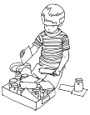
Working Alone
Some people learn best on their own. They
• Think in relation to their feelings and needs
• Enjoy working alone, pondering, planning, setting goals, monitoring their own progress
• Learn by programmed learning, independent assignments, individual projects, choices, self assessment

April 2014



Sunday
Monday
Tuesday
Wednesday
Thursday
Friday
Saturday

April Fool’s Day

Passover Begins
Easter

Earth Day

Copyright ©2011 Integreat! Thematic Units www.thematicteacher.com

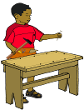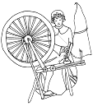
Making Things
Some people learn best by putting things together and taking things apart. They
• Think in arrangements, processes, and patterns
• Enjoy building, working with their hands, weaving, making models, designing things, sewing, knitting
• Learn by putting things together, inventing, analyzing how things work, constructing, & taking apart

May 2014




Copyright ©2011 Integreat! Thematic Units www.thematicteacher.com

Sunday
Monday
Tuesday
Wednesday
Thursday
Friday
Saturday

May Day

Cinco de Mayo

Teacher
Appreciation Day

Memorial Day

Mother’s Day
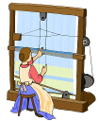
Resources for More Information
So Each May Learn: Integrating Learning Styles and Multiple Intelligences by Harvey F. Silver, Richard W. Strong, and Matthew J. Perini
Multiple Intelligences in the Classroom by Dr. Thomas Armstrong
You’re Smarter Than You Think: A Kid’s Guide to Multiple Intelligences by Dr. Thomas Armstrong
The Big What Now Book of Learning by Carol Barnier

June 2014



Sunday
Monday
Tuesday
Wednesday
Thursday
Friday
Saturday

Children’s Day

Flag Day

Father’s Day

First Day
of Summer

Copyright ©2011 Integreat! Thematic Units www.thematicteacher.com


Many Ways to Learn: Survey
Take a survey online to see how you learn best!
• http://literacyworks.org/mi/assessment/findyourstrengths.html
• http://www.bgfl.org/bgfl/custom/resources_ftp/client_ftp/ks3/ict/multiple_int/questions/questions.cfm
• http://www.ldrc.ca/projects/miinventory/miinventory.php

July 2014
Sunday
Monday
Tuesday
Wednesday
Thursday
Friday
Saturday

Independence
Day

Copyright ©2011 Integreat! Thematic Units www.thematicteacher.com

