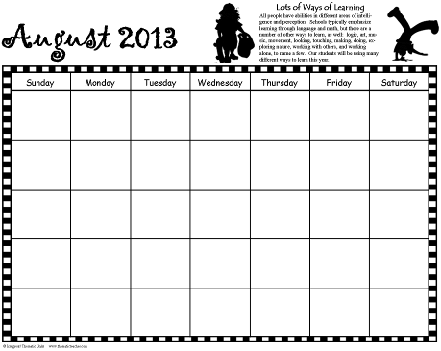

**Artful Teaching**

Copyright © 2011 Integreat! Thematic Units www.thematicteacher.com

Communication

Calendar

You can use these black and white calendars to communicate with parents during the year. Each month features a learning style to help parents better understand the variety of experiences you are providing for your students. The calendars are blank so that you can fill in the information that’s appropriate for you. They begin with August, but you can begin anywhere. (August has an introductory passage, though.)

You can change the month names and the years—just double click on them and retype what you need. Click in the upper left corner of each box to input numbers. Click in the center of each day to type information there.

I left the holidays from a previous year. Many of them occur on the same days each year. To move a holiday to a different day, click and drag the image to the new space. Click in the new box to type in the holiday name. Highlight the old name and backspace to delete it. To move a holiday icon from one month to another (as in Easter), right click on the image and select copy. Go to the new page. Right click on the place you want to place the image and select paste. Click and drag to move it more precisely, if needed.

I hope you’ll find the calendar easy and fun to use!



**Lots of Ways of Learning**

All people have abilities in different areas of intelligence and perception. Schools typically emphasize learning through language and math, but there are a number of other ways to learn, as well, including logic, art, music, movement, looking, touching, making, doing, exploring nature, working with others, and working alone. Our students will be using many different ways to learn this year.

**August 2013**



Copyright ©2011 Integreat! Thematic Units www.thematicteacher.com

Sunday

Monday

Tuesday

Wednesday

Thursday

Friday

Saturday



**Body Movement**

Some students learn best through body movement. They:

• **Think** in muscle movements

• **Enjoy** building, running, jumping, dancing, moving, touching, and making things

• **Learn by** acting, reenacting, muscle memory, hands on activities, & manipulating things



**September 2013**





Copyright ©2011 Integreat! Thematic Units www.thematicteacher.com

Sunday

Monday

Tuesday

Wednesday

Thursday

Friday

Saturday

Labor Day

Grandparent’s Day

First Day of Fall

**Language**

Some students learn best through listening, speaking, reading, and writing. They

• **Think** in words

• **Enjoy** words, telling stories, reading, writing, playing with words, second languages

• **Learn by** books, taking notes, reading, writing, discussion, debates, stories



**October 2013**





Copyright ©2011 Integreat! Thematic Units www.thematicteacher.com

Sunday

Monday

Tuesday

Wednesday

Thursday

Friday

Saturday

Columbus Day

Halloween

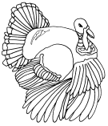

**Logic**

Some students learn best through logic, numbers, & patterns. They

• **Think** by reasoning things out

• **Enjoy** data collection, puzzles, looking for patterns, asking questions, experimenting, math

• **Learn by** manipulating, experimenting, discovering, charting, analyzing data, data maps



Sunday

Monday

Tuesday

Wednesday

Thursday

Friday

Saturday

Copyright ©2011 Integreat! Thematic Units www.thematicteacher.com

Veteran’s Day

Daylight Savings ends

Thanksgiving

**November 2013**



**Working with Others**

Some people learn best by working with others. They

• **Think** by talking ideas over, considering differing points of view

• **Enjoy** organizing people, helping others, leading, counseling, solving conflicts

• **Learn by** working with others, social groups, cooperative groups, clubs, & meetings

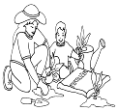

**December 2013**



Sunday

Monday

Tuesday

Wednesday

Thursday

Friday

Saturday

**Christmas Eve**

New Year’s Eve

Copyright ©2011 Integreat! Thematic Units www.thematicteacher.com

Kwanzaa Begins

Christmas

Hanukkah Begins



**Music**

Some people learn best through music. They

• **Think** in rhythms, melodies, chants, patterns

• **Enjoy** tapping fingers and feet, snapping, singing, humming, whistling, raps, chants, jingles

• **Learn by** songs, raps, chants, jingles, musical and sound patterns, pattern notation, codes



**January 2014**





Sunday

Monday

Tuesday

Wednesday

Thursday

Friday

Saturday

Copyright ©2011 Integreat! Thematic Units www.thematicteacher.com

Martin Luther King, Jr. Birthday

New Year’s Day



**Nature**

Some people learn best by working with nature. They

• **Think** in natural images and patterns

• **Enjoy** caring for plants and animals, being outdoors, exploring nature, identifying plants, collecting

• **Learn by** exploration, examination, testing hypotheses, discovery, observation

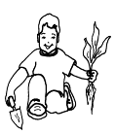

**February 2014**





Sunday

Monday

Tuesday

Wednesday

Thursday

Friday

Saturday

Ground Hog Day

Valentine’s Day

Copyright ©2011 Integreat! Thematic Units www.thematicteacher.com

President’s Day



**Art**

Some people learn best through art. They

• **Think** in pictures, movies, patterns, & icons

• **Enjoy** drawing, painting, sculpting, carving, maps, charts, graphs, photographs

• **Learn by** drawing, charting, analyzing images, videos, movies, photographs, puzzles, story boards, graphic organizers



**March 2014**



Copyright ©2011 Integreat! Thematic Units www.thematicteacher.com

Sunday

Monday

Tuesday

Wednesday

Thursday

Friday

Saturday

Daylight Savings Begins

St. Patrick’s Day

First Day of Spring

**Working Alone**

Some people learn best on their own. They

• **Think** in relation to their feelings and needs

• **Enjoy** working alone, pondering, planning, setting goals, monitoring their own progress

• **Learn by** programmed learning, independent assignments, individual projects, choices, self assessment

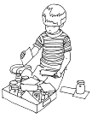

**April 2014**

fool costume



Sunday

Monday

Tuesday

Wednesday

Thursday

Friday

Saturday

April Fool’s Day

Passover Begins

Easter

Earth Day

Copyright ©2011 Integreat! Thematic Units www.thematicteacher.com

**Making Things**

Some people learn best by putting things together and taking things apart. They

• **Think** in arrangements, processes, and patterns

• **Enjoy** building, working with their hands, weaving, making models, designing things, sewing, knitting

• **Learn by** putting things together, inventing, analyzing how things work, constructing, & taking apart

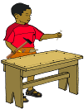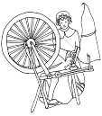

**May 2014**





Copyright ©2011 Integreat! Thematic Units www.thematicteacher.com

Sunday

Monday

Tuesday

Wednesday

Thursday

Friday

Saturday

May Day

Cinco de Mayo

Teacher

Appreciation Day

Memorial Day

Mother’s Day

**Resources for More Information**

So Each May Learn: Integrating Learning Styles and Multiple Intelligences by Harvey F. Silver, Richard W. Strong, and Matthew J. Perini

Multiple Intelligences in the Classroom by Dr. Thomas Armstrong

You’re Smarter Than You Think: A Kid’s Guide to Multiple Intelligences by Dr. Thomas Armstrong

The Big What Now Book of Learning by Carol Barnier

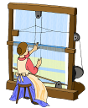

**June 2014**

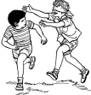



Sunday

Monday

Tuesday

Wednesday

Thursday

Friday

Saturday

Children’s Day

Flag Day

Father’s Day

First Day

of Summer

Copyright ©2011 Integreat! Thematic Units www.thematicteacher.com

**Many Ways to Learn: Survey**

Take a survey online to see how you learn best!

• http://literacyworks.org/mi/assessment/findyourstrengths.html

• http://www.bgfl.org/bgfl/custom/resources_ftp/client_ftp/ks3/ict/multiple_int/questions/questions.cfm

• http://www.ldrc.ca/projects/miinventory/miinventory.php



**July 2014**



Sunday

Monday

Tuesday

Wednesday

Thursday

Friday

Saturday

Independence

Day

Copyright ©2011 Integreat! Thematic Units www.thematicteacher.com