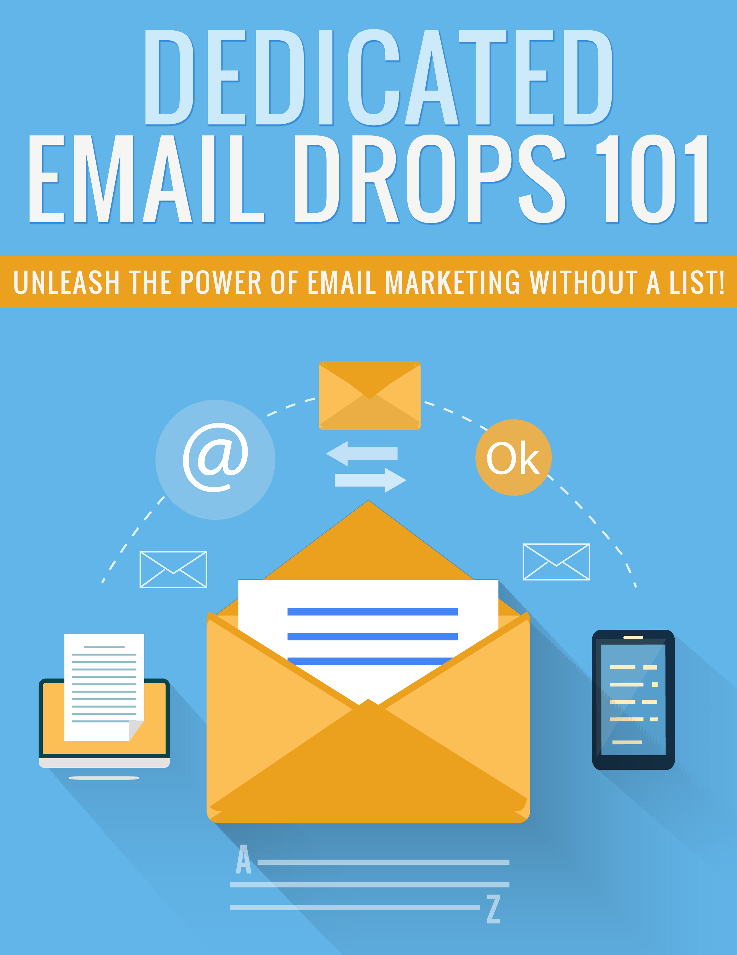

Legal

No part of this publication may be, including but not limited to, reproduced, in any form or medium, stored in a data retrieval system or transmitted by or through any means, without prior written permission from the publisher. The information contained herein has been obtained from sources believed to be reliable at the time of publication. The opinions expressed herein are subject to change without notice.
The publisher disclaims all warranties as to the accuracy, completeness, or adequacy of such information. The publisher assumes no liability for errors, omissions, or inadequacies in the information contained herein or from the interpretations thereof. The publisher specifically disclaims any liability from the use or application of the information contained herein or from the interpretations thereof.

Table of Contents

Legal 2
Table of Contents 3
Introduction 5
What Are Dedicated Email Drops? 6
Risk Reduction 7
Finding Lists 9
Before You Advertise 11
Buying Your Ad 13
Creating Your Email 14
Post-Email Results 16
Conclusion 17
Resources 18

Introduction

Pretty much every business person on the planet has heard by now that email marketing is one of the most powerful things you can do to market your business, but what if you don’t have an email list of your own?

The fact is, it takes time and a heck of a lot of effort to build a decent sized email list. You should be doing so right now if you aren’t already. It’s just THAT powerful.

But what if you’re just getting started? You don’t have an email list, yet. You don’t have enough traffic to build a large list, yet.

Enter dedicated email drops.

Dedicated email drops will let you access other people’s email addresses to promote whatever you want (your own product, affiliate offers, CPA offers, etc.) You can even steal their subscribers right out from under them by promoting your own squeeze page, getting people onto YOUR list so you can market to them again and again!

In this guide, you’re going to learn what dedicated email drops really are, and how you can take advantage of them to market your own business.

So let’s get started.

What Are Dedicated Email Drops?

A dedicated email drop is a one-time email someone sends to their own email list on your behalf in exchange for a fee. You will not receive the list itself. The list owner will send the email to the list for you.

Of course, that doesn’t mean you can’t get those people onto your own email list. All you have to do is send the traffic to a squeeze page instead of straight to a sales page.

The good news is that once that person has subscribed to YOUR email list, you can then market whatever products you want to them.

Dedicated email drops can be extremely expensive, but they can also be very affordable. It all depends on the owner of the list and what they’d like to charge. It’s very possible to find list owners who either don’t know the true value of your subscribers, or just don’t want to charge a fortune.

Dedicated email drops have a lot of benefits. For one thing, you can get a huge amount of traffic overnight, whereas other methods like social marketing and SEO can take months to see real results. Additionally, there aren’t as many restrictions as there are with advertising methods like AdWords and Facebook. If you’re looking to promote offers they traditionally frown on like weight loss or dating, dedicated email drops are a great choice.

Risk Reduction

There’s risk in everything in business, but there’s also a way to mitigate some of that risk.

With regard to dedicated email drops, there’s a possibility that the quality of the list isn’t what you’re hoping for, that the subscriber numbers aren’t as high as the seller claims, etc.

Fortunately, you can take a few steps to help reduce your risk. Here are a few ways you can help mitigate the potential risk involved in buying dedicated email drops.

- Ask For “Make Goods” – Some list owners will be willing to “make good” on their offer if they send an email out and it doesn’t perform. As upfront if they are willing to do this for you if you don’t get good results.
- Use Cheaper Options First – If the list owner offers cheaper options such as text, display, or banner ads, try those first to see if you get any results. If so, you can then purchase a dedicated drop. If not, you might want to find another list to try.
- Use Tracking – It’s a good idea to set up conversion tracking so you can see how many people make it to your thank you page and not just the traffic you get to the landing page.
- Buy A Partial Send – You may be able to buy a partial send, which is when the list owner sends your email only to a small segment of their list at a lower price. For example, if the owner charges $200 for a dedicated email to a list of 20,000 people, they might send an email to 5,000 of those people for only $50 to let you test the quality.
Even with these techniques, there’s still a possibility that you won’t get the results you’re hoping for, but this way you won’t have as much at stake, so your potential for loss is greatly reduced.

Finding Lists

Perhaps the most difficult and time-consuming part of buying dedicated email drops is finding lists that fit with your niche. There are two main ways to do this. You can either use a broker, or you can find lists on your own.

If you would like to check out a broker, here are two sites to take a look at:

http://next.srds.com/home

http://www.nextmark.com/

Brokers are great, because you can let them do all the work finding the lists, negotiating deals, etc. However, it comes at a price. The broker takes their cut of the money, making the service significantly more expensive than if you buy direct from list owners.

You can also take a look here:

http://lists.nextmark.com/

The above link will let you search about 60,000 mailing lists to try to find some that will work for you. But a lot of people use this same site, so it may be hard to find something affordable.

The other way to find lists is a bit more work, but you have the potential to locate “hidden” sources that might have lists that aren’t overused and that are priced a lot more reasonably.

Let’s say you’re in the weight loss niche. Start visiting popular websites in the weight loss niche and looking for the links that say “advertising” and such. Many websites will have a list of all their different promo opportunities, or at least a contact page so you can inquire about them. They may also have a media kit that

You can also Google like this:

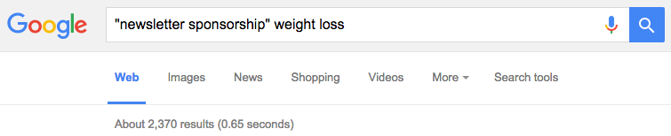

As you can see, this search came up with over two thousand potential sites you might be able to advertise on.

You may have to wade through a lot of sites, but eventually you will come up with a nice list of sites you can contact about advertising.

Before You Advertise

There’s a couple of things you need to do before you commit to advertising with any list. Primarily, you need to subscribe to the list and watch it for a week or two to get an idea of what the list is like.

Things you need to look for:
- How frequently do they send emails? If they slam the list day after day, it probably won’t be very responsive. If they hardly ever email, the list may have gone cold.
- Do they mail only ads, or do they also send valuable content? If the list is nothing but ads, it probably won’t be very responsive.
- Do they endorse their advertisers or merely send ads? Ideally, you want to see the emails coming with the list owner’s name in the FROM field, and you want them to say something like “Our friends at Your Site Name have a really cool offer for you!”

Once you have a few prospects that fit these criteria well, it’s time to start contacting them and finding out how much the list owner charges for advertising and you’ll want to ask a few other questions.

Here are a few important questions to ask:

- List Size – You’ll obviously want to know their subscriber numbers, but also ask if they are willing to send a test email to a smaller segment of their list at a lower price so you can see how well it converts before you commit to a larger price.
- Cost – Find out how much their standard rates are.
- Estimated Open Rate and CTR – Many list owners don’t know this information, but those who do should be fine with providing it. If not, it could be a red flag.
- Split Testing – Find out if they allow split testing so you can test different elements of your promotion.
- Other Incentives – Ask if the list owner is willing to offer any special incentives to get your business. For example, 30-day terms so you can pay after the email is sent, or a reduced rate if you buy ads on their website or a lower rate as a first-time buyer.

Buying Your Ad

Once you’re ready to buy, find out their availability. You should be able to schedule a specific date and time. Hopefully the list owner will be able to tell you which days and times perform best for them, but if not, a good rule of thumb is that the best days are usually Tuesday-Thursday between 8 PM and Midnight Eastern time.

Weekends can also do well, but make sure you ask what their typical open rate and CTR is on weekends, because it could be lower or higher on weekends depending on the list.

Make sure you’re going to be the only email sent to the list that day. Otherwise, you’ll risk getting lost in the shuffle, and you won’t see the kind of results you could if you were the only email that day.

Remember to ask for those bonus incentives. If you don’t ask, it’s not likely they will be offered voluntarily. As for every possible discount you can get, such as a discount for it being your first time advertising with them, and discounts off putting banner ads on their website.

Finally, don’t forget to try to negotiate Net 30 payment terms, meaning you have up to 30 days after the email is sent to pay. This will let you see what the results will be before you pay, and you can negotiate afterward for a “make good” email before you pay if results are dismal.

Creating Your Email

Creating your email is an extremely important step. You need to be sure you have a great subject line, and that your text is absolutely free from errors before you send it.

Be sure to ask what format the list owner prefers the email to be in. Many will want it to be in HTML format, if possible, unless you’d rather just send plain text with no images.

You will probably have to send your email over at least 3 days before the date you’ve scheduled so they have time to set up your email and send out a test email.

You will definitely want to use a spam checker to be sure your emails aren’t in danger of going into spam boxes. If your message ends up in people’s spam folders, you definitely won’t see results.

Here’s a good tool for checking emails for spam:

http://www.emailspamtest.com/

You should already be subscribed to the list, and the list owner should make sure the test email goes out to you. When you receive it check for the following:

- Are there any broken links?
- Was it in the spam box?
- Any errors in the email?
- Was the list owner’s name in the FROM field?

You’ll also want to be sure you were the only email they sent out on the day the email actually goes out to everyone.

Post-Email Results

After the email goes out, you should keep a close watch on your results for about three days. You can’t expect all of the results to happen on the first day, because a lot of people don’t check their email every single day. After three days, you should have a good idea of how well your ad performed.

If you got close to the results you wanted, that’s a good thing. But if you got far, far less than you expected, you might want to negotiate a solution with the vendor.

Here are some potential solutions:

- The vendor could send a second email for free
- You could get a hefty discount off your current ad, if you have not yet paid
- You could get a hefty discount off future ads
- You could get a free ad on their website for a period of time

Not all list owners will work with you on this, and you may just have to accept whatever results you get. But many will work with you to find a good solution.

Conclusion

It takes a lot of time and dedication to build an email list. If you don’t have that kind of patience, you can use dedicated email drops to speed up the process.

Remember, you don’t have to send people directly to a sales page. If you send them to a squeeze page, you can have your autoresponder send a promotional email for anything you want after they join, and that way you have them on your list so you can advertise to them time and time again.

Make sure you negotiate for better rates and bonuses. Most list owners are happy to haggle as long as you’re reasonable and don’t expect too much. If they aren’t willing to negotiate, it might be a red flag.

Also, I can’t stress the importance of testing and tracking your results. You need to know how many people made it to your landing page, as well as how many people converted into leads or sales in order to know if the ad was truly a success.

I wish you the best of luck with your promotions!

Resources

Here are quick links to the resources mentioned in the guide:

List Brokers:

http://next.srds.com/home

http://www.nextmark.com/

Check for email lists:

http://lists.nextmark.com/

Test emails for spam flags:

http://www.emailspamtest.com/

