a head start in music, math & life

Te s t i m o n i a l s

This simple, half hour weekly class will aid in empowering him when it is time for kindergarten. I asked Aidan how he felt about his piano lessons and he said “I
Want to take piano lessons until I
WUNDERKEYS

Parent Information Guide
Offered by Hollis Musical Arts
HollisMusicalArts.com

a head start in music...

am one hundred.” He is so proud of his ability and accomplishments with each lesson and home practice.

Katrina Grounds

It warms my heart that we have found a fun and completely age- appropriate music activity. I want my children to enjoy learning and appreciate music in all forms and this has been an exceptional experience so far for all of us.

Natasha Hennessy

We love the one-on-one time each week rather than a group session. She always comes out of her lesson happy and with a smile on her face

Genneine Mckenzie

Welcome to WunderKeys Piano For Preschoolers – a unique program for preschoolers ages 3 to 5.

An encouraging first experience in music lessons is critical to your child’s enjoyment of the piano. The WunderKeys Program has been designed to be that and more! WunderKeys lessons are tailored to meet the needs of preschool-aged children and to ensure that their first music lesson experience is positive and enjoyable.

Designed as an all-encompassing piano lesson, students participate in five different unique activities during their lesson time, ensuring they remain focused, engaged and happy.

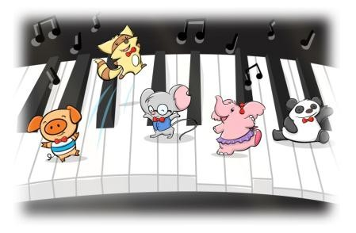Throughout the 3 book series, your child will develop piano and music skills that will

allow for a smooth transition into mainstream piano method books. Beginners in this program start with no prior piano or music experience and finish with solid keyboard awareness, an understanding of rhythmic notation, and the ability to play simple pieces with both hands.

Practicing at home requires no prior musical knowledge on your part. Easily laid out homework sheets guide you and your child through several fun activities each week designed to both reinforce what was learned in the lesson and create “bonding on the bench” time at home.

During WunderKeys lessons, your child has the opportunity to participate in fun activities both on and off the piano bench, which have been created to build confidence, increase enjoyment and solidify important music and math concepts. These activities include: musical math songs, patterning activities, finger poem exercises, book work, and music card games.

We use songs, games, and fun manipulatives to keep your child engaged and begging for their next lesson!
a head start in music, math, & life

Te s t i m o n i a l s
a head start in math...

It helps children to appreciate music and explore their own creativity in an atmosphere of support and encouragement, while building a strong musical foundation. Many of the concepts overlap with the principles of
math they will be learning in kindergarten and they don't even realize they are learning- it's
such fun!

Jane Saunders

The program is extremely enjoy- able which keeps kids interested and excited about learning more.

Kimberley Gent

If I knew music was this much fun, I would have started when I was much, much younger.

Student, 5 years old
It is no secret that music, and specifically the piano, is built around mathematical principles. This fact is highlighted by numerous studies revealing the piano to be a powerful tool for developing mathematical thinking. It is, however, relatively unknown that there exists a window of opportunity during the preschool years when learning the piano can facilitate neural connections in the brain needed for mathematical understanding later in life.

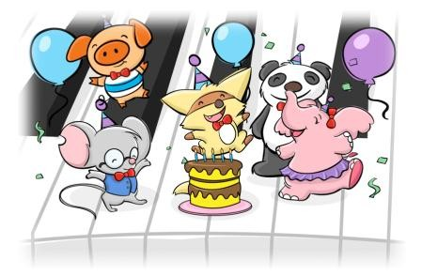

a head start in life...

For many students beginning the WunderKeys program, this is their first experience one-on- one with an adult other than their parents. It’s their first opportunity to be independent, to feel as though they have ownership over their own learning, and to feel pride in their individual accomplishments. The program is designed to foster feelings of confidence, self esteem, and the joy of learning.
Knowing that this window of opportunity is relatively short and with the aforementioned research in mind, the WunderKeys Program was developed to make the most of these important years.

Through this program, your child will get a head start on the math concepts they will be learning in Kindergarten. WunderKeys students finish the program with a solid understanding of patterning, sorting, grouping, classification, counting, number recognition, “more than/less than”, one-to-one correspondence and more. Not only will they be familiar with these important mathematical concepts, but their first experience with math will be one that is both enjoyable and approachable, in which they were made to feel successful.

Offered by Cindy Hayes, Director
Hollis Musical Arts
Lessons include a free trial period
followed by Low Monthly Tuition

for more information, call us at 603-400-1026
or email Director@HollisMusicalArts.com

