OUR HISTORY
The Roy I. Rhodes Chapter 306, Inc. of the Vietnam Veterans of America, located in Morgantown, WV has been established as a Chapter for 35 years. During those years, our numbers have increased and decreased but our Members and our Associate Members have worked together for many causes, fundraising events and support to each other while remaining “in service to America” and our community.

OUR MEETINGS
The Roy I. Rhodes Chapter 306 meetings have been changed in lieu of a monthly Social Brunch Get Together at Apple Annie’s. See page five for more information. Please watch your emails for updates and send your RSVP so we can give a count of people attending to the restaurant.

OUR WEBSITE
For more information please visit our newly updated
website at:

www.VVA306.org

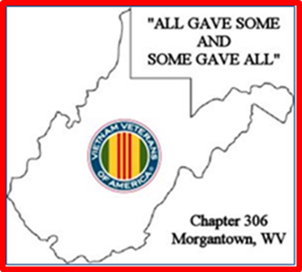

PLEASE NOTE:

DUE TO THE
COVID-19 CRISIS,
VVA Chapter 306
MONTHLY MEETINGS
HAVE BEEN CANCELED UNTIL JUNE.

REMEMBER TO CHECK YOUR EMAIL AND THE WEBSITE FOR
NEW UPDATES AS THE COVID-19 CRISIS CONTINUES!

JANUARY NOTES ON THE COVID-19 VACCINES
Please check your email as we are getting information on where our Veterans are able to get the vaccine.
Thank you to Doug, Mike H. and Lynn for your help in gathering information to pass along to the Members on where to get a shot.
Currently, the Morgantown CBOC is NOT giving shots.
The Clarksburg VA is starting to call people who are 65 and older and making appointments.

The Pittsburgh VA will begin to vaccinate veterans who are 65 and older on a first come first served basis. It is a walk in arrangement at the downtown facility next to UPMC (Oakland VA). The only caveat is you must be a patient in that facilities system (received care at that VA location in the past). Being a patient in the Clarksburg VA system will not work.

Mon County Health Department is doing injections on an appointment basis.

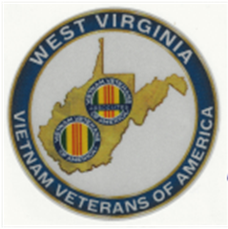
WEST VIRGINIA STATE COUNCIL MEETINGS

PLEASE NOTE:
DUE TO THE
COVID-19 CRISIS,
WV STATE COUNCIL MEETING FOR MARCH IS CANCELED.

We just got word THAT Dave Simmons has cancelled the State Council Meeting for March. He is optimistic by June 2021, it will be safe enough for a WV State Council Meeting.

However, we would still like volunteers to attend these meetings when the crisis is over and the West Virginia State Council meetings resume.

Please let the VVA Chapter 306 leadership know you would like to be involved!

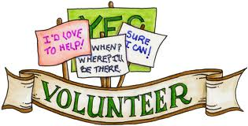

ARE YOU RETIRED?

ARE YOU LOOKING FOR
AN OPPORTUNITY TO SERVE?

HAVE YOU VOLUNTEERED LATELY?

YOUR FELLOW VETERANS NEED YOU!

There is no pay, but the rewards are very great!

We look forward to serving with YOU!

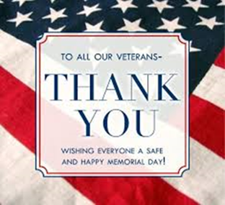

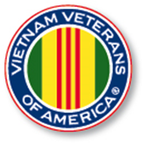

The Special Offer
of $50.00 for
LIFETIME
MEMBERSHIP
continues
for both the
VVA and AVVA
Members!

We could not generate enough interest to participate in the Grafton Parade on Memorial Day, 2021, so we have cancelled our parade appearance. Hopefully everyone can find something to do on Memorial Day. Be safe!

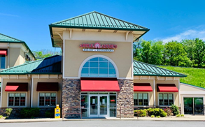

VVA Chapter 306
Social Brunch
Monday, June 14, 2021

The Chapter met for the first time in about a year and a half at Apple Annie’s for a Social Brunch. Speaking for the group, I think a GREAT Time was had by all that attended! We had a total of 24 participants.
We also had several with sick call issues that attended as an inspiration to others.
YOU JUST CAN NOT KEEP A VETERAN DOWN.

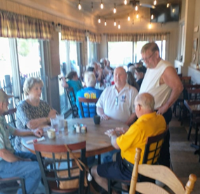

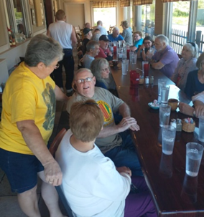

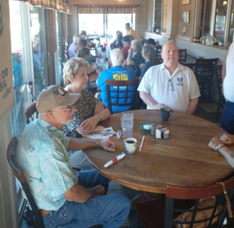

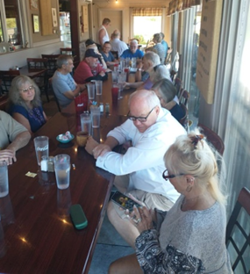

FLAG DAY CELEBTRATION
Monday, June 14, 2021
6:00 PM, Elks Lodge

The Elks Lodge contacted the Chapter to participate in their Flag Day Event.

Several attended the Flag Day Celebration at the Elks Lodge at 6:00 p.m.

There was more good food to eat and an enjoyable program of our flag history.

The weather did not cooperate for the Burning Ceremony. This will be done at a later date with an email notification.

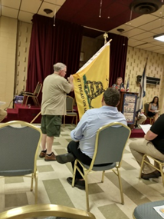

Jamie, June 14, 2021

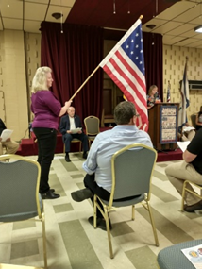

Janet
June 14, 2021

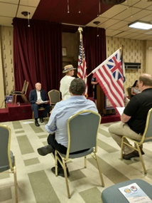

Lee
June 14, 2021

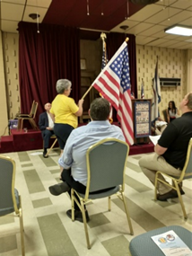

T.J.
June 14, 2021

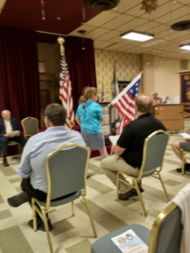

Megan
June 14, 2021

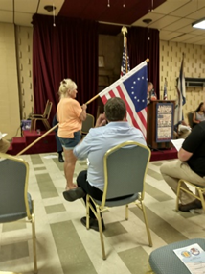

Jane
June 14, 2021

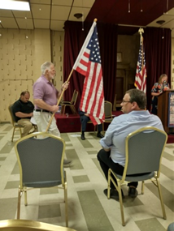

Don
June 14, 2021

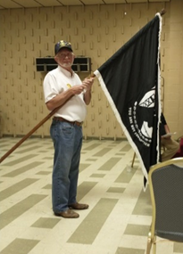

Gary
June 14, 2021

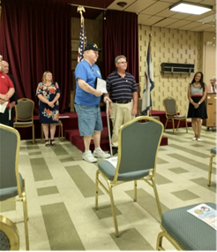

President Charlie Harrington
Receiving the Flag Day Certificate, June 14, 2021

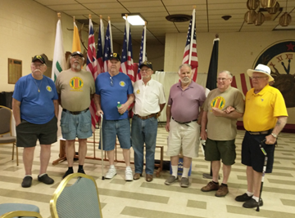

VVA CHAPTER 306 MEMBERS
at the Elks Lodge
Flag Day Ceremony
June 14, 2021

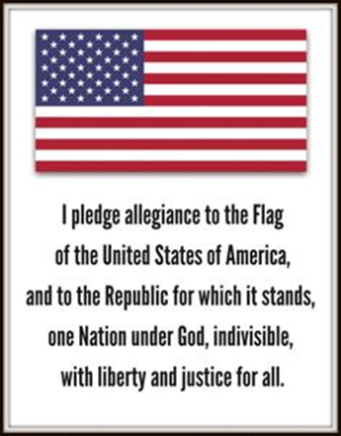

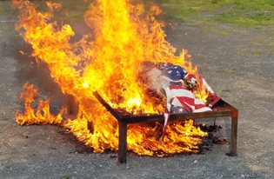

SPECIAL ANNOUNCEMENT REGARDING FUTURE CHAPTER MEETINGS

A motion was made and the majority approved for the Chapter to continue with the Social Brunch Get Together instead of the monthly meeting at the Elks.

These brunch gatherings will be held the 2nd Monday of every month at 10:00 a.m.

An email will be circulated a week prior with the place and time along with a RSVP email to get the total of planned attendees.

In the winter we will conduct the brunch every two months.

All members and family are welcome. And again we understand if you cannot attend.

If we have business to conduct or information to share it will be done at these meetings.

Mark your calendar:
2nd Monday of each month
at 10:00 a.m.

SEE YOU THERE!

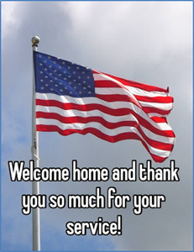

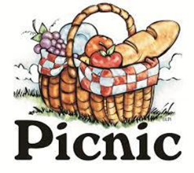

VVA Chapter 306 Picnic
Community United Methodist Church Pavilion
Grafton Road
Monday, September 13, 2021
6 p.m.

The Chapter is furnishing the drinks and meat. Chapter members are asked to bring a pass-a-round. RSVP reservations are being taken until Friday, September 10th.
This is a family event; please include them in your RSVP.

So far we have thirteen members or family attending with desserts. We could use casseroles, vegetables, chips.

SPECIAL ANNOUNCEMENT REGARDING
a VERY SPECIAL
FAMILY AND FRIENDS CELEBRATION

Saturday, September 18th

Address:
32 Kelly Road
Morgantown, WV 26508

Time: 11:00 am. to 7:00 pm.
Snacks will be provided.

Gary has decided not to continue with further chemotherapy treatments.

The family hopes friends will stop by and spend some time with the celebration.
Snacks will be provided.

A Few Words from
Chapter 306 Leadership

We hope all are well, staying healthy and finding a way to stay active during the Covid-19 issue.

Please keep in touch by email or phone.

Remember to watch your email for important Chapter 306 information and for upcoming events mentioned in this newsletter.

Please take care of yourself, stay healthy and well.

Please pray for Members on the Sick Call List. Keep the spouses in prayer as we all know they could use some prayers.

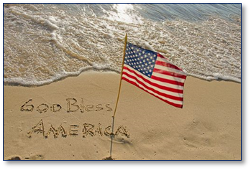

Updates for the
VVA #306 Trailer Memorial

Many people that I talked with recently said they had never seen the VVA #306 Trailer Memorial.

With that said I have attached a couple photos for review. These are older pictures and missing a couple updates. The name tapes will be ordered and installed.

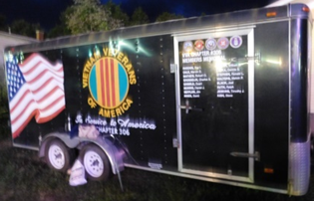

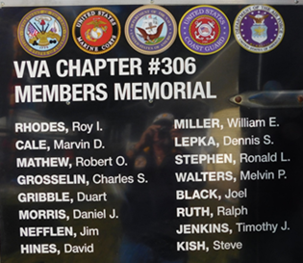

The members of the VVA and the AVVA of Chapter 306 extend our deepest sympathy to
the STRANG Family
in the loss of their loved one,

EARL B. STRANG, Jr.

Earl was one of the
Charter Members involved with getting the VVA #306 started.
Earl served on the Board,
and was a Life Member of
VVA Chapter 306.

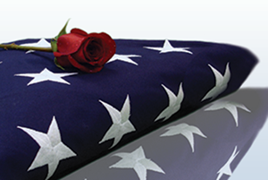

To the Officers
of VVA Chapter 306

Only the Lord and your spouse know the countless hours you have given to this Chapter as you served. You may have served once, and then served again to make sure this Chapter kept going, now 35 years from the first meeting.
Thank you for your sacrifice and your service!

Respectfully Submitted by
VVA Chapter 306
Morgantown, WV

PRESIDENT
Charlie Harrington
VICE PRESIDENT
Robert Jamie Welch
SECRETARY
Doug Geary
TREASURER
Don Davis
ACTIVITIES & MEDIA REPORTER
Janet. L. Finerfrock

