SPECIAL MEETING
JANUARY 4, 2016

A Special Meeting of the Town Board of the Town of Hampton, County of Washington and the State of New York was held at the Town Hall, 2629 State Route 22A, Hampton, New York on the 4th day of January, 2016.

PRESENT: David K. O’Brien----------Supervisor
Tamme Taran---------------Councilwoman
Donald Sady----------------Councilman
Andrea Sweeney-----------Councilwoman-absent
Roger Weeden--------------Councilman
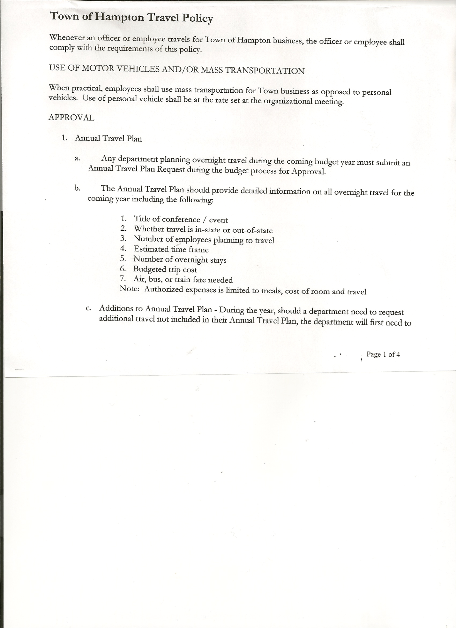
Rebecca Jones--------------Town Clerk
Camilla Shaw--------------Tax Collector/Deputy Town Clerk

Also present: Susan O’Brien, Carrie O’Brien, Matthew Pratt and Heather Weeden

The meeting was called to order by Supervisor O’Brien at 7:03pm followed by the Pledge of Allegiance. Location of Fire Exits were given.

OATH OF OFFICE

The Oath of Office was administered to the elected officials present.
(David O’Brien, Supervisor; Tamme Taran, Councilwoman,
Roger Weeden, Councilman and Camilla Shaw, Tax Collector)

RESOLUTION NO. 1-2016
HAMPTON ORGANIZATIONAL CHARTER FOR 2016
On a motion of Councilman Sady, seconded by Councilwoman Taran the following resolution was ADOPTED Ayes 4 O’Brien, Taran, Sady, Weeden
Nays 0
Absent 1 Sweeney
RESOLVED that upon review the Hampton’s Organizational Charter for 2016 is adopted as proposed and amended.

Yearly Audits…..Town Justice, Town Clerk, Tax Collector and Bookkeeper to be done on January 20th, 2016.

RESOLUTION NO. 2-2016
OPERATIONAL LETTER OF AGREEMENT
On a motion of Councilwoman Taran, seconded by Councilman Sady the following resolution was ADOPTED Ayes 4 O’Brien, Taran, Sady, Weeden
Nays 0
Absent 1 Sweeney
RESOLVED to sign an Operational Letter of Agreement with Poultney Rescue Squad and Fair Haven Rescue Squad for 2016.

TOWN BOARD MEETING
JANUARY 4, 2016 PAGE 2

RESOLUTION NO. 3-2016
HAMPTON TOWN POLICIES
On a motion of Councilman Sady, seconded by Councilman Weeden the following resolution was ADOPTED Ayes 4 O’Brien, Taran, Sady, Weeden
Nays 0
Absent 1 Sweeney
RESOLVED that upon review the following policies:
- Travel Policy
- Investment Policy
- Cell Phone Policy
- Sexual Harassment Policy
- Workplace Violence Policy
- Procurement Policy 2016
- Credit Card Policy
- On-line Banking Policy
- Ethics Policy
- Computer Usage Policy
- Record Storage Policy
- Employee Handbook
- Drug/Alcohol Testing Policy
- Town Hall Use
of the Town of Hampton are approved.

RESOLUTION NO. 4-2016
AUTHORIZE TO PRE-PAY ITEMS
MOTION BY: COUNCILWOMAN TAMME TARAN
SECONDED BY: COUNCILMAN ROGER WEEDEN

TITLE: RESOLUTION AUTHORIZING THE TOWN SUPERVISOR TO PAY BILLS IN ORDER TO AVOID PENALTIES AND INTEREST

WHEREAS, the Town has determined that due to certain bills being due prior to the Town Board Audit of bills,

AND WHEREAS, the Town Board is desirous of avoiding late fees, penalties and interest and maintain its good credit standing,

NOW THEREFORE, BE IT RESOLVED:
That the Town Board of Hampton hereby authorizes the Supervisor to approve the payment of bills before audit if in the reasonable discretion of the Supervisor, it is necessary to do so to avoid any costs, penalties, interest or termination of service. The supervisor may pay claims for public utilities, postage, freight and express charges, before they are audited. The term “public utilities” includes electric, gas, water, sewer and telephone services and the purchase of fuel oil. All claims must be presented for audit at the next regular board meeting audit. The claimant and the town officer incurring or approving these claims are jointly and severally liable for any amount disallowed upon audit.

TOWN BOARD MEETING
JANUARY 4, 2016 PAGE 3

BE IT FURTHER RESOLVED:
That the Town Board is not required by law to pre- audit payments of fixed salaries, compensation of officers or employees, principal and interest indebtedness, or amounts coming due on certain contracts
BE IT FURTHER RESOLVED that in the absence of the Supervisor, the Deputy Supervisor is authorized to review the bills and make the determination to authorize payment for the same reason.
BE IT FURTHER RESOLVED that the Town Clerk is hereby authorized and directed to add the following policy to the policy manual/employee handbook for the Town of Hampton.

DATED: January 4, 2016 Supervisor O’Brien AYE
Councilwoman Taran AYE
Councilman Sady AYE
Councilman Weeden AYE
Councilwoman Sweeney ABSENT

RESOLUTION NO. 5-2016
CHANGE MEETING TIME
On a motion of Councilman Sady, seconded by Councilman Weeden, the following resolution was ADOPTED Ayes 4 O’Brien, Taran, Sady, Weeden
Nays 0
Absent 1 Sweeney
RESOLVED, to change the January Regular Town Board Meeting from 7:30pm to 7:00pm.

Camilla Shaw, Tax Collector submitted her annual report for 2015 to the Town Board and had board members sign bank statement for December 2015.

On a motion of Councilman Sady, seconded by Councilwoman Taran, the meeting adjourned at 7:40pm. All in favor Aye.

Respectfully submitted,

Rebecca S. Jones, RMC
Town Clerk

