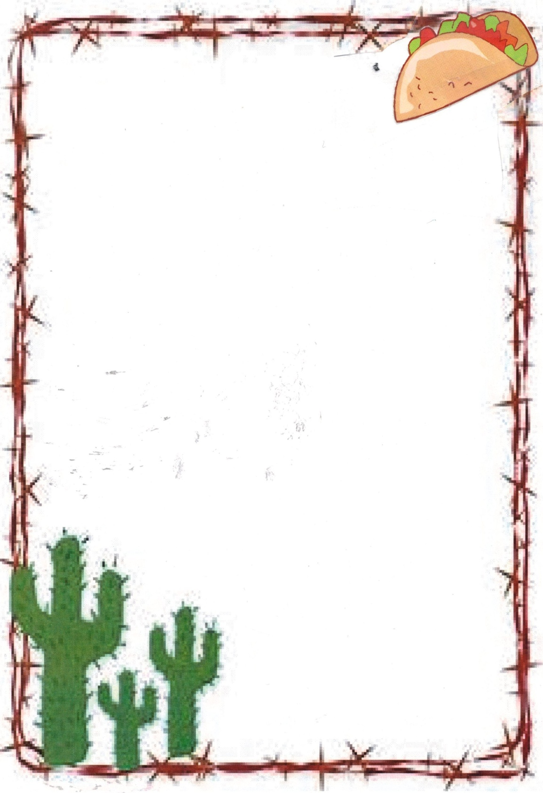
Rio Abajo Community Cookbook
Entry Rules

The Rio Abajo community includes:
Abeyta Jarales San Francisco
Bernardo La Joya San Juan
Blue Springs Ladron Foothills Tierra Grande
Bosquesito Las Nutrias Veguita
Contreras Sabinal
All entries must be submitted by someone living in this community or by someone whose family came from this community.
There are no limits as to the number of entries being submitted, but selection of recipes to be included into the cookbook will be made by the RACL Review Board. Submittal of a recipe does not guarantee entry into the cookbook.
With each recipe, please provide exact measurements for each ingredient rather than approximations – i.e., a palmful of flour in my hand equals ¼ c, but someone else’s palm may equal a full cup. Approximations can produce a household disaster!
Before submitting a recipe, please double-check that no ingredient has been overlooked or forgotten.
Recipe categories will include:
- Appetizers & Beverages
- Breads and Rolls
- Main Dishes and Casseroles
- Sauces, Dressings, Gravies, Marinades
- Soups and Salads
- Vegetables
- Pies, Pastry & Desserts
- Cakes, Cookies & Candy
- This & That (anything that does not fit the categories, such as a good Play Doh or silver-cleaning recipe)
Rio Abajo Community Cookbook
Entry Form

Person entering recipe(s):
Address:
City: Zip
Contact phone:
Email:
If not presently living in the Rio Abajo community, please explain family connection to the community:
Name of recipe(s) being submitted (recipes on separate sheet):

Each batch of three recipes must include a little story, description of occasion and/or a picture.
- Please submit your story or history on a separate sheet or submit via email to RACLibrary@hotmail.com (one story/history per every three (3) recipes).
- Regarding any picture, please send via email or come into the library so originals can be scanned and returned promptly.
Submit entry form with attachments to: RACL Community Cookbook at 28 S. Calle de Centro, La Joya, NM 87028.

