**SCSTMA 2017 Field of the Year Awards**   
Sponsored by Turface Athletics   
and   
Burnett Athletics

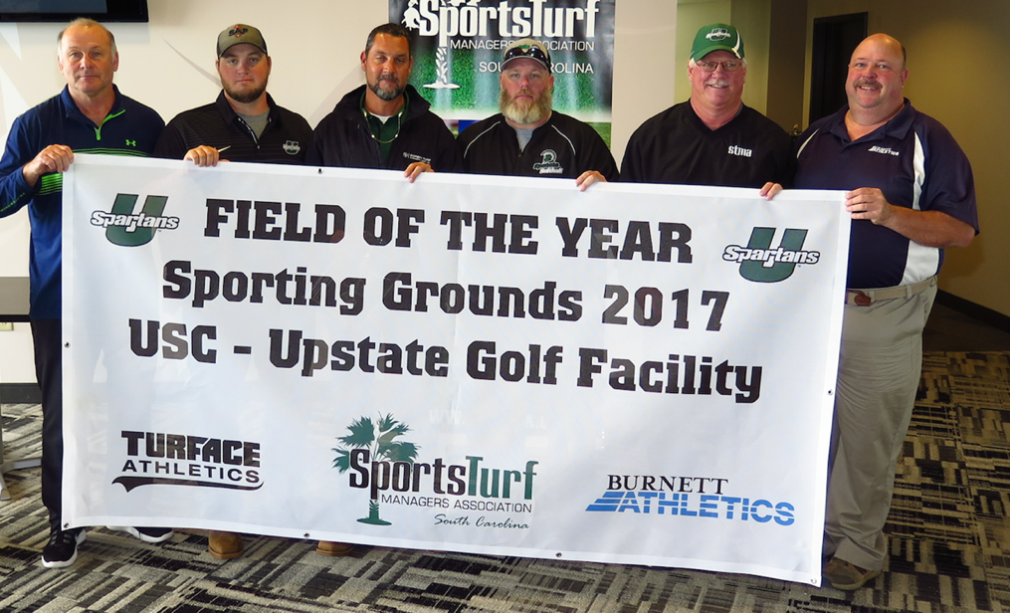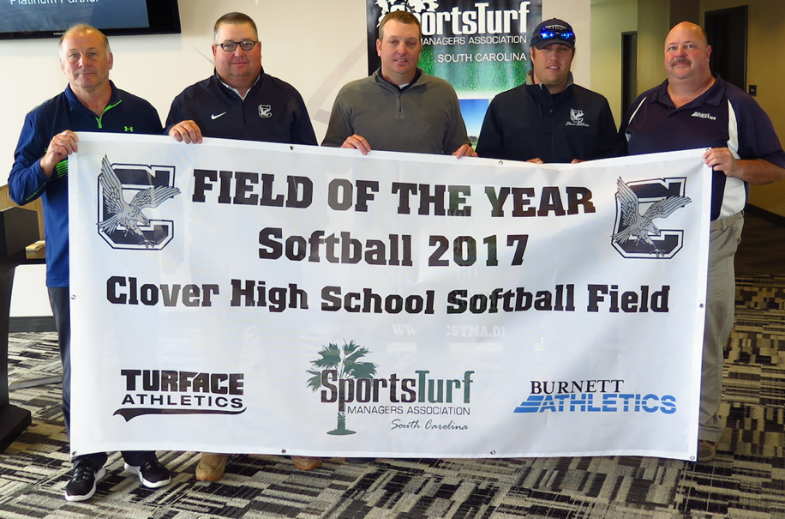

**These awards were given in December at our annual business and awards meeting. The 2017 meeting was held in Columbia at the Fireflies Spirit Communications Park.**

