3 Step Goal Setting
Use three steps to set and accomplish your goals. Use the goal planning worksheet to first set goals, then identify next steps each week to accomplish your goals, and finally take time each month to celebrate and reflect about your goals.

- Goals

Coaching

3. Monthly Reflection

2. Identify Next Steps

Step 1: Determine Goals
First: Reflect on what you want to accomplish | Next: List as many ideas as you can and mark (star, place a sticker, circle, or highlight) the 2 to 5 that are the most important to you
Example list:
- Become a better communicator
- Develop stronger with curriculum and modeling
- Hold consistent meetings with administration
- Create more effective professional development
- Complete 2 Implementation Plans
- Move teachers through the Stages of Implementation
Finally: List the final goals you have chosen on your goal planning worksheet
- Become a better communicator
- Hole consistent meetings with administration
- Complete 2 Implementation Plans
- Move teachers through the Stages of Implementation

Example:
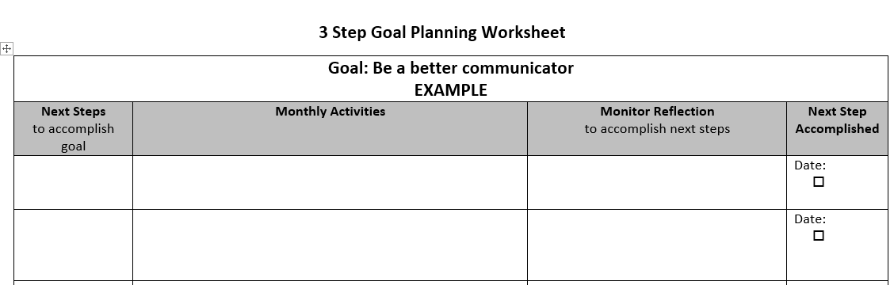

Step 2: Identify next steps to accomplish the goals
First: List as many next steps as you can for accomplishing each goal | Next: Reflect about which ones make the most sense for you and your school | Then: List the next steps on your goal planning worksheet
Example goal and steps: Complete 2 Implementation Plans  - Create plans  - Develop coaching cycles around the plans  - Meet with other coaches in the district to review plans  - Gather data to determine coaching effectiveness  - Meet with teachers weekly about plans  Example goal and steps: Be a better communicator  - Share positives about teachers with principal  - Place notes in mailboxes  - Attend team meetings on a regular basis  - Send out weekly email  - Arrive every morning at 7:30 am to be available for teachers |  | Example steps I can accomplish:  - Create plans  - Develop coaching cycles around the plans  - Gather data to determine coaching effectiveness  Example steps I can accomplish:  - Share positives about teachers with principal  - Place notes in mailboxes  - Attend team meetings on a regular basis
Finally: List the activites you will do each month to accomplish your next steps

Example:
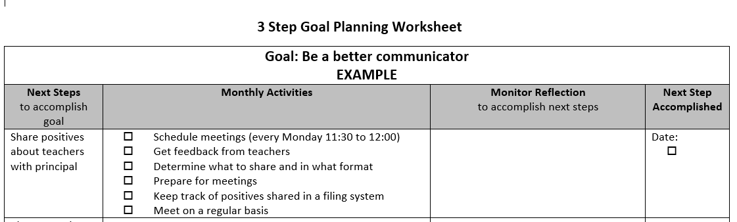

Step 6: Monthly Reflection and Next Steps
First: Complete the Monthly Reflection in your Goal Planning Worksheet, Coaching Calendar or in a notebook.  Answer the questions  - What went well this month? Why?  - What did not go well? Why?  - Am I on track for achieving my goals?  - What do you want to revisit or adjust? | Finally: Revisit your goals and next steps  - Do you need to adapt or change any goals?  - What next steps do you need to review?  - What can you improve with your monthly activities?  - Did you take time to celebrate what you accomplished? MAKE THE TIME TO CELEBRATE! Add a coaching sticker or two!
Example of completing the monthly reflection:  What went well this month?  Almost all of the meetings I scheduled, occurred, so I feel like I am really on track for meeting the goal I set.  What do you want to revisit or adjust?  I also provided a lot of feedback to my principal about teachers but didn’t feel like I provided enough feedback directly to teachers, so I’m going to try to write more notes and place them in teacher’s mailbox this month. | Example of revisiting your next steps and activities:  - Continue regular meetings with principal  - Continue to provide positive feedback about teachers during the meetings with principal  - Add to Goal Planning Worksheet under Monthly Activities…Add at least one positive note in each teacher’s mailbox
Example:

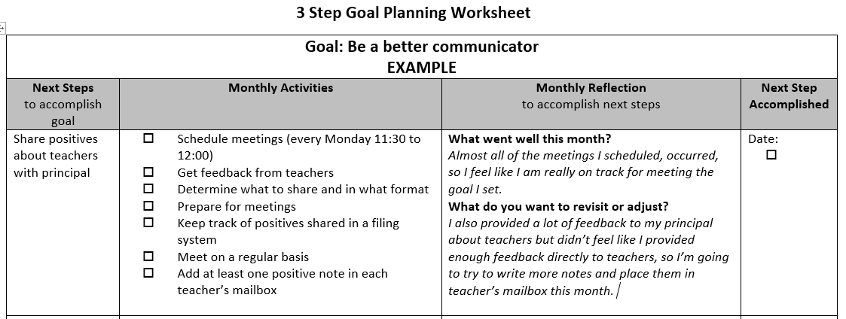

A few things to consider…
Reflection and next Steps
Bring your monthly reflection full circle by revisiting your Goal Planning Worksheet and checking off any next steps and monthly activities, and ultimately when you have accomplished a goal. Also, add a few coaching stickers for celebration!
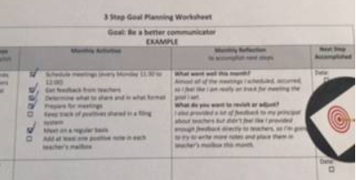
Both the coaching calendar and coaching notebook have places for checking off details you accomplish. Be sure to check off what you have accomplished. It makes you feel good! www.strivingreaders.com, www.howdoiplanandteachreadinggroups.com
Coaching Notebook (www.strivingreaders.com or www.howdoiplanandteachreadinggroups.com)
Include a next steps at the end of each topic or section in your notebook. Then, review your notebook at least weekly. Decide what to do with your next step notes. Add them to the calendar? Add them to Coaching Cyles? Add them to an agenda? Once you have completed the PD, meeting, appointment, etc., cross them off your list, tear out the page, and put it in in a file in chronological order. This will help you analyze your Coaching Effectiveness in part 6 of the Coach’s Handbook.
Example: If I was doing a coaching cyle with Ann, I would add “put postive note in Ann’s mailbox” to the end of the coaching cycle. If I wasn’t, I would add it to my weekly work in my coaching calendar. I would also add “principal follow-up” to my weekly work in my coaching calendar.
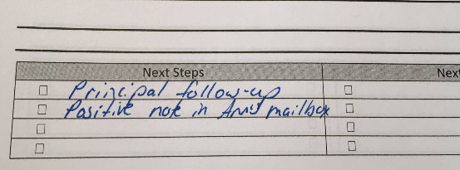
Organization
One thing I have found very helpful in staying organized and on track for accomplishing my goals, is to create a pocket folder for each of my current projects. I keep notes and critical documents in the folder. I revisit these each week and add “next steps” to my notebook or calendar. Goal planning is one of my project folders. In the folder, I have my Goal Planning Worksheet and resources I have found that support my goals including articles, notes, and ideas. It takes me 15 to 20 minutes each week to review my project folders and identify next steps and where to place those next steps.

