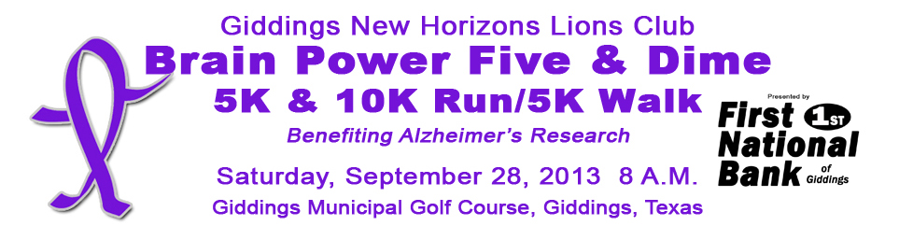

It’s time to get ready for the Giddings New Horizons Lions Club Brain Power Five & Dime - 5K & 10K Run/Walk & Kid’s Fun Run to benefit Alzheimer’s research. We have big plans for our 2016 run, and a goal of hosting 300+ participants. Our event has attracted hundreds of runners and walkers from all over Texas who support this worthy cause. With your help we have provided almost $20,000 for Alzheimer’s Research. Help us make our 2016 event the best ever.

**Please consider one of the following sponsorship opportunities**

**_____ 5/10K & Kid’s Fun Run Presenting Sponsor (1): $1250** - This is the exclusive sponsor of the 2016 BPFD. Sponsor will get company logo printed in a prominent location on the FRONT of all participant and volunteer t-shirts. Logo will be printed on promotional materials and advertisements associated with the event. Sponsor will get special recognition at the event. Logo will be placed on event website and Facebook page, and business will have the opportunity to place their signage and or promotional materials in participant packets.

**_____ Timing & Results Sponsor (1): $1000** - Company logo printed on the back of the participant and volunteer t-shirts in a priority position and prominent size. Sponsor will get special recognition at the event. Logo will be placed on event website and Facebook page, and business will have the opportunity to place their signage and or promotional materials in participant packets.

**_____ Power Stops & Refreshments Sponsor (1): $500 -** Company logo printed on the back of the participant and volunteer t-shirts in a priority position and prominent size. Sponsor will get special recognition at the event. Logo will be placed on event website and Facebook page, and business will have the opportunity to place their signage and or promotional materials in participant packets.

_____ **Platinum Sponsor $350:** Company logo printed on the back of the participant and volunteer t-shirts in a priority position and prominent size. Awards sponsor will receive special recognition at the event and their logo will be placed on event website and Facebook page and business will have the opportunity to place promotional materials in all participant packets.

_____ **Gold Sponsor: $250** – Company logo printed on the back of the participant and volunteer t-shirts in a priority position. Recognition at the event and logo placed on event website and Facebook page and business will have the opportunity to place promotional materials in all participant packets.

_____ **Silver Sponsor: $100** – Company name printed on the back of the participant and volunteer t-shirts in a secondary position and size. Recognition at the event and logo placed on event website and Facebook page.

_____ **Bronze Sponsor: $50** – Company name printed on the back of the participant and volunteer t-shirts. Logo placed on event website and Facebook page.

_____ **Individual/Family Sponsor: $25** – Name placed on event website and on printed materials in runner packets.

Sponsor/Company Name:_______________________________________­­­_______________________________

Company Representative:______________________________________________________________________

Mailing Address:______________________________________________________________________________

Contact Email & Phone #_______________________________________________________________________

**Please mail form and payment to: Giddings New Horizons Lions Club P.O. Box 531 Giddings, TX 78942**

**For more information contact Dana Lehmann 979-716-8033. Sponsor logo can be** emailed **to LionsBrainPower@gmail.com**

**www.GiddingsLions.com**

**Saturday, September 17, 2016 9:00 A.M**