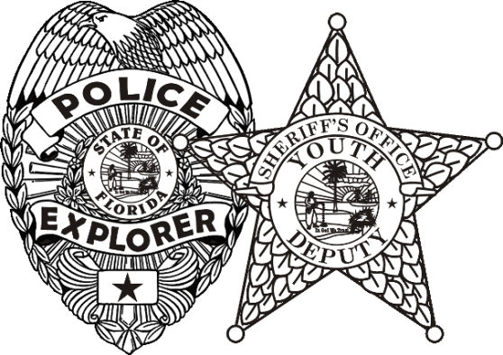
Central Florida Law Enforcement Explorer Academy 2022
Class # 19

Dear CFLEEA students and/or student guardians,
Welcome to the eighteenth year of the Central Florida Law Enforcement Explorer Academy to be held June 21st through July 1, 2022 at Seminole State College, Sanford FL. On behalf of the Seminole County Police Athletic League and each administering police agency involved with the event, we’d like to share some important information with you prior to the beginning of the academy itself.
- ***Mandatory orientation for ALL students will be held Monday June 20th, 2022 from 6:30 P.M. - 8 P.M. at Seminole County PAL Center, 1151 E. 28th St, Sanford. Parents/guardians/post advisors are encouraged to attend.
- ***Graduation will be held on Friday July 1st, 2022 ..location TBA.
- The location of the academy itself will be Seminole State College, 100 Weldon Boulevard Sanford FL. Building and room numbers will be available at orientation.
- Academy hours/class instruction will be held Monday- Friday the weeks of June 20th and June 27th . Academy hours are 7 A.M. - 5 P.M. with the exception of the last day (July 1 st) when students will be released by 1 P.M. in order to prepare to assemble for graduation that evening. CFLEEA policy requires student attendance every day with exceptions only for extenuating circumstances and with written documentation. Absences will mean “make-up” consequences.
- The academy incorporates outdoor physical activity several times per day. Please hydrate and arrive at the academy well rested. Water will be provided for students throughout the day during academy hours.
- Paperwork and payment deadline is May 27th. Please ensure that these things are completed and turned in. Please note the cost of the Academy is $200 per Explorer to cover expenses.
Thank you very much for your interest and dedication to the CFLEEA.

Sincerely,
Stephanie Berrios and Keith Betham, CFLEEA Coordinators

