Project Synopsis for
1st LT Frank Luke, Jr. Memorial Interactive Historeum, Research & Restoration Center
An Innovative & Dynamically Tactile Educational Endeavor with
Combined Symbiotic Projects & are Led by a Large Scale
Interactive Education Historeum, Research & Restoration Center
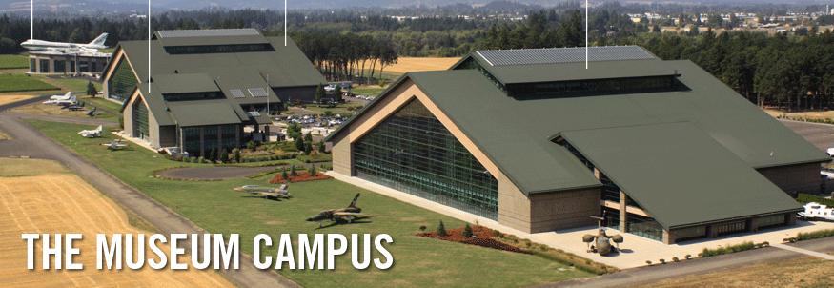
Litchfield Park | Luke AFB, AZ
_____________________________________________________________________________________________
General Overview
Representation of Possible Historeum Campus Style
- Primary Focus: The purpose of this fully interactive facility and programs is mainly but not limited to educating elementary school children with the intent to increase their accurate knowledge of our U.S. war history and related events beginning with WWI and our local hero Frank Luke. It is also our goal to provide Vietnam and other Veterans the capability to conduct unit / personnel research.
- Secondary: Construct a restoration center for military vehicles and small aircraft. This center would have a dual mission; restore vehicles for the museum and other museums and conduct a certified training program for disabled veterans with a job offer at the completion of their formal training. It is our goal to hire only PTSD/TBI-documented veterans once the program is established.
- Tertiary: The third purpose of this facility is to carefully restore various military vehicles, planes and equipment for the museum displays by employing and training PTSD soldiers as restorers, technicians or trainees.
Site & Facilities
The site would be located next to or close to Luke Air Force Base.
The Historeum would need up to 40 acres of buildable land for a series of four to five separate buildings.
- Museum (40,000 sq ft+)
- Restoration Facility (20,000 sq ft)
- Vehicle & Equipment Test Track (2 acres)
- Storage Facility (15,000 sq ft enclosed)
- Storage Facility (large vehicle interactive displays as an extension of the Historeum)
- A Large Airplane Hanger (large interactive displays as an extension of the Historeum)
Interactive Historeum
Interactive Historeum
- The museum will be set up in nine or more interactive modules / dioramas seating up to 45 persons in each section. Beginning with WWI there would be up to 3 levels of detailed videos ranging from 20 minutes to 90 minutes depending upon the audience. A school field trip would be built around the 20 minute presentation with a broad overview. Each module would end at the same time so classes could rotate to the next presentation. It is the director’s intention to have all theaters be completed no later than by opening day. All major wars and conflicts would be covered through the current date.
- Each interactive module / diorama would have a video presentation, and an electric geographic lighted map for tracking with the video. It would also include a large scale combat picture as backdrops with an appropriate vehicle / aircraft of that time, along with field gear for a multi-dimensional scene and various interactive stations. A small step-up stage and lectern could be used for custom presentations and veterans’ testimonials.
- Each diorama would also feature Arizona heroes like Frank Luke Jr., Sylvester Herrera and Fred Ferguson, in the time period represented along with their citations of valor.
- The research center would assist all our military veterans in reconnecting with their former units and fellow countrymen.
- A special section would be developed for reconnections with former Vietnamese soldiers living in country or in the U.S.
- It will have exhibits from Blue Star Moms & Gold Star Moms, Red Cross, etc. The Veterans Pride Battalion Sea Cadets would regularly drill at the museum.
- The museum could be used for community service club meetings, specialevents of military recognition and special historical lecturers on our military history. A kitchen facility would be necessary for catering of events as needed.
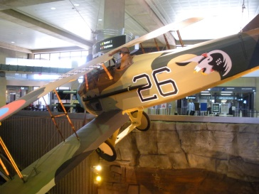
- The museum will be set up in nine or more interactive modules / dioramas seating up to 45 persons in each section. Beginning with WWI there would be up to 3 levels of detailed videos ranging from 20 minutes to 90 minutes depending upon the audience. A school field trip would be built around the 20 minute presentation with a broad overview. Each module would end at the same time so classes could rotate to the next presentation. It is the director’s intention to have all theaters be completed no later than by opening day. All major wars and conflicts would be covered through the current date.
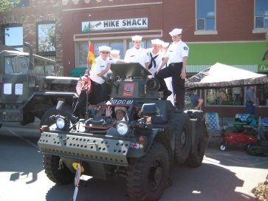
- Each interactive module / diorama would have a video presentation, and an electric geographic lighted map for tracking with the video. It would also include a large scale combat picture as backdrops with an appropriate vehicle / aircraft of that time, along with field gear for a multi-dimensional scene and various interactive stations. A small step-up stage and lectern could be used for custom presentations and veterans’ testimonials.
- Each diorama would also feature Arizona heroes like Frank Luke Jr., Sylvester Herrera and Fred Ferguson, in the time period represented along with their citations of valor.
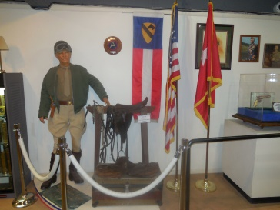
- The research center would assist all our military veterans in reconnecting with their former units and fellow countrymen.
- A special section would be developed for reconnections with former Vietnamese soldiers living in country or in the U.S.
- It will have exhibits from Blue Star Moms & Gold Star Moms, Red Cross, etc. The Veterans Pride Battalion Sea Cadets would regularly drill at the museum.
- The museum could be used for community service club meetings, special event of military recognition and special historical lecturers on our military history.
- A kitchen facility would be necessary for catering of events as needed.
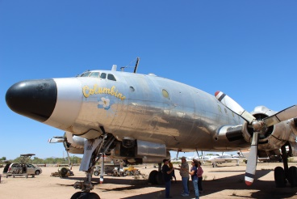
Hanger Facility
This 10,000 sq ft facility would be for Columbine II Air Force One #8610
Restoration Facility
This 20,000 sq ft facility would consist of 8 large work bays with four heavy lifts and a bridge crane capability. It will include eight to Ten 18-foot commercial electric roll up doors at both ends of the building for flow through traffic.
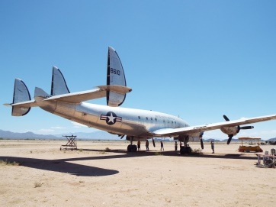
This facility would hire PTSD documented soldiers and also conduct a formal Wounded Warrior skill program for transition to the civilian work force.
There would be the following capabilities inside this building:
- Fabrication Shop & Necessary Equipment
- Paint Shop / Booth (separate building from Restoration center)
- Mechanical Lifts / Hoists with Equipment & Tools for a Depot Level Repair
- Office & Parts Department
- Lunch Room Facilities & Required Cleaning Areas & Restrooms
Storage Facility
This would be at least a 15,000 sq. foot facility that would be enclosed for storage of larger items that cannot be displayed in the museum due to size. It could also house future restoration projects. Part
of the storage area would be an extension of the museum with history plaques located at each
vehicle explaining its history.
The Test Track
This would be located behind the restoration building for testing vehicles that have been repaired or serviced and for dynamic presentations of these vehicles.
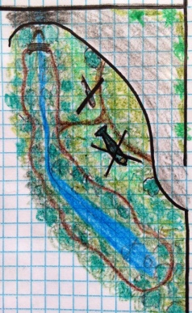
- Office & Parts Department
- Lunch Room Facilities & Required Cleaning Areas & Restrooms
Storage Facility
This would be at least a 15,000 sq. foot facility that would be enclosed for storage of larger items that cannot be displayed in the museum due to size. It could also house future restoration projects. Part
of the storage area would be an extension of the museum with history plaques located at each vehicle explaining its history.
The Test Track
This would be located behind the restoration building for testing vehicles that have been repaired or serviced and for dynamic presentations of these vehicles.
_____________________________________________________________________________________________
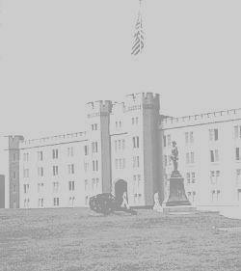
Future Plans
- Military High School Academy
The co-educational boarding high school is structured for the academic growth and personal development of each cadet. It is dedicated to educating the mind, shaping the character and nurturing the creativity of young men and women in a community that is academically and culturally diverse. We will challenge every cadet, support excellence in every area of learning, and promote active participation in a wide range of areas of life, service, growth and learning. The school will offer a demanding college preparatory curriculum, teach skills that build confidence and instill values that will endure for a lifetime.
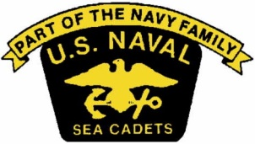
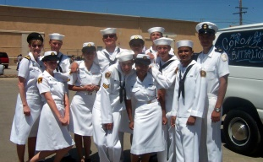
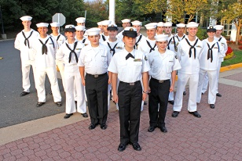
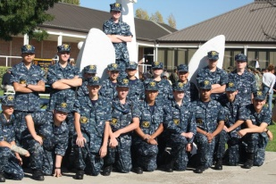
- Military Preparatory Academy
The United States Military Academy Preparatory Schools Program (USMAPS) purpose is to prepare candidates selected by the United States Military Academy Admission’s office for the academic, physical, and military challenges of the different United States Military Academy’s and are qualified to be accepted into those academies. The vision for this academy is to reach out to approximately 90-120 of the 17-19 year old cadets per semester, from Arizona first and then nationally, who have achieved a GPA of at least 3.0 and above and scored very high in their PSAT’s and SAT’s to achieve the optimal grading scores and physical fitness for the military academies of their choice.
- This is a private Military High School Academy for 200+ cadets grades 8 through 12 and a full Military Preparatory Academy for 90 to 120 cadets ages 17-19. This would require the total of 40-60 acres for both schools. A Charter or Private School format is optional.
- The military school and military preparatory academy would need a series of 6 separate buildings.
  - Military School (40,000 sq ft)
  - Military Prep Academy (30,000 sq ft)
  - Cadets Dormitory (55,000 sq ft)
  - PT | Athletic Training Facility (65,000 sq ft+)
  - Multi-Purpose Facility (20,000 sq ft)
  - Training Fields, Courses & Athletic Fields
_____________________________________________________________________________________________
1st Lt. Frank Luke Jr. Memorial Museum & Research Center
501(c)3 pending
Board of Directors
Lt. Col. Bill Simon, U.S. Army(ret)
Founder & President
Cell 602.677.6175
Email azsimon@msn.com
www.desertwarriorsofarizona.com
Ltjg. Dean Tomlinson
Vice President
Cell 602.478.9459
n8sdad98@yahoo.com
Sandi Simon
2nd Vice President
Denice Tomlinson
Secretary
Theresa Koontz
Blue Star Mom
Treasurer
_____________________________________________________________________________________________

7.13.14, RecFX Foundation, FLH-MPA-1001

