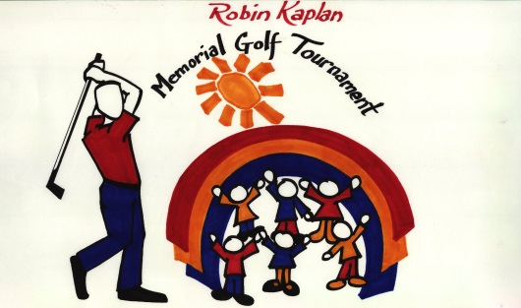

21sth Annual Robin Kaplan

Memorial Golf Tournament
Benefiting Crohn’s & Colitis Foundation
Camp Oasis Kids’ Programs

Wednesday, August 7, 2024 Foxwoods Resort, Ledyard, CT

Thursday, August 8, 2024 Lake of Isles GC, Foxwoods, Ledyard, CT

Donation Contract

Donor Information Name:
Address:

City, State, Zip:
Daytime Phone:

Item Information Item Donated:
Description:

Estimated Value:
Expiration Date:
Exchange Privileges:
Legal Restrictions:
Delivery or Pickup Instructions:

Items will be allocated to use during the tournament, or at the live or silent auction, at the discretion of the Executive Committee
RKMGT’s IRS Tax Exempt number is # 74-3169269

Please submit all donations by August 1, 2024 to:
Robin Kaplan Memorial Golf Tournament
P.O. Box 1171
Upton, MA 01568

For more information, visit: www.rkmgt.com

