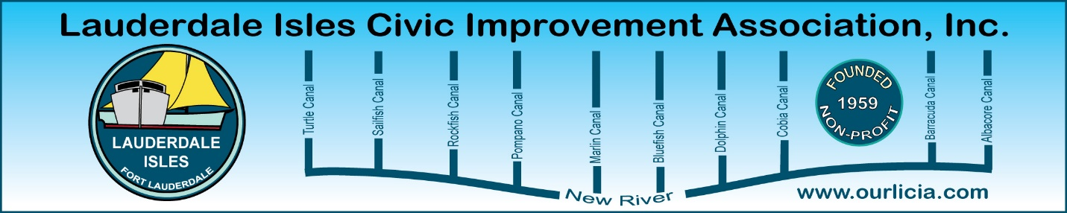
Minutes of the Lauderdale Isles Civic Improvement Association Board Meeting Zoom call April 18, 2024
The meeting was called to order by President Earl Prizlee at 7:05pm.
Roll call was taken.
Present: Earl Prizlee, Geoff Rames, Karen Rames, Diana Steeger, Dick Cahoon, Dawn Hannah, Trent Simpson, Aynsley Geramanis, Andrew Silverman, Julie Gordon, Glo Knowles, Jackie Zumwalt, Penny Shea and Joann Kratky.
Code Compliance: Marco was not available to attend this meeting and he sent Geoff his report for the month. During Jan 17-April 17, there were 7 cases complied, 28 cases closed, 21 with no violations and 11 pending compliance. There were 5 derelict vehicles, 3 cases for exterior maintenance required, 4 for solid waste containers placed curbside outside of the appropriate timeframe, 3 for exterior maintenance and 3 for fence/garden wall in disrepair.
Joann asked:
- Can you operate a business out of your home? Geoff advised home offices are permitted but you cannot sell anything, do repairs or have customers come to your home
- How far can you dock your boat from your property line? Boats can go to the property line but your dock must not be closer than 10 feet from your property line.
March Treasurer report: Geoff made the motion to approve, Joann seconded the motion and we all approved.
March Secretary report: Joann made the motion to approve, Penny seconded and all approved.
Community Center update: Earl stated that the first reading for the $2.5 million was done by the City Commission. Then the Community will provide input and the design will move forward. Earl to provide timeline in the next newsletter.
City Building Height Amendment: Geoff and Earl agreed to write the article for the May newsletter. The next General Meeting on May 16 includes a presentation on this topic.
FLPD report: Officer Jackson advised there were no Part 1 crimes. Officer Jackson told us about the Snyder Park Bow Wow event on April 30 from 4-7pm.

May 16 General Meeting: Julie suggested Marty Kiar, Property Appraiser, as our guest speaker. He is not able to attend. Ella Parker and staff from the Urban Planning & Development Department will be our guests and will present the Building Height Amendment.
Geoff suggested we take a vote at the General Meeting and provide ballots to do so. The choices will include remain at 20 feet, raise to 25 feet or raise to 35 feet.
Need to check the by-laws to determine voting rules. Dawn volunteered to report back.
Vacation Rentals Bill update: Geoff reported that lobbyists and other people he met with in Tallahassee say the Governor will hopefully veto the bill.
Newsletter: Geoff thanked Dawn, Joann, Julie and Dick for their articles. We have great pictures from the Waterway Cleanup. The Building Height Amendment will be included int this newsletter.
New River Middle School Traffic: Diana said people are parking down the lanes again. Earl will bring this up again with the Commissioner.
Community Signs: Earl will show the new vs. old sign ideas at the next meeting. Lane sign lighting is a future project.
New Business: Discussion of Candidate Night. We will reschedule the General Meeting from August to September 19 General Meeting to host the candidates.
Joann advised that she invited Joe O’Toole who lives in the Sunset neighborhood to attend our next General Meeting to observe.
Welcome Kit: Karen reminded everyone we have a Welcome Kit for new neighbors and wanted to be sure our new lane reps are aware of this. Joann requested a kit.
LICIA participation at Waterway Cleanups: Diana asked for clarification of the LICIA participation at the 2 Waterway Cleanups, March and November. She mentioned the March event is a Broward County event and LICIA pays for breakfast, approximately $80. Geoff said 99% of the people are from our neighborhood and we have always provided a light breakfast and coffee. Diana asked for backup to support LICIA paying for breakfast at this event. Earl suggested he and Diana work on a budget and bring to the Board for approval for annual expenses.
Joann suggested we try to collect dues from participants at the Waterway Cleanup. At the next event, Joann will coordinate this effort.
Motion made by Dawn to adjourn the meeting. Joann seconded and all approved. The meeting ended at 8:17pm.
Submitted by Karen Rames, Secretary

