OCEAN CITY AARP CHAPTER 1917
Presents

SEPTEMBER 29-30, 2020

JOIN US FOR SOME GAMBLING FUN & LIVE ENTERTAINMENT!

COST: $125 PP (DBL); $169 (SNGL)
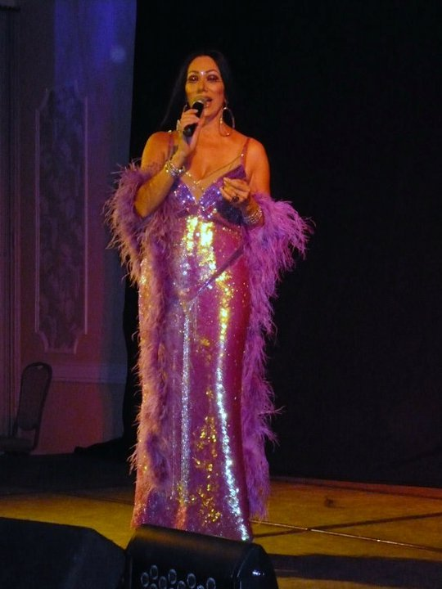

INCLUDES:

$50 PLAY MONEY!

Admission to the “ALMOST CHER” Show

Overnight Accommodations & Breakfast Buffet

Bus Transportation, Gratuities & Driver Tip Included

Itinerary:

Tuesday, September 29th

9:30 am Depart from OC, 65th St. & Coastal Hwy. – Public Safety/Circuit Court Bldg. Lot

11:00 am Arrive at Dover Downs Casino – Lunch on Your Own

4:00 pm Room Check-In – Dinner on Your Own

6:30 pm “ALMOST CHER” Show

Wedsday, September 30th

7 am – 11 am Enjoy a Complimentary Breakfast Buffet/Free Time for Gambling

11:00 am Depart for Ocean City

Legal Photo ID Required -- Bring Your Capital Club Players Card, Too!
For Reservations, Contact: Sandy Kvech 443-664-2003
Payment Due by June 11th.
-------------------------------------------------- Registration Form - Cut Here --------------------------------------
LEGAL NAME(s): (1) _____________________________________ (2)__________________________________________
CAPITAL CLUB PLAYERS CARD #: (1)______________________________ (2)_______________________________ ADDRESS: ________________________________________________________ ZIP:_____________________
PHONE: _______________________CELL: ___________________E-MAIL____________________________
TRIP: DOVER DOWNS - SEPT 29-30, 2020 # People:__________________
CASH: _____________________ CHECK#:_______________ CHECK AMT:___________________

I ACKNOWLEDGE THAT I HAVE READ THE TRAVEL-TRIP RULES AND AGREE TO ACCEPT [ ]
SIGNATURE: _____________________________________________________Date__________________
MAKE CHECKS PAYABLE TO: AARP 1917 Travel MAIL TO: PO Box 4193, Ocean City, MD 21843
DISCLAIMER: These trips are a project of and are offered to the Ocean City, MD Chapter 1917 of AARP. The chapter and any agent it may use in arranging these or any other trips are not responsible in whole or in part to the traveling member for any loss, damage, or injury, whether financial or otherwise, to persons or property, however caused during or in with these or any other trips. These trips are activities conducted by Ocean City, MD AARP 1917 and are in no way offered, sponsored or conducted by AARP, which has no responsibility with such trips.

