**Local Police Report**

**May 2018 ~ Naunton**

Number of incidents reported to police over a twenty four month period:

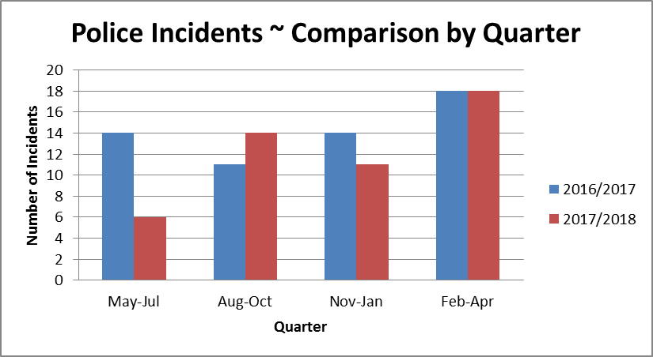

Breakdown of incidents by type reported to police over a twenty four month period:

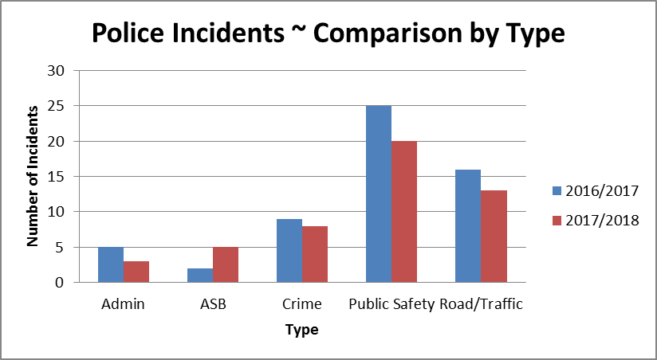

Breakdown of incidents related to crimes dealt with by police over a twenty four month period:

|  |  |  |
| --- | --- | --- |
| **Type of Crime** | **2016/2017** | **2017/2018** |
| Burglary dwelling | 1 | 2 |
| Burglary non dwelling | 2 | 0 |
| Crime - other | 1 | 1 |
| Fraud/forgery/deception | 0 | 1 |
| Theft - other | 3 | 2 |
| Theft from motor vehicle | 1 | 2 |
| Theft of motor vehicle | 1 | 0 |
| **Total** | **9** | **8** |

**PTO**

|  |  |  |
| --- | --- | --- |
| **Admin**   * Complaint against police * Lost or found Property or animals * Messages inc. press release * Police generated resource activity * Pre-planned event | **Public Safety**   * Alarms ~ Personal, etc. * Animals/Wildlife * Awol/abscond from hmp * Civil dispute-not btw neighbours * Concern for safety * Domestic incident - non crime * Missing Person * Susp. Circs./Insecure veh./prems. | **Road/Traffic**   * Highway disruption * Road related offence * RTC Death / Injury * Rtc_damage only(inc animal rtcs) |

**NB.** Each ‘Incident’ represents a contact report made to the Police via email, 101, 999, <https://www.gloucestershire.police.uk/contact-us/report-a-crime-or-incident/> , F2F with an officer, or at Stow on the Wold Police Station Reception. This being the case, it may be that a single event generates a number of incidents. An example of this could be a single vehicle losing control and damaging a number of properties which could result in a number of ‘Criminal Damage’ incidents.

For precise details of recorded ‘Crimes’, please visit: <https://www.police.uk/gloucestershire>

**Crime:**

Over the past two years, there has been no statistically significant change in the number or type of crime incidents reported for Naunton. In 2017/2018 the average daily number of Crime Incidents for Naunton remained in the order of 0.021.

**NB.** Please be aware that during April 2017, Central Government changed the way burglaries are to be categorised; consequently direct comparisons with last year are problematic.

**ASB:**

Despite a slight rise in the headline figure, closer inspection highlights that non-neighbour/family related ASB incidents remain unchanged at approximately 0.008 per day in each of the previous twelve month periods.

**Road/Traffic:**

Despite a fall in the headline figure for this type of incident, the number of recorded RTC incidents remains unchanged at approximately 0.013 per day during each of the last 12 month periods.

**General:**

Your Neighbourhood Policing Team in the North Cotswolds continues to take the concerns of the community, together with those of every victim seriously, and endeavours to provide the best service possible; however this must be within the resourcing constraints under which they have to operate.

***We will not be able to attend every meeting we are invited to and on some occasions may have to cancel meetings providing little or no notice due to the nature of Emergency service demands. We will however always provide a Police Report which is designed to provide clear and simple information which can be shared with all those present at the meeting.***

***If questions are raised by those present please note the email addresses of both Beat Managers and PCSOs covering your area. We will be happy to address any concerns you have or that are raised during the meeting.***

***We will endeavour to attend as many meetings as we can but the new format of police Report combined with an up to date list of contact details will be provided for occasions we are not present.***

PC 0436 Jason Page

[Jason.Page@gloucestershire.pnn.police.uk](mailto:Jason.Page@gloucestershire.pnn.police.uk)

PCSO 9251 Charlie Symes

[Charles.Symes@gloucestershire.pnn.police.uk](mailto:Charles.Symes@gloucestershire.pnn.police.uk)