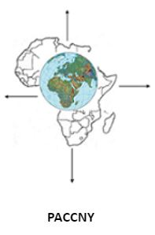

PACCNY Membership Form
Kindly fill out and mail to membership@paccny.org

Name

First Name Last Name
Email Address

Physical Address
Street Address

City

State Zip Code

Membership Type:
☐ Regular - Dues shall be $50 per member per year.
☐ Student - Dues shall be $15 per member per year.
☐ Affiliate - Dues shall be $50 per organization (up to 3 members) per year.
☐ Life - Dues shall be dues of $1,000 shall be payable in a lump-sum upon becoming a member of
PACCNY after which the life member will pay $15 per year.

All membership dues are payable in installment option or in a lump-sum with complete conciliation of total payment by the end of the first quarter (April 30) of each fiscal year.

