Agenda of Brimpsfield Parish Council meeting
To be held on 14th April 2022 at 7.30pm
In the Village Hall
Welcome and introductions
Attendance to be recorded (anticipated) as Parish Councillors Tom Overbury, Roger Lock, Michael McWilliam, Jane Parsons, Heather Eaton, Claire Jardine & Archie Larthe. District Councillor Judd and County Councillor Joe Harris

Apologies for absence to be recorded

Declaration of interests on matters on the agenda to be invited
Public session to take place- up to 15 minutes at the discretion of the Chair of Council, where members of the public (and any Councillors who have declared an interest) will be invited to speak to and ask questions of the Parish Council on matters on the agenda or any other matter of interest to the Parish
Minutes of the previous meeting to be approved (as attached) and any amendments to be approved by Council
An opportunity for District and County Councillors to speak to the meeting regarding the proposed Boundary Review and its possible implications
Council to consider and approve its response to Boundary review consultation – details attached
Council to approve letter to property owners/contractors at Woodfield, Caudle Green
Any other business for the purpose of information sharing as no decisions can be made at this point
Date of next meeting to be noted as 17th May 2022 at 7.00pm- AGM and 8pm for Parish Assembly
Close of meeting

Draft Minutes of Brimpsfield Parish Council meeting
held on 15th March 2022 at 7.30pm
In the Village Hall
Welcome and introductions
Attendance recorded as Parish Councillors Tom Overbury, Michael McWilliam, Jane Parsons, Heather Eaton, Claire Jardine and 2 members of the public
Apologies for absence recorded
Parish Councillors Roger Lock and Archie Larthe
District Councillor Judd and County Councillor Joe Harris did not attend
Declaration of interests on matters on the agenda were invited -none
Public session where members of the public were invited to speak to and ask questions of the Parish Council on matters on the agenda or any other matter of interest to the Parish- no comments at this point
Update on report from District Councillor Judd as distributed via email
Report from County Councillor Harris – none received
Minutes of the previous meeting were approved as attached
Council noted the update of the A417 proposed upgrade and correspondence received as distributed via email
Change of “fly-up” access point
November 22 anticipated date of decision
Next Teams meeting at the beginning of April 22 noted
Council is highlighting traffic mitigation during construction phases
Council noted update from Village Hall Committee as distributed and received verbal update from Mikhail Mandrigin (Chair of Village Hall Committee)
Organised events have been re-started
Friday fish and chip evening
Bar opening of Saturdays
Music Society Fete in July 22 and proceeds raised will be donated to Village Hall and Music Society. Councillors queried if other village organisations have been invited to be involved
Development works – H & S plans, list of tasks etc are being prepared, principal contractor R Harbour, principal architect Mikhail Mandrigin
Financial matter – Councillors queried if grant has been able to have been accessed from the A417 funding

Council considered and approved financial reports and payment list as attached
Council approved appointment of I Selkirk as independent internal auditor
Council considered and approved NALC salary increase in line with contract of employment
Council approved subscription for GAPTC for 2022/23 £74.04
Council received update on electronic banking and noted Clerk is still waiting for welcome pack
Council considered update on highway issues
- Brimpsfield Common Bridge – Clerk has again raised this matter in January 22 and has c.c County Councillor Harris seeking update on anticipated date of work
- Cllr Jardine has been seeking email confirmation for 15 months on matters relating “to Caudle Green”- Clerk suggested that Cllr Jardine send the Clerk the emails, and the Clerk will follow up with County Councillor Harris and D C Judd.
- Member of the public asked about Caudle Green speeding issue resolution update, 20mph schemes TRO, warning notices etc
Council considered update on PROW issues
- Ivy cottage footpath now opened -
Council considered update on Hermits Corner
Activity reported by Councillors- report and ask for update from DC Judd
Council considered hedges, hedgerows and Caudle Green Ash trees
- Reports required for trees on Council land – Cllr Parsons (Clerk to give name of tree survey)
- 3 quotations from tree surgeon not yet received -cfwd
- Hedgerow cut back has been requested from landowners by Cllr Jardine- Clerk advised that the legal requirement to cut back hedgerows should come from Glos Highways and that any hedgerows obstructing the road should be reported through “Report it” portal.
- Cllr Jardine will report any issues/ actions taken at future meeting
Council considered update on War Memorial (Cllr Lock) cfwd
War memorial cleaning sample has been checked and would take 6 months to act and is not expected to damage the stone
Council considered update on Queens Platinum Jubilee celebrations
Events are being organised by residents in liaison with Village Hall Committee
Application for road closure has been submitted – no objections from Council
Beacon lighting suggested for Thursday in line with other local Parishes
Oak Tree planting is taking place on Saturday with the Garden Society. 2 will be planted in Caudle Green / Council common land area – final position to be agreed by Council and the other 2 will be on Brimpsfield Common land
Street Party /Big Picnic on Sunday – Village Hall Committee will provide 2 marques
Council considered update and matters arising from the Common Land Management Policy Group- Cllrs Lock, Larthe, Eaton and Parsons - cfwd
Proposal for permission for grass removal /gravel over common land for approx. 4 foot on Caudle Green track for local resident to access her gateway. The access point was described as unsafe. Council agreed to the proposal
Council considered updates on road safety issues- discussed under Highways item
- from Road Safety Policy Group- Cllrs Jardine and McWilliam
- Twenty is plenty campaign group – as distributed via emails updates included GCC excluding non-residential areas.
- Don’t miss out – as distributed via email – Council agreed that Clerk will support on behalf of Council
Council noted planning matters
- New applications received via email
22/00297/FUL Single storey side extension and demolition of single storey garage at
1 Old Rectory Brimpsfield – emailed to Cllrs on 7/2/22 no comments registered under delegated authority -expired on 3/3/22
22/00441/TCONR -4 x tree works The Old Forge Climperwell Road- emailed to Cllrs on 22/2/22 – no response received- approved on 8/3/22
Council noted the CDC local plan consultation as distributed via email-
Any other business for the purpose of information sharing as no decisions can be made at this point
GLEAM correspondence as distributed via email -clerk to submit under delegated authority
Date of next meeting confirmed as 17th May 2022 at 7.00pm for AGM and 8pm for Parish Assembly
Bar open and suggestion box, reports from Village Hall and other organisations to be invited to make reports
Close of meeting 20.56

Email 22/3/22 – distributed to Councillors

As part of the Community Governance Review, Cowley Parish Council have submitted a proposal to change the boundary between itself and Brimpsfield.
The change would move a number of properties from Brimpsfield into Cowley.
In addition to this proposal, Cowley Parish is asking for views on a proposal to split Cowley and Birdlip into two separate entities.

The next step in the process is to seek the views of Brimpsfield Parish Council and the occupiers of those properties affected by the change.

As the change is significant, particularly around the move to two parishes, we are holding two drop-in sessions in the parish during April.
The attached letter gives more detail of the process and rationale including the dates and times of the two drop-in sessions.

I would welcome your views on the proposal to change the boundary. If you have any questions, please let me know

Summary from CDC officer/discussion points

Option 1 – green line – takes Blacklains Farm and Farmhouse into Birdlip
does this divide Blacklains Farm between the two parishes?

Option 2 – red line – includes Gowanlea in Birdlip

Option 3 – purple line – this is the proposal to move the properties at Hawcote Hill into Birdlip. I believe the suggested line is acceptable and no change is needed here

Option 4 – decide not to make any changes to the boundary and leave all properties as they are

Option 5 – move the properties at Hawcote Hill into Birdlip but leave the rest of the boundary as it is

In terms of responses, the properties at Leveretts and Sidelands have expressed a desire to stay in Brimpsfield.
Occupiers of Blacklains Farm House and Blacklains Farm would like to be part of Birdlip
My understanding is that the owners of Gowanlea would like to be in Birdlip. Please confirm?
The occupier of 1 Blacklains Cottages expressed at the meeting that he would like to be in Birdlip.

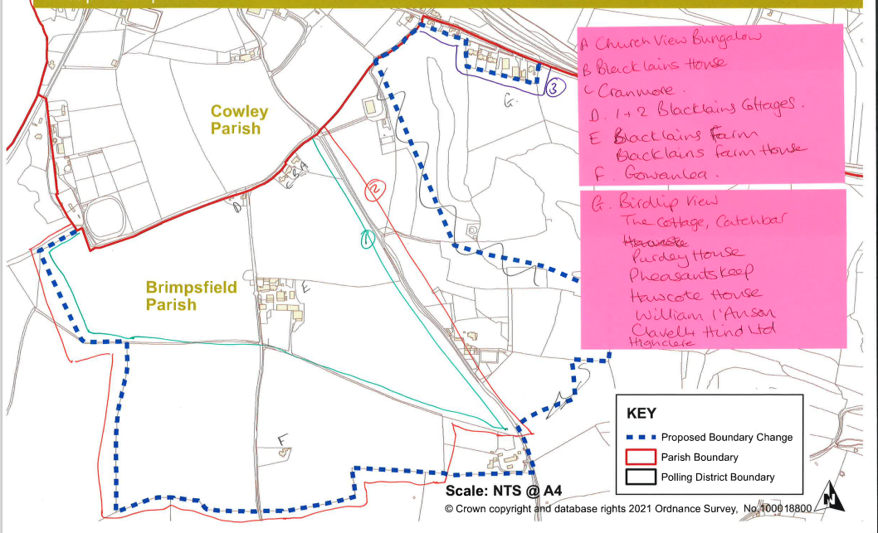

What is happening?
Cowley Parish Council has been considering its boundaries and electoral arrangements and Cotswold District Council is conducting a Community Governance Review to consider the options for change within the parish. This information sheet is a summary of the proposals and options.
Cowley Parish Council
The Parish Council covers the villages of Birdlip and Cowley. The area is currently divided into two polling districts to allow residents to vote at polling stations near to their village i.e. St Mary’s Church and Deer Park Guide HQ respectively.
There are currently 7 Parish Councillors representing the whole area. There are currently 316 electors in the Parish of which 213 are in Birdlip and 103 in Cowley.
The Parish feels that there is an increasing disconnect between Birdlip and Cowley driven by the differences in issues for each area. Whilst Cowley is a small hamlet, with limited development, Birdlip has seen a number of planning applications and development over the past few years and this, coupled with the traffic issues means that Birdlip has become the dominant area within the parish.

The Councillors representing Cowley now feel that their community is completely different to Birdlip, with different issues and concerns.
The Parish Council are therefore asking Cotswold District Council to consider splitting the parish into Birdlip and Cowley, with Birdlip being a Parish Council and Cowley, due to its size, becoming a Parish Meeting.
Options for consultation
The purpose of the consultation is to seek the views of residents on the options which are:
∙ Do nothing – status quo; or
∙ Stay as a Parish Council including Cowley and Birdlip – but increase the number of Councillors representing Cowley so they are proportionate/equal; or
∙ Create Parish Wards with a number of Councillors for each one e.g. Cowley =3 Councillors and Birdlip=4 Councillors; or
∙ Split immediately (so that one is a Parish meeting and the other in a Parish Council); or
∙ Split and Cowley merge or group with a neighbouring Parish Council
The Parish Council’s preferred option is therefore to split the parish into Birdlip Parish Council and Cowley Parish Meeting. The information below gives details of the differences between parish councils and parish meetings.
In addition to this proposal, Cowley Parish Council submitted a proposal to change the boundary to bring a number of properties into the parish from Brimpsfield. This proposal will affect the following properties:
1 and 2 Blackbain Cottages Blackbains Farm
Blackbains House
Birdlip View
Church View Bungalow Cranmore
Gowanlea
Haregrove
Hawcote House
Highclere
Leveretts Barn
1, 2 and 3 The Leveretts Pheasants Keep
Sidelands Farm
The Cottage, Sidelands Farm The Cottage, Parsons Pitch
Details of this proposal will also be included in the drop-in session and views will be sought from the property occupiers and Brimpsfield Parish Council.
Parish Councils
A Parish Council is a local authority that makes decisions on behalf of the people in the parish. There will be elected Councillors who will make decisions on behalf of the Parish, but local electors are not able to vote on decisions made by the Council.
On their own, Parish Councils have limited powers to make decisions. But they do have the ability to negotiate with, and the power to influence, those other organisations that do make the final decisions (such as the district council, health authorities, police etc.) The
organisations that make the final decisions know that a Parish Council gives the best reflection of how a community feels about something, and its views will be taken seriously.

Parish Meetings
The law requires that Parish Meetings assemble annually on some day between 1 March and 1 June and on at least one other occasion during the year. They may meet more frequently.
There are no elected Councillors in a Parish Meeting, but one person must be elected as Chair of the Meeting to conduct business on behalf of the Parish.
Their meetings are open to the public but only the registered electors for the Parish are permitted to speak and vote on any proposal.
A Parish Meeting is not a corporate body and is not, generally speaking, a local authority. Its powers are not as wide as those of a Parish Council. A Parish Meeting may set a precept to cover costs within the Parish
Consultation Roadshows
To give local residents the opportunity to ask questions and discuss these options, two drop-in roadshows will be held in the parish:
Tuesday 5 April at St Mary’s Church, Birdlip between 4pm and 7pm
and
Tuesday 12 April at Cowley Manor, Cowley between 4pm and 7pm
Both roadshows will cover all the options, so residents from anywhere in the Parish may attend either session.
District Councillor Julia Judd, Parish Councillors, District Council staff and a representative from Gloucestershire Association of Parish and Town Councils will be in attendance to answer any questions.
If you are not able to attend either of the roadshows but have questions, please get in touch with the office using the contact details below.
How to give your views
Views are being sought from residents within the Parish and you can do this either at one of the roadshows or by writing to the Elections Office using the details below.
Comments should be received no later than 19 April 2022.
Elections Office, Cotswold District Council, Trinity Road, Cirecnester, GL7 1PX. 01285 623002 elections@cotswold.gov.uk

