Location
Aberdeen, Ohio

Facility Type
Residual Solid Waste Landfill

Client
Dayton Power and Light Company

Services Provided
- Construction Inspection and Quality Assurance
- Construction Certification Reporting
- Soils Pre-qualification
- Engineering Design and Permit Alterations

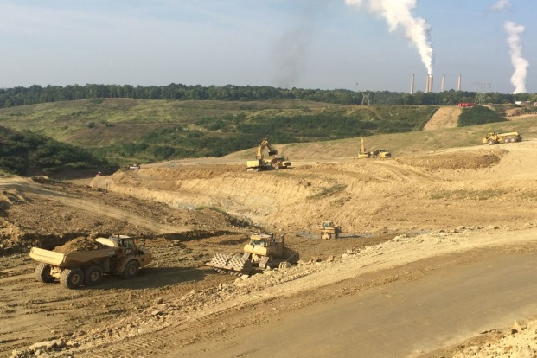
Excavation and hauling of Structural Fill

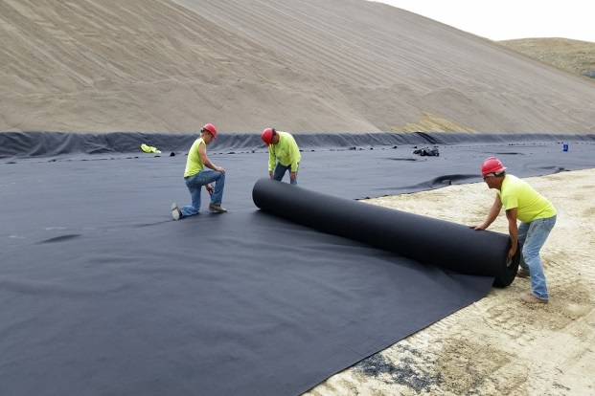
Geosynthetic deployment

Project Description
NPE has provided soils pre-qualification, construction quality assurance and certification services for the construction of an initial 19.6 acre disposal cell and supporting facilities. Components of the work included:

- Excavation, Structural Fill and Random Fill placement: 2,200,000 million cubic yards (estimated)

- Added Geologic Material: 6,200 cubic yards

- Recompacted Soil Liner: 103,300 cubic yards

- Underdrain Piping: 18,250 linear feet

- Leachate Collection and Cleanout Piping: 5,500 linear feet

- Leachate Transmission Piping: 7,850 linear feet

Additional elements of construction included 7,700 feet of access roadway, drainage channels, two sedimentation basins and a synthetically lined leachate holding pond.



