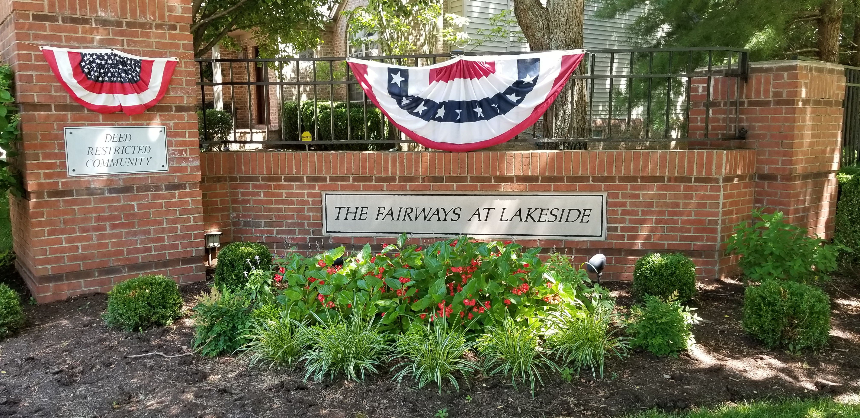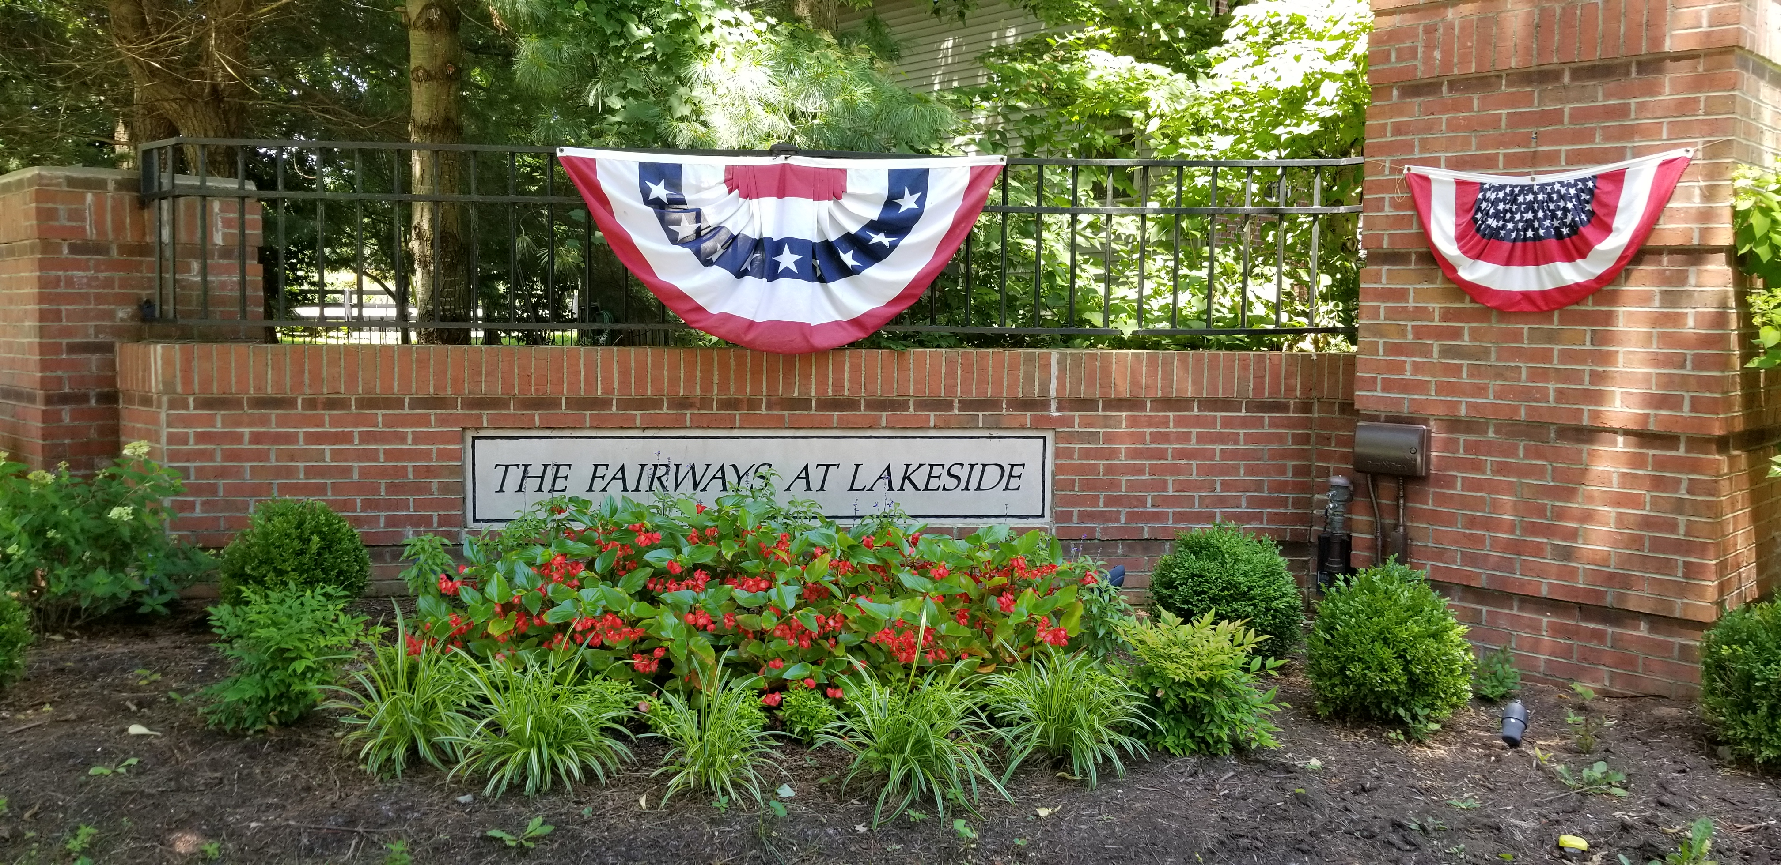
Fairways at Lakeside Community Association Newsletter
October 2019

A Word from Our President

Hope everyone had a great summer and is looking forward to fall.

Do you ever wonder what the Board does or why we have a homeowners association? I would like to challenge some of our homeowners who have not participated on the Board before or who are new to the neighborhood to volunteer to serve on the Board. Everyone in the neighborhood should be concerned with serving on the Board to make sure that our neighborhood remains a safe, friendly atmosphere in order to raise a family or enjoy retirement.

Please contact me if you would be interested in learning more about the Board and Officers. You do not need any experience – being a homeowner and concerned citizen are the key requirements.

Thanks,

Robin C. Gall
President

Treasurer’s Report

As of August 31, 2019, John Kreitzman reports the following FALCA account balances:

Checking Account: $18,472.84
Certificate of Deposit #1: $ 6,167.34
Certificate of Deposit #2: $ 4,258.05
Certificate of Deposit #3: $ 5,188.47
Total FALCA Funds: $34,806.70


Please join the Board in welcoming the following new homeowners:

3668 Green Park Court – John “Fritz” and Susan McWilliams

3688 Park Pointe Drive – James & Renee Hittner


2019 Annual Meeting

We will hold our Annual Meeting on Thursday, December 5th, at 7:00 pm, at Eastside Branch of the Public Library (NEW LOCATION – 3000 Blake James Drive – corner of Man-O-War and Palumbo). Please join us for an update on the Board actions and concerns, discussion on adding survellance cameras at the entrance to the neighborhood and Board and Office elections for 2020.

- Board of Director one 3-year position. Duties include attending Board Meetings, reviewing emails and voting on Board motions.
- Officer positions:
  - President
  - Vice President.
  - Treasurer
  - Secretary

We would really like to have some homeowners who have not served on the Board or as an Officer help us for 2020. Please contact the Nomination Committee if you would like to learn more. Robin Gall, Jennie Hale, Kevin Wilder and Jonathan Groth.


The Board has received numerous complaints this year about dogs and cats toileting in homeowners’ yards. If you have a dog and take it for walks please have the dog toilet in your yard before beginning on your walk. Please be sure to take bags with you to collect waste should the dog need to toilet while out. Please do not let your cat or cats out in the neighborhood. Our declarations prohibit resident outside cats.

Please remember that many folks do not have dogs and do not want dog waste or urine in their yard. Please be a considerate neighbor and take measures to limit dogs toileting in other homeowners’ yards. Also, if your dog does toilet, collect the waste and dispose of this in your own Herbie the Curbie – please do not use other homeowners’ Herbie the Curbies.

One other reminder LFUCG and FALCA have leash requirements. Please make sure your dog is on a leash if outside of your backyard.



Just a reminder that our homes are close together. Please calm your dog or bring them in the house if they are barking. There are LFUCG regulations as well as FALCA regulations regarding barking dogs. Please be considerate of neighbors and everyone wanting to be outside in the summer.


Thanksgiving week trash collection will be on Wednesday, November 27 instead of Friday!!


2020 Board and Officers
Please consider serving on the Association Board. For 2020 we will have 2 Board Member positions open and all our Officers are up for election.

The Board is vital for our community. As a deed restricted community with common property (the front entrance and the four-board plank fence) we are required to have a Board of 5 and Officers (President, Vice President, Treasurer and Secretary).

Board Members need to have access to email and be willing to attend meetings as needed. The Board is required to hold at least 4 Board Meetings a year and arrange and hold the Annual Association Meeting. In the past the Board has met monthly, however that is not required. In the past several years most of the Board actions are handled via email and then recorded at the Board Meetings. This allows the Board to act quickly on an issue and limit the length of meetings to an hour. You do not need to have any experience to serve on the Board – having newer homeowners’ input and participation on the Board would be very beneficial.

Officers’ Duties:

President: Preside at all meetings, is an ex-officio member of all committees, is responsible for the general and active management of the Association. The President is responsible for making sure all required actions are completed timely, for answering all homeowner questions and answering all complaints.

Vice President: Is responsible for taking over the President’s duties should the President be unable to perform said duties.

Secretary: The Secretary must attend meetings and take the Minutes of said meetings, must maintain the Minutes Books, shall distribute prior notice of all Association and Board Meetings, maintain a complete listing of homeowners and other duties as needed.

Treasurer: The Treasurer maintains the banking accounts of the Association, reconciling them monthly to the bank statement and presenting a Treasurer’s Report to the Board monthly. The Treasurer is responsible for maintaining receipts and making necessary expenditures for the Association as ordered by the Board. The Treasurer is also responsible for preparing and mailing annual fee statements and recording payments.

As stated in the past, if we are not able to get the necessary homeowners to volunteer to serve on the Board or Officers we may be forced to hire a management company which would mean an increase in annual fees.

Please consider serving as an officer on the Board for 2020. We need some new homeowners to participate.



Please come to a complete stop at our corners (Park Pointe and Green Park and Green Park and Coy’s Lane). Many times we have walkers, kids or pets crossing the street that may not be looking for a car. Please come to a complete stop and look both ways before turning.

Also, we recently had a homeowner’s visitor’s car rearended causing $7,000 of damage because the driver of the other car was looking up Richmond Road instead of paying attention to the car in front of him. Please be aware and do not be a distracted driver.



Modifications to the outside of your home…

As a reminder, if you are considering making a modification to the outside of your home, adding a fence or replacing your roof, these items require approval from the homeowners association. Our Deed Restrictions require that a homeowner have approval prior to starting any project that will alter the exterior of the house.

The Board has recently adopted a standardized form for requesting approval. Depending on the project or request you may need to submit a drawing with dimensions, photos of the area and expected result or color of siding, shingles, or other building material to be used.

Failure to submit the necessary information, drawings or pictures and receive Board approval could force the Board to require change after-the-fact or seek legal action to remedy any issues not completed as approved.

Attached is a copy of the Property Modification Request form. This can be emailed or hand delivered to any Board Member or mailed to The Fairways at Lakeside Community Association, PO Box 54897, Lexington, KY 40555.

Contact information for Officers and Board Members: Please always feel free to contact a Board Member or Officer when you have a question or concern. The Board and Officers will do their best to resolve any issues or answer questions that are brought directly to their attention. It is hard to know how to handle situations that we hear about indirectly. Please remember that your Board Members and Officers are volunteers who give freely of their time to help keep our neighborhood a wonderful place to live. We need your input and your support.

Director/President: Robin C. Gall 806-8843 rgall30539@aol.com
Vice President: Gary Renner 264-0069 garyrenner@windstream.net
Treasurer: John Kreitzman 272-1524 johnbkreitzman@gmail.com
Secretary Jonathan Groth 480-310-1108 jrgroth@gmail.com
Director: Kevin Wilder 227-5323 kwilder701@gmail.com
Director: Tiffany Compton 606-422-5712 tcompton0427@gmail.com
Director: Jennie Hale 327-9621 jennie.hale02@gmail.com
Director Marty Surbaugh 278-8728 msurbaugh1@gmail.com

