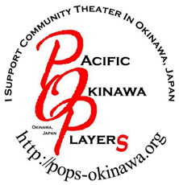
Proposal Form

Important Notes to the Director:

-In order to direct a show with POPs, you must have directed, assistant directed, or, have been musical director on a previous POPs production.
-If you have any questions regarding this form, please contact POPs’ Artistic Director
-During the months of November and December, the theater is NOT available. You may propose a show, hold auditions and rehearsals during these months, but you will need to find another rehearsal space.
-The use of the MCCS Community Center Auditorium is on space available basis. As a non-profit we are in a lower category than military units or family services. There is a chance the dates you request may not be available.

Pacific Okinawa Players
Proposal Form

GENERAL INFO:

Title:

Circle One: Play Musical

Casting:

Orchestra (Musicals):

Show Synopsis:

PROPOSED SCHEDULE (revised)

Production Meeting

Auditions

Rehearsals

Set Building

Tech Week

Performances

Cage Clean-up/Strike

BUDGET:

Expenses
Set: $
Costumes: $
Props: $
Publicity: $
Programs: $
Crew shirts: $
Miscellaneous: $
Performance rights: $
Total Expenses: $

Proposed Income
Ticket Prices:

Ticket Sales (including ticket prices):

Concessions/Raffle:

Total Income: $

PRODUCTION STAFF:

Director: Costume Designer:
Asst. Director: Lights:
Producer: Sound:
Musical Director: Choreographer:
Stage Manager: Master Carpenter:
Scenic Artist: Properties Master:
House Manager:

Main POC Name:

Main POC E-mail: Cell Phone:

FOR ARTISTIC DIRECTOR USE ONLY

Proposal Approved Proposal Denied

Finalized Show dates

