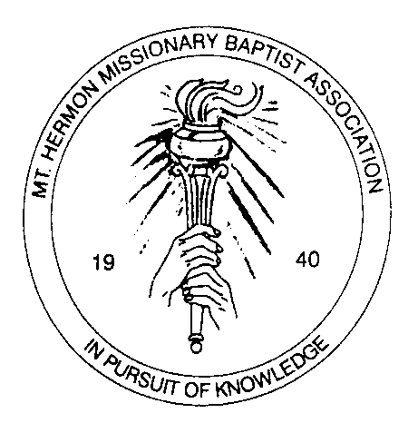

Mount Hermon Missionary Baptist Association
Memorial Period

Name of Church_______________________________________________________________

Name of Pastor________________________________________________________________

List of Deceased Members since the last Annual Session:
____________________________________________________________________________________________________________________________________________________________________________________________________________________________________________________________________________________________________________________________________________________________________________________________________________________________________________________________________________________________________________________________________________________________________________________________________________________________________________________________________________________________________________________________________________________________________________________________________________________________________________________________________

Faithfully Submitted by,

P.S. Please turn in to the Secretary, Tuesday, October 21, 2014

