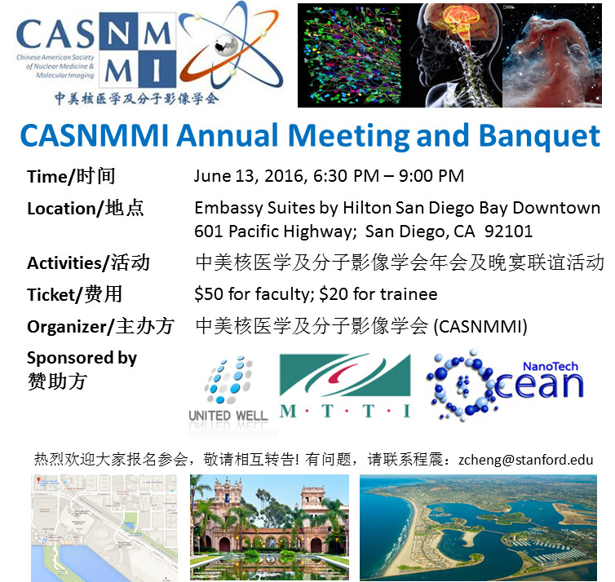

**News Letter**

**May 2018 Special Issue**

TABLE OF CONTENTS

1. CURRENT MEMBERS OF BOARD OF DIRECTORS (BOD) OF CASNMMI
2. CONFIRMATION OF PRESIDENT-ELECT
3. ELECTION FOR NEW BOD MEMBERS
4. ANNOUNCING 2018 YOUNG INVESTIGATOR AWARD (YIA)
5. ANNOUNCING CASNMMI Annual Meeting/Banquet AND AWARD CEREMONY DURING ANNUAL SNMMI CONFERENCE IN PHILADELPHIA
6. **Current Acting Members of Board of Directors (BoD), CASNMMI**

Yumin Zhang, President, Chair of BoD

Principal Scientist, AbbVie Translational Imaging, AbbVie, North Chicago

Phone: (847) 937 8523

[yuminster@gmail.com](mailto:yuminster@gmail.com)

Zhen Cheng, Past-President, Member of BoD

Associate Professor, Molecular Imaging Program at Stanford, Dept. of Radiology, Stanford University

Phone: ([650) 736 9781](tel:650-736-9781)

[zcheng@stanford.edu](mailto:zcheng@stanford.edu)

Yubin Miao, Secretary General, and Treasurer, Member of BoD

Associate Professor, [Colorado Translational Research Imaging Center (CTRIC)](http://www.ucdenver.edu/academics/colleges/medicalschool/departments/Radiology/ctric/Pages/CTRIC.aspx), Radiology, University of Colorado School of Medicine

Phone: (303) 724 3763

[yubin.miao@ucdenver.edu](mailto:yubin.miao@ucdenver.edu)

Kai Chen, Member of BoD

Associate Professor, Molecular Imaging Center, Keck School of Medicine, University of Southern California

Phone: (323) 442 3582

[chenkai@med.usc.edu](mailto:yubin.miao@ucdenver.edu)

Chun Li, President-Elect, Member of BoD

Professor, Department of Cancer Systems Imaging, Division of Diagnostic Imaging, The University of Texas MD Anderson Cancer Center

**Phone:** (713) 792 5182

[cli@mdanderson.org](mailto:cli@mdanderson.org)

1. **Confirmation Election of President-Elect**

**Nominated by the Active Members of BoD, Professor Chun Li (李 春), PhD, as the President-Elect, CASNMI, and Chairman of BoD**

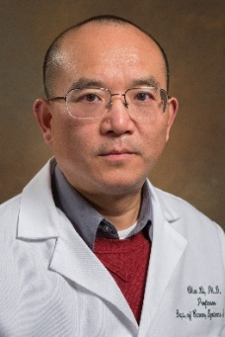Chun Li, Ph.D. is a professor in the Department of Cancer Systems Imaging at The University of Texas M. D. Anderson Cancer Center. Dr. Li earned his doctorate degree in chemistry from Rutgers-The State University of New Jersey under the mentorship of Professor Joachim Kohn. His undergraduate degree was obtained from Peking University. He spent 3 years as an Instructor at Sichuan University before studying oversea. Research in Dr. Li’s laboratory is primarily focused on two areas: 1) Develop targeted imaging probes for noninvasive characterization of molecular events associated with tumor progression and regression. Multiple imaging modalities, including PET, SPETC, MRI and optical imaging are used to acquire complementary data with increased sensitivity and selectivity for early tumor detection, tumor-marker profiling, and the monitoring of early treatment responses. 2) Develop novel drug-delivery systems for image-guided interventions. The long-term goal of Dr. Li’s laboratory is to apply the “seek and treat” strategy in the development of targeted imaging/ therapeutic agents that will eventually be translated to the clinic to improve the management of cancer through early tumor detection and individualized therapy. Dr. Li has more than 140 papers published in peer-reviewed journals (H-index 56 based on Google Scholar), 12 issued patents (4 of which have been licensed), 1 edited book, and 14 book chapters. Dr. Li has served as an adjunct professor in Texas A&M University (College Station, Texas, USA), Rice University (Houston, Texas, USA), University of Houston, Peking University Cancer Hospital (Beijing, China), and Zhejiang University (Hangzhou, China). He has been serving as a board member of the Chinese-American Society of Nuclear Medicine and Molecular Imaging since 2014.

**Personal Statement:** CASNMMI is an excellent platform serving both Chinese and Chinese American professionals in the field of nuclear medicine and molecular imaging. In the past, I have served as President of Peking University Alumni Association in Greater Houston (PKUAA-Houston) and as Vice President of China Overseas China Education Fund (海外中国教育基金会). Over the past a few years, I have seen CASNMMI being built on a solid foundation under the leadership of past and current presidents and the board of directors. I view CASNMMI as a bridge that brings trainees, scientists, and health care professionals with Chinese heritage in the fields from USA, China, and other parts of the world together, with shared vision and goals of networking, advancing careers, building collaborations, and bringing discoveries in the lab to the clinic. I am willing to work diligently with my colleagues to achieving these goals and contributing to CASNMMI’s future growth.

Please see the **Confirmation Vote Voucher** in the last page of the Newsletter

1. **Election of Two Non-Officer Board Members for Year 2019-2021**

According to the Bylaw of the CASNMMI and subsequent Amendments each board member has a maximum of two 2-years term limit. This year, we will elect 2 board members. The number of board members will be expand from 5 to 7. Please cast your votes to elect 2 board members from the 3 candidates nominated by the active members of the BoD. Brief Biographs and Personal Statements of candidates are listed below.

**1. Dr. Ximin Li** **(李喜敏)** currently holds the position of Principal Research Scientist at Avid Radiopharmaceuticals, a wholly-owned subsidiary of Eli Lilly & Co. She received her B.S and M.S degrees at Nanjing University of Science and Technology, followed by three years of working experience as a research scientist in the agrochemical industry in China. After obtaining her Ph.D. in Organic Chemistry at Washington University in St. Louis in 2008 and conducting one year of postdoctoral research at the University of Pennsylvania, Dr. Li joined the R&D group at Avid.

****In the past 10 years, Ximin has been working on the discovery and development of novel PET imaging agents for neurodegenerative diseases, focusing on Alzheimer’s and Parkinson’s diseases. Particularly, Ximin made her contribution in the development of Florbetapir (AV-45) and Flortaucipir (AV-1451). She is also interested in developing new methodologies in organic synthesis, especially in the application of new fluorination reactions in radiochemistry.

With education and industry working experience in both China and the United States, Ximin hopes to support CASNMMI as a common platform for communication and collaboration among researchers and scientists in academia, industry and other organizations. At CASNMMI, we are working together to find more efficient ways to tackle scientific challenges, transfer technologies from benchtop to bedside, and improve diagnosis, treatment and outcomes for patients.

Please see the **Election Vote Voucher** in the last page of the Newsletter

*This space is left blank intentionally*

2. **Dr. Wenping Li (李文萍)** received her Ph.D. degree in Radiochemistry from the University of Missouri-Columbia under Professor Silvia Jurisson’s mentorship in 2000. Her dissertation focused on radiochemical separation method development for carrier free radiolanthanides and radiosynthesis of peptides/peptide conjugates as radiopharmaceuticals.

****Wenping continued in the field of nuclear imaging with a postdoctoral appointment at the Washington University St. Louis School of Medicine in the Mallinckrodt Institute of Radiology. She was subsequently promoted to a research instructor at the School of Medicine. Her research interest included the development of radiotracers for PET/SPECT cancer imaging and therapy. More specifically, she investigated the somatostatin analogs radiolabeled with 124I/125I, 111In, 64Cu and 86/90Y as receptor imaging and therapeutic agents in tumor bearing animal models. She radiolabeled matrix metalloproteinase (MMPs) inhibitors with various radionuclides for use as potential anticancer agents to detect tumor metastatic potential at an early stage. She continued research on epidermal growth factor receptors (EGFR) in cancer with radiolabeled antibodies.

Wenping joined Merck’s Imaging Department in 2005. Since then she has had various roles at Merck, including director of the PET tracers group. Wenping’s research at Merck focused on the discovery of novel small molecule PET tracers for both preclinical and clinical application. Wenping has laid the groundwork for establishing critical characteristics for successful PET tracers. She has establishing strong collaborative relationships with experts in medicinal chemistry, in vitro pharmacology, drug metabolism, safety assessment, clinical PET, and other functional expertise. More important, she led to the discovery and application of novel PET tracers for 7 different CNS targets, primarily for the purpose of guiding neuroscience drug development. Currently Wenping leads a Small Molecule PET Tracers group within Translation Imaging Biomarkers at Merck, with a mission to discover, develop and implement novel PET biomarkers to impact drug discovery and development.

Platform Statement: CASNMMI is a non-profit professional organization serving the rapidly growing Nuclear Medicine and Molecular Imaging community with a special focus in the Chinese community. There is increasing pressure to promote radiopharmaceutical sciences, facilitate scientific and business cooperation between academic and industry, and foster Junior member’s career development. As representatives of CASNMMI, Directors of Board have a duty to improve early diagnosis and treat patients more efficiently with radiopharmaceuticals. If appointed, Wenping would perform her role with energy, enthusiasm and integrity. She will do her best to advocate interactions/connections in research and development of radiopharmaceuticals.

Please see the **Election Vote Voucher** in the last page of the Newsletter

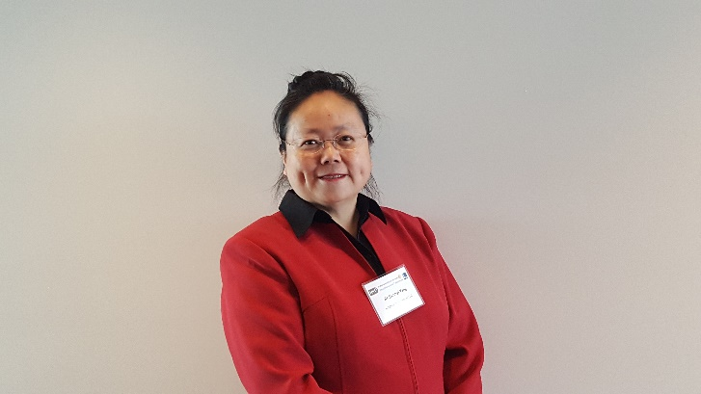**3. Dr. Jenny J. Yang** **(杨 洁)** is a Regents’ University Professor of Chemistry and associate director of the Center for Diagnostics and Therapeutics at Georgia State University. She received her Ph.D. in Biochemistry at the Florida State University with Harold van Wart in 1992. She was a Research Fellow at Syntex Discovery Research (Roche Biosciences), Institute of Biochemistry and Cell Biology, Palo Alto, CA.

From 1993 to 1995, she was an Oxford Center for Molecular Sciences (OCMS) Research Fellow at the University of Oxford, UK led by Professor Christopher M Dobson (FRS).  She was also a Harford Research Fellow of Molecular Biophysics and Biochemistry at Yale University. In 1997, Dr. Yang joined the faculty at the Chemistry Department of Georgia State University, promoted to Associate professor 2002, and full professor in 2006. Dr. Yang is the founder and leader of the Atlanta Calcium Club established at 1999. Dr. Yang received the Outstanding Junior Faculty Award in 2001, the Outstanding Faculty Achievement Award 2003, the Alumni Distinguished Faculty Achievement Award 2011, and Distinguished University Professor at GSU (2013-2017).

Dr. Yang’s laboratory applies protein design and engineering approaches to understand molecular basis of diseases, modulate calcium signaling, and create novel reagents and tools for research, diagnostics and disease treatment. Dr. Yang’s research team has developed a novel class of protein-based MRI contrast agent (ProCA) with significantly improved MRI relaxivity (sensitivity), dose efficiency and selectivity to enable molecular imaging by MRI for several disease biomarkers with strong preclinical application of drug discovery and clinical application in diagnosis, prognosis, and patient selection. They have also designed several reagents with improved therapeutic effects against cancer and fibrosis. Dr. Yang has over 130 publications and > 20 patent applications. She has mentored > 140 members who now are major work force for research and education. Dr. Yang is a Founder and president of Inlighta Biosciences. She is also a Competent Communicator of the International Toast Master Public Speech Club.

Dr. Yang’s career goal is fully committed to making an impact in biomedical research and human health. She has extensive service experience such as establishing and organizing several professional organizations, chairing and hosting local, national and internal conferences. She has mentored many junior scientists for their career development. She and her group have regularly attend WMIC and other nuclear medicine conferences and actively participate in activities of the Chinese American Society of Nuclear Medicine and Molecular Imaging (CASNMMI). She has devoted her effort in facilitating international collaborations among CASNMMI and other organizations. She has been working closely with current and present leaders of CASMMI. She has strong collaborations with Clinicians and Scientists in China and other countries. She also holds Honorary Professorship at the Central South University; China since 2012. Dr. Yang believes that her extensive experience and devotion will provide a strong addition to current leadership of CASMMI with complimentary skills and culture background.

Please see the **Election Vote Voucher** in the last page of the Newsletter

1. **CASNMMI Young Investigator Award (YIA)**

Dear Friends and Colleagues:

This year, we will once again select outstanding work done by trainees (graduate students or postdoctoral fellows) from China, United States, and other parts of the world with Chinese heritage to receive Young Investigator Award.

In addition to award certificates, the winners will receive monetary awards.

To apply, please send the Abstracts plus Poster/or 2-3 selected slides from oral presentations with key findings) to Professor Kai Chen at chenkai@med.usc.edu

Deadline for submission: 6/15/2018

The members of the Board of Directors will review the applications and select finalists, and the Awards will be announced during the CASNMMI Annual Meeting.

For details, visit our website: <http://www.casnmmi-us.org/>

Please distribute this award opportunity to your friends and colleagues.

*This space is left blank intentionally*

1. **Invitation to CASNMMI’s Annual Meeting/Banquet**

The 2018 Annual Meeting of Chinese American Society of Nuclear Medicine and Molecular Imaging (CASNMMI) will be held in Marriott Downtown Philadelphia:

**Date and Time:** June 25, 2018, 6:30—11:00 pm

**Venue:** Marriott Downtown (Grand Ball Room)

**Address:** 1201 Market St, Philadelphia, PA 19107

**Agenda:**

* President Open Remarks
* CASNMMI Board Introduction by newly elected Chairman of BoDs
* Announcement and Award Ceremony of Young Investigator Awards for the best presentations of the SNMMI by the Secretary General of CASNMMI
* Award Ceremony Life-Time Achievement Awards
* Finance Report by Treasurer of CASNMMI
* Briefings from Sponsorship Representatives
* President Highlight Presentation for Accomplishments from Members in 2018
* Closing Remark and Social Networking

*This space is left blank intentionally*

**Vote Voucher (please cut from the line and cast your votes)**

---------------------------------------------------------------------------------------------------------------------

|  |  |
| --- | --- |
| **President-Elect** | |
| Professor Chun Li, PhD | Confirmation: |

|  |  |
| --- | --- |
| Non-officer BoD Members (select 2 out of 3 by checking the Election box) | |
| 1. Wenping Li (李文萍), PhD | Election: |
| 1. Ximin Li (李喜敏), PhD | Election: |
| 1. Jenny J. Yang (杨 洁), PhD | Election: |