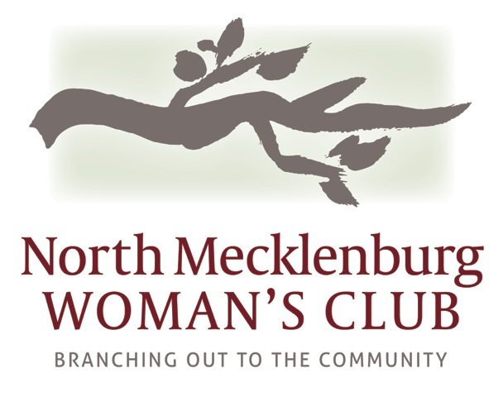 2016-2017 Sponsorship Form

Name:________________________________________________________

Company:_____________________________________________________

Phone:_______________________ Email: _________________________

Chosen Sponsorship Level:

____ Platinum Partner $5000

____ Gold Partner $2500

____ Silver Partner $1000

____ Friends of NMWC $250

I would like to commit to NMWC sponsorship for:
____ one year ____two years ___three years (billed annually in September)

____ My employer offers matching donation funds.

_____ Yes, I would like a free business card listing in the NMWC business directory.

In addition to a business card listing Partners are eligible for an ad in the NMWC business directory.

____Platinum Partner Full Page ___Gold Partner ½ Page ___Silver Partner ¼ Page

We will email you listing and ad information for the NMWC business directory.

100% of all donated funds go to the charities we serve.
NMWC is a 501c3 organization. Your donation to NMWC is 100% tax deductible.

Please make checks payable to NMWC.
Please mail to:
Barb Kasprzak, 8742 Branchside Lane, Huntersville, NC 28078
For more information contact Barb at 248-935-7539, bkasprzak55@gmail.com

