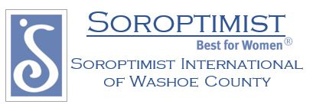

**2018-2019 Board:**

**Lesli Brisson – President**

**Kristin Setty – Vice President**

**Chris Wells – Secretary**

**Mary Long– Treasurer**

**Juanita Hluchan – Delegate**

**Soroptimist International of Washoe County PO Box 5876 Reno, NV 89513**

siwashoecounty@hotmail.com

[**www.siwashoe**](http://www.siwashoe)**county.org**