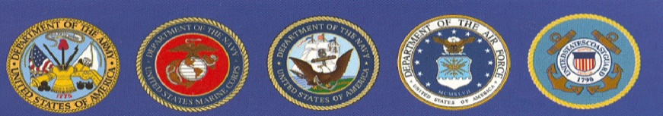
EBBETTS PASS VETERANS MEMORIAL DISTRICT
“Honoring Those Who Have Served”
P.O. Box 175, Murphys, CA 95247

MINUTES
REGULAR BOARD MEETING
November 1, 2022

CALL TO ODER: 7:00 by Redman
Directors Present: Redman, Carlon, Palmer, Padou
Employees/Guests Present: Rocco, Yeadon, Fischer. Board Candidate Craig Stone
APPROVAL OF MINUTES of the Regular Board Meeting of October 4, 2022. Padou motioned to approve the minutes as submitted. 2nd by Palmer. Board Approved.

PUBLIC COMMENTS: 0
CORRESPONDENC:0

MATCA: Tom Eising with his annual report. Current Membership of 75. Alfredo Leon does groundskeeping. Received a $10,000 Grant from Calaveras Community Foundation to go towards resurfacing of the tennis courts. Requested financial assistance from EPVMD up to $5,000 to complete project. Rocco will update the MOU and have new board members from both organizations sign. Don motioned to approve the MOU with the new addition of listing EPVMD as additional insured. 2nd by Carlon. Board Approved. The request for financial assistance will be put on the January 2023 agenda per Palmer’s request.

VACANT BOARD POSITION: Padou motioned to appoint Craig Stone to fill Richard Elliott’s vacant position. 2nd by Carlon. Board Approved. The Oath of Office was read and signed, along with the appointment form. Rocco will take to County Office.

OLD SCHOOL HOUSE: 0
MEMORIALS: 0
CARETAKER REPORT BY YEADON: Regular maintenance

VETERAN’S DAY CEREMONY: Deb updated board on progress of confirmation of event details. Board will meet on Thursday to help with table and chair setup.

COMMUNITY EVENTS INVOLVEMENT: Michelson School Veteran’s Flag Ceremony. 11/10 @ 8:15 am.

FINANCIAL / BUDGET By Megan Fischer

OPEN FORUM led by Board Chairman: 0

ADJOURN PUBLIC MEETING: 8:06 by Redman

The next meeting is scheduled for December 6, 2022 @ 7 pm. EPVMD Community Hall

*Craig Stone, PO Box 160 Avery, CA 95224. (209) 728-8683 cstone2019@comcas.net

