REGULAR MEETING

MARCH 19, 2020

A Regular Meeting of the Town Board of the Town of Hampton, County of Washington and the State of New York was held at the Town Hall, 2629 State Route 22A, Hampton, New York on the 19th day of March 2020.

Due to the Corona Virus, the OPEN MEETINGS LAW has been suspended by New York State,

therefore our Regular Town Board Meeting was closed to the Public. Supervisor O’Brien did provide a conference call number for people to call in.

PRESENT: David K. O’Brien------------Supervisor

Tamme Taran----------------Councilwoman

Donald Sady-----------------Councilman – absent in person, listened in via phone

Andrea Sweeney------------Councilwoman

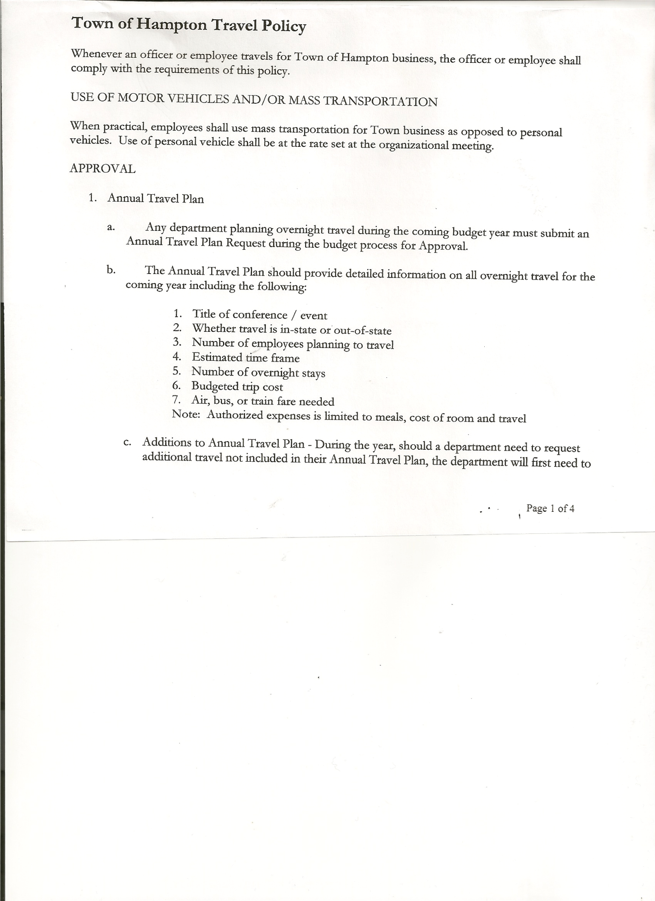 Michael Pietryka------------Councilman

Rebecca Jones---------------Town Clerk

Camilla Shaw----------------Tax Collector/Deputy Town Clerk - absent

Herbert Sady, Jr.-------------Highway Superintendent

Planning Board Member(s): Bonnie Hawley, Matthew Pratt and Renee Rountree all listened in on the conference call number.

The Regular Meeting was called to order by Supervisor O’Brien at 7:30pm, followed by the Pledge of Allegiance. Location of Fire Exits were given. Quorum of board members present.

**RESOLUTION NO. 30-2020**

**APPROVAL OF THE MINUTES**

On a motion of Councilwoman Taran, seconded by Councilman Pietryka, the following resolution was ADOPTED: Ayes 4 O’Brien, Taran, Sweeney, Pietryka

Nays 0

Absent 1 Sady

RESOLVED, that the Regular Town Board Minutes for February 20th, 2020 are approved

There was a lengthy discussion regarding the EMS Services for the Town of Hampton. A representative from the Poultney Rescue Squad was originally going to be in attendance, but was unable due to the restrictions involving the Corona Virus.

Some points that were discussed were the following:

* There was a thought that the Town could obtain the CON (Certificate of Need) and include the Poultney and Fair Haven Rescue Squads, but both squads would have to get their own CON and would also have to go thru additional training.
* Response time is a concern for Skenesborough
* Suggested to change mutual aid tone out to be quicker…would need to have all the

County Supervisors to agree (17 towns)

* The initial cost to start the process is $7500.00, this is for the application paperwork
* Supervisor O’Brien is proposing that the Town of Hampton pay for the Poultney Rescue Squad to obtain a CON
* The Poultney Rescue Squad and members would need to agree to this, it would require them to have additional certifications and training.
* Hampton Fire Company interested in First Responder Program, this is a 6-8 month process.

TOWN BOARD MEETING

MARCH 19, 2020 PAGE 2

Larry Carman, Dog Control Officer submitted his report, which was read by Supervisor O’Brien, copy of report is attached for 02/16/20-03/16/20.

Tax Collector’s Report – Submitted February 2020 report to the Board. Also submitted Bank Statement to the Board for review and signatures.

Planning Board Report…

Copy of report is attached

* Town Historian John Mead attended the Planning Board Meeting on 3/11/20

Herbert Sady, Jr., Highway Superintendent submitted his report, copy of which, is attached.

* Garage Doors….discussion regarding replacing or repairing. Highway Superintendent will get prices for both…replacing and repairing.
* Culvert on Staso Road….culvert is a 6’ culvert that needs to be replaced…Board would like the highway to wait until June or July to replace if possible.
* Loading ramp at the sand pile needs to be replaced. Looking to purchase 18 Mafia blocks from Carrera to do this

Town Highway Loader….Supervisor would like the Town Board to consider borrowing money

for 4 to 5 years to purchase a Loader. Will discuss further at a future Town Board Meeting.

**SUPERVISOR’S REPORT/COUNTY UPDATES/COMMUNICATIONS**

**RESOLUTION NO. 31-2020**

**APPROVAL OF SUPERVISOR’S MONTHLY REPORT**

On a motion of Councilwoman Taran, seconded by Councilwoman Sweeney, the following resolution was ADOPTED: Ayes 4 O’Brien, Taran, Sweeney, Pietryka

Nays 0

Absent 1 Sady

RESOLVED that, the Supervisor’s Monthlyreport be accepted as submitted for **FEBRUARY**

01/31/20 02/29/20

ACCOUNT BALANCE RECEIPTS DISBURSEMENTS BALANCE

General Fund $ 33,637.20 $ 63,398.81 $ 25,971.61 $ 71,064.40

Highway Fund $144,428.14 $ 90,460.45 $ 38,454.50 $ 196,434.09

Equipment Reserve $ 29,855.68 $ 35,001.46 $ 0.00 $ 64,857.14

Fire #1 $ 0.00 $ 42,448.00 $ 0.00 $ 42,448.00

Fire #2 $ 0.00 $ 10,000.00 $ 0.00 $ 10,000.00

Cemetery $ 1,726.57 $ .43 $ 0.00 $ 1,727.00

Totals $209,647.59 $241,309.15 $ 64,426.11 $386,530.63

All Board Members present signed Supervisor’s Report.

TOWN BOARD MEETING

MARCH 19, 2020 PAGE 3

**NEW BUSINESS**

Following a discussion regarding the Hampton Volunteer Fire Company’s interest in the First Responder Program, the following resolution was introduced.

**RESOLUTION NO. 32-2020**

**SUPPORT FOR HAMPTON VOLUNTEER FIRE COMPANY, INC. TO PURSUE CERTIFICATION**

MOTION BY: COUNCILWOMAN TAMME TARAN

SECONDED BY: COUNCILMAN MICHAEL PIETRYKA

**TITLE:** **RESOLUTION OF SUPPORT FOR THE**

**HAMPTON VOLUNTEER FIRE COMPANY, INC.**

WHEREAS, the Town of Hampton (the “Town”) has an agreement with the Hampton Volunteer Fire Company, Inc., (the “Fire Company”) to furnish volunteer fire protection and rescue services to the Town in accordance therewith; and

WHEREAS, the Town and Fire Company have identified a need for a local response to first responder medical assistance needs to be provided to the residents of the Town of Hampton; and

WHEREAS, the Fire Company has requested the Town Board’s support as they pursue the requisite certifications to provide first responder medical care.

NOW, THEREFORE BE IT:

RESOLVED, that the Town Board, upon due deliberation of the request from the Fire Company fully support their pursuit of first responder medical care certification and finds that their obtaining certification would be in the best interests of the Town; and be it further

RESOLVED, Supervisor is hereby authorized to assist the Fire Company in pursuing the state certification and execute any necessary letters of support; and be it further

RESOLVED, that this resolution shall take effect immediately.

DATED: March 19, 2020 Supervisor O’Brien AYE

Councilwoman Taran AYE

Councilwoman Sweeney AYE

Councilman Pietryka AYE

Councilman Sady ABSENT

TOWN BOARD MEETING

MARCH 19, 2020 PAGE 4

The Town Clerk’s report for February 2020 was submitted to the Board. The Town Clerk had Board Members review and sign bank reconciliation statements for the Town Clerk Account and Special Clerk Account dated February 29th, 2020.

**PUBLIC COMMENTS/COUNCIL COMMENTS**

Renee Rountree, via the conference call, regarding the Council on Aging, there are a lot of different programs that are available to the people in Town. When the circumstances (the Corona Virus) have changed, would like to have some informational meetings for the public.

**RESOLUTION NO. 33-2020**

**AUDIT OF CLAIMS**

On a motion of Councilwoman Taran, seconded by Councilwoman Sweeney, the following resolution was ADOPTED: Ayes 4 O’Brien, Taran, Sweeney, Pietryka

Nays 0

Absent 1 Sady

RESOLVED that the bills have been reviewed by the Town Board and are authorized for payment in the following amounts.

General Fund No. 30 through No. 34 $ 1,100.34

Highway Fund No. 24 through No. 41 $ 20,854.89

Total both funds $ 21,955.23

On a motion of Councilwoman Sweeney, seconded by Councilwoman Taran, the meeting adjourned at 8:47pm All in favor Aye.

Respectfully submitted,

Rebecca S. Jones, RMC

Town Clerk