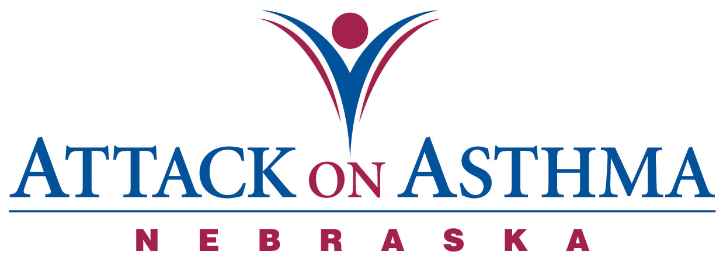

Characteristics of Individuals and Protocol Use in Nebraska Schools
2006-07

Data was voluntarily reported to Attack On Asthma Nebraska (AOAN) during and following the 2006-2007 school year. During this period of time there were 56 reported incidents of the Emergency Response to Life-Threatening Asthma or Systemic Allergic Reaction (Anaphylaxis) protocol being implemented. Schools submit data using a standardized form.

- While most schools reported only one incident of protocol administration with a student there were five schools that reported two or more incidents with the same student. Two students twice, one student three times, one student five times and one student seven times.

- The majority of incidents occurred during the months of August, September, October and November (61%).

- More females (61%) than males (39%) were administered the protocol.

- The administration of the protocol was split quite evenly with High School students (30%), Middle School students (36%) and Elementary students (29%). There were also two staff and one parent incident reported (5%).

- The greatest percentage of incidents was reported in conjunction with PE class (41%). Classroom (20%) and recess (18%) as locations followed.

- The majority of the incidents were with an individual reporting a history of asthma to the school (41%) with eight reporting a history of anaphylaxis (14%) and thirteen reporting no history of either (23%).

- Slightly over two-thirds (68%) received epinephrine as a correct usage of the protocol.

- Four (7%) individuals with no history of asthma returned to school with an action plan.

- Six (11%) individuals with a history of asthma and no action plan on file returned to school with an action plan after protocol administration.

- Of those students with a history of asthma slightly more than one third (37%) had an action plan on file.

- Of those students with a history of anaphylaxis almost two thirds (63%) had an action plan on file.

- No one required the use of CPR.

- There were sixteen incidents (29%) where only albuterol was administered.

- Emergency Medical Services (EMS) was called 80% of the time. Of the eleven times that EMS was not summoned, all eleven incidents were treated with albuterol only.

- Thirty-eight individuals (66%) were transported to a medical facility via the Emergency Medical System. Ten individuals (18%) were transported to a physician’s office or medical facility by a parent or spouse.

- Thirteen school districts reported the 56 incidents. Of these thirteen districts, seven (54%) are rural and six are urban (46%) districts.

- Nineteen incidents (34%) occurred in the seven rural districts and thirty-seven (66%) in the urban districts.

- Each school district had access to or has a school nurse.

Assumptions made: Action plans on file at school include prescribed medication(s).

Notes: The numbers and percentages above include all incidents, not to exclude the students of repeat protocol administration. The student receiving the protocol five times has a difficult co-morbid condition along with asthma that complicates the presentation. This student is under medical supervision.

