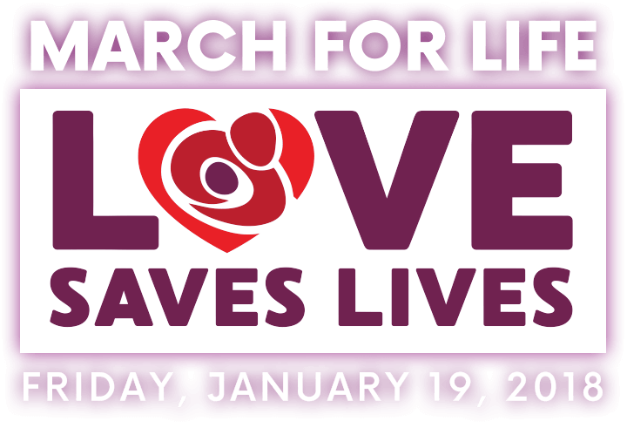

YOU ARE INVITED!! Please come.

As the 45th anniversary of Roe vs. Wade approaches, we prepare to join with hundreds of thousands across the nation in protesting this decision that legalized abortion nationwide.

You have the opportunity to show your support in reversing this decision by participating in our local Mini-March For Life. The March will be held January 19, 2018, meeting in Fountain Park at 11:00am. We will march to the K of C Hall on Woodland Ave. A light lunch will be served with a prayer service to follow ending at 12:30.

The theme for this years March is ‘LOVE SAVES LIVES’. Let us all show our love of life from conception to natural death. You can be a voice for the voiceless. A quote from Jeanne Mancini, president of March for Life, “ If every marcher responded to God’s call to them, to their potential, abortion would be ended that year, I’m convinced of it!” Also from Chuck Donovan, the president of Charlotte Lozier Institute, “ Love doesn't sit out in the back pew, it gets out front.”

The Pregnancy Life Center and the Van Wert Interdenominational community invite you to make our March this year the best and biggest ever. All Donations for the luncheon will given to the Pregnancy Life Center.

God is with us and He always listens!!

