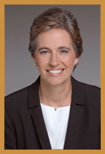

Dr. Elizabeth McConnell, MD, FACS, FASCRS
McConnell Colorectal Center
Phoenix Office
6245 N 16th Street
Phoenix, AZ 85016

Glendale Office
20325 N. 51st Ave Ste 102
Glendale, AZ 85308

Phone: (602) 253-4271

http://www.azcolorectal.com/

