CITY OF OSKALOOSA, KS

REGULAR COUNCIL MEETING MINUTES

212 W WASHINGTON STREET

MAY 15, 2024 \* 7:00PM

\*\*\*\*\*\*\*\*\*\*\*\*\*\*\*\*\*\*\*\*\*\*\*\*\*\*\*\*\*\*\*\*\*\*\*\*\*\*\*\*\*\*\*\*\*\*\*\*\*\*\*\*\*\*\*\*\*\*\*\*\*\*\*\*\*\*\*\*\*\*\*\*\*\*\*\*\*\*\*\*\*\*\*\*\*\*\*\*\*\*\*\*\*\*\*\*\*\*\*\*\*\*\*\*\*\*\*\*\*\*\*\*\*\*\*\*\*\*\*\*\*\*\*\*\*\*

GOVERNING BODY MEMBERS PRESENT

John Norman, Mayor

Ken Newell, Council President

Mike Smith, Council

Aron Boyce, Council

Chauncey Young, Council

GOVERNING BODY MEMBERS ABSENT:

John Metzger, Council

OFFICIALS PRESENT

Lee Hendricks, City Attorney

Patty Hamm, City Clerk

Nathaniel Copp, City Superintendent

Paul Bolinger, Chief of Police

Paul Crawford, Zoning Administrator

PUBLIC PRESENT

Sandra Pantle, Oskie 92 Station

Sarah White, PEC Civil Municipal Engineering

Pam Ireland, 500 Monroe Street

Brain Zachary, 409 St Joseph Street

CALL TO ORDER

John Norman, Mayor, called the regular meeting of the Oskaloosa City Council to order at 7:00pm.

PUBLIC

Oskie 92 Station

Sandra Pantle introduced herself as the manager of the new Oskie 92 Station. Ms. Pantle advised that it is the hope of the owner, Muhammad Abubaker, to open mid June. Ms. Pantle stated that they are in the hiring process and hope to hire employees who live locally. She went on to say that Mr. Abubaker is a very community oriented person and enjoys giving to local groups and organizations as much as possible. Ken Newell made a motion to approve the Cereal Malt Beverage license application for Oskie 92 Station. Chauncey Young seconded the motion. Vote: Yes=4, No=0; Motion Carried.

EPA LEAD & COPPER

Sarah White, Project Engineer for Civil Municipal Engineering, stated that she is working with KDHE in helping cities fulfill their requirements for EPA Lead and Copper. Ms. White updated the Council on the steps that have been taken thus far to bring the City into compliance with the next step being to check the City’s inventory. Ms. White advised the inventory deadline is October 16, 2024 with the construction process expected to begin March 2026. Ms. White noted the current inventory indicates 5% of the properties will need replacement, however, she expects that percentage to decrease dramatically as they move along in the process. Patty Hamm reported that, in order to meet the submission deadline, she directed Ms. White’s office to proceed with the Kansas State Revolving Fun pre-application in the amount of $280,000; noting the funding can be decreased or not used at all if not needed.

POLICE / CODE ENFORCEMENT / ANIMAL CONTROL

Mike Smith made a motion to approve Ordinance No. 24-2-211 Feral Cats. Ken Newell seconded the motion. Vote: Yes=4, No=0; Motion Carried.

COUNCIL MEETING MINUTES

PAGE 2 OF 4 05/15/24

Patty Hamm reported Jim Schohnerr has received the code violation notice and is cleaning the property up in hopes to open an outside storage facility for RV’s, campers and boats.

Paul Bolinger reported on individuals riding through the cemetery. Lee Hendricks noted the City has no jurisdiction within the cemetery due to private property.

Lee Hendricks reported on Code Enforcement at the trailer park and recommended a walk-thru with the new owner prior to the next City Council meeting. Ken Newell made a motion to not allow any new utility services within the trailer park until the owner has secured a permit from the City to operate the park. Mike Smith seconded the motion. Vote: Yes=4, No=0; Motion Carried.

Lee Hendricks reported the property at 1001 Cherokee Street is set for trial next month.

MAINTENANCE

Nathaniel Copp advised he will be putting together a street improvement plan for Council review at the next meeting.

Nathaniel Copp reported the part-time summer help will start working on Friday.

PARK & POOL

Mike Smith made a motion to approve the purchase of a Dolphin Wave 120 Commercial Robotic Pool Cleaner in the amount of $6000 plus shipping. Chauncey Young seconded the motion. Vote: Yes=4, No=0; Motion Carried.

Aron Boyce made a motion to approve the donation of a scoreboard from the Oskaloosa Recreation Commission for the Park field. Mike Smith seconded the motion. Vote: Yes=4, No=0; Motion Carried.

LEGAL COUNSEL

Lee Hendricks advised he had a proper title search done and the ownership of the library building belongs to the Board of Directors of Oskaloosa Library. The City does not own the building and will no longer provide maintenance on the building. Patty Hamm will send the library board official written notification of the findings.

ZONING

Lee Hendricks reported on the Keystone property. Lee’s recommendation to the Council is to vacate the east ½ of the east/west alley and to close the west ½ of the east/west alley and close all of the north/south alley while maintaining a 20’ utility easement within the closed alleys. Lee stated the hearing will take place at the next City Council meeting as long as the property ownership is clarified by Keystone.

Lee Hendricks reported on the request from Eugene Zachary to vacate part of Hamilton Street. Lee recommended the Council consider waiving part or all of the setback requirement within the conditional use permit process rather than vacate.

CORRESPONDENCE

Patty Hamm reported on receipt of the contract agreement between Paula Ellis and Bald Eagle Barn Wood for the demolition of the house at 609 Walnut Street with a start date of June 2025 and a completion date of October 2025’. Council asked about the demolition of the garage/shed. Patty will write an inquiry letter to Ms. Ellis.

MEETING MINUTES

Ken Newell made a motion to approve the minutes of the April 17, 2024 regular Council meeting as written. Mike Smith seconded the motion. Vote: Yes=4, No=0; Motion Carried.

FINANCE

Mike Smith made a motion to approve the financial statement and vouchers as presented. Chauncey Young seconded the motion. Vote: Yes=4, No=0; Motion Carried.

Ken Newell made a motion to approve Resolution No. 24-05 GAAP. Chauncey Young seconded the motion. Vote: Yes=4, No=0; Motion Carried.

COUNCIL MEETING MINUTES

PAGE 3 OF 4 05/15/24

OLD BUSINESS

Oskaloosa Foundation meeting is Wednesday, May 22, 2024 at 6:00pm.

Ken Newell made a motion to increase the general liability insurance policy for cybersolutions. Chauncey Young seconded the motion. Vote: Yes=4, No=0; Motion Carried.

NEW BUSINESS

Mike Smith made a motion to approve Triebs T-Town Fireworks Stand at Oskaloosa Lumber from June 27th through July 5th. Chauncey Young seconded the motion. Vote: Yes=4, No=0; Motion Carried.

Ken Newell reported that 512 Atchison Street has accumulated more yard items after the City cleaned up. Lee Hendricks will send Mr. Snow a letter to address the issue.

John Norman made the following appointments:

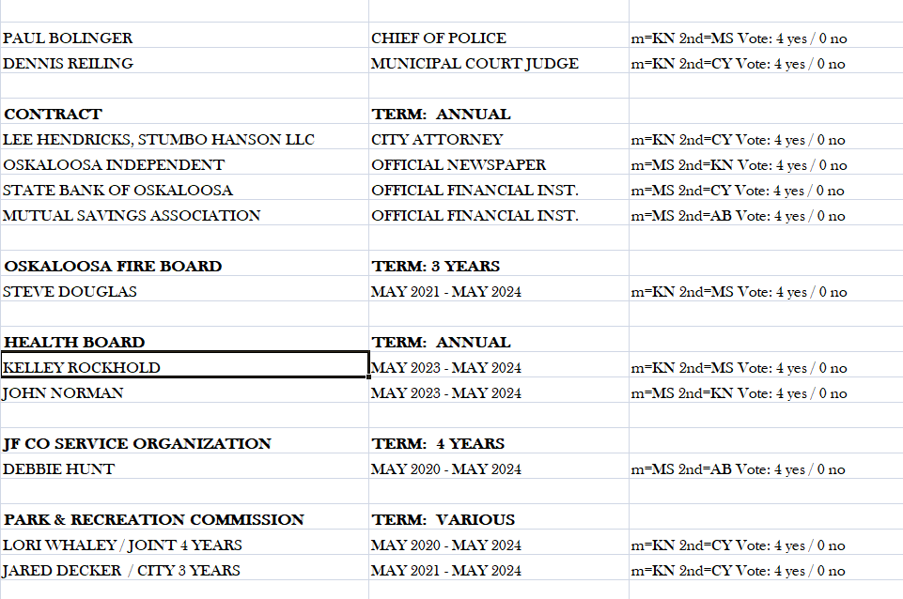

Motions Carried.

COUNCIL MEETING MINUTES

PAGE 4 OF 4 05/15/24

ADJOURNMENT

There being no further business to discuss, Ken Newell made a motion to adjourn the meeting at 8:50 pm. Mike Smith seconded the motion. Vote: Yes=4, No=0 Motion Carried.

John Norman, Mayor

ATTEST:

Patty A. Hamm, City Clerk

Minutes Approved: JUNE 19, 2024