Texas History with Mr. Brown Name ____________________ Period _____

Ch 20.2 Review: The Oil Boom After Spindletop

Directions: Use your study guide to answer the following questions about chapter 20 section 2.

1) After 30 years of oil boom expansion Texas was the _____________________________ leader in oil production.
2) What happened to Texas towns as a result of the oil boom? ____________________________________________
3) ______________________________ began using oil as a fuel to run machinery.
4) As drilling increased, _______________________________ sprang up around successful wells.
5) What was the job of a boomer? ______________________________________________________________________
6) What effect did boomers have on Texas towns? _______________________________________________________
7) Life as an oil worker could be adventurous but was full of _____________________________________________.
8) Oil rigs operated for ____________ hours a day.
9) Name three things that made working on oil rigs extremely dangerous: ________________________,
________________________, ________________________
10) What area of Texas had the most highly concentrated discoveries of Oil? _______________________________
Define the following
11) Boom –

12) Natural gas –

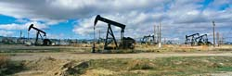
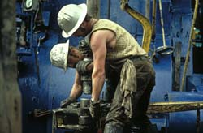
13) Boomtown –

