AUGUST ‘23 | 18-22 Teacher Inservice  21 Back to School Night  23 First Day of School |  |  | 5 Teacher Inservice  8 School Resumes  15 MLK Jr. Day  No School  17 Quarter 2 Ends
  WThFSS
  MT |  | 1 | 2 | 3 | 4 | 5
  6 | 7 | 8 | 9 | 10 | 11 | 12
  13 | 14 | 15 | 16 | 17 | 18 | 19
  20 | 21 | 22 | 23 | 24 | 25 | 26
  27 | 28 | 29 | 30 | 31
  JANUARY ‘24
  S | M | T | W | Th | F | S
   | 1 | 2 | 3 | 4 | 5 | 6
  7 | 8 | 9 | 10 | 11 | 12 | 13
  14 | 15 | 16 | 17 | 18 | 19 | 20
  21 | 22 | 23 | 24 | 25 | 26 | 27
  28 | 29 | 30 | 31
 | 4 Labor Day  29 September Break  No School |  |  | 9 Annual Gala  16 P/T Conferences  ½ Day of School  19 February Break  No School
  SEPTEMBER ‘23
  S | M | T | W | Th | F | S
   |  |  |  |  | 1 | 2
  3 | 4 | 5 | 6 | 7 | 8 | 9
  10 | 11 | 12 | 13 | 14 | 15 | 16
  17 | 18 | 19 | 20 | 21 | 22 | 23
  24 | 25 | 26 | 27 | 28 | 29 | 30
  FEBRUARY ‘24
  S | M | T | W | Th | F | S
   |  |  |  | 1 | 2 | 3
  4 | 5 | 6 | 7 | 8 | 9 | 10
  11 | 12 | 13 | 14 | 15 | 16 | 17
  18 | 19 | 20 | 21 | 22 | 23 | 24
  25 | 26 | 27 | 28 | 29
 | 20 P/T Conferences  ½ Day of School  23 Fall Break  24 Quarter 1 Ends |  |  | 18 Quarter 3 Ends  28 Holy Thursday  ½ Day of School  29 Good Friday  No School  31 Easter Sunday
  OCTOBER ‘23
  S | M | T | W | Th | F | S
  1 | 2 | 3 | 4 | 5 | 6 | 7
  8 | 9 | 10 | 11 | 12 | 13 | 14
  15 | 16 | 17 | 18 | 19 | 20 | 21
  22 | 23 | 24 | 25 | 26 | 27 | 28
  29 | 30 | 31
  MARCH ‘24
  S | M | T | W | Th | F | S
   |  |  |  |  | 1 | 2
  3 | 4 | 5 | 6 | 7 | 8 | 9
  10 | 11 | 12 | 13 | 14 | 15 | 16
  17 | 18 | 19 | 20 | 21 | 22 | 23
  24 | 25 | 26 | 27 | 28 | 29 | 30
  31
 | 20-24 Thanksgiving Break |  |  | 1 Easter Monday  No School  15-19 Spring Break
  NOVEMBER ‘23
  S | M | T | W | Th | F | S
   |  |  | 1 | 2 | 3 | 4
  5 | 6 | 7 | 8 | 9 | 10 | 11
  12 | 13 | 14 | 15 | 16 | 17 | 18
  19 | 20 | 21 | 22 | 23 | 24 | 25
  26 | 27 | 28 | 29 | 30
  APRIL ‘24
  S | M | T | W | Th | F | S
   | 1 | 2 | 3 | 4 | 5 | 6
  7 | 8 | 9 | 10 | 11 | 12 | 13
  14 | 15 | 16 | 17 | 18 | 19 | 20
  21 | 22 | 23 | 24 | 25 | 26 | 27
  28 | 29 | 30
 | 19 Christmas Play  20 Last Day Before  Christmas Break  ½ Day of School  Dec 21-Jan 5  Christmas Break |  |  | 22 8th Grade Graduation  24 Last Day of School  ½ Day of School  Quarter 4 Ends
  DECEMBER ‘23
  S | M | T | W | Th | F | S
   |  |  |  |  | 1 | 2
  3 | 4 | 5 | 6 | 7 | 8 | 9
  10 | 11 | 12 | 13 | 14 | 15 | 16
  17 | 18 | 19 | 20 | 21 | 22 | 23
  24 | 25 | 26 | 27 | 28 | 29 | 30
  31
  MAY ‘24
  S | M | T | W | Th | F | S
   |  |  | 1 | 2 | 3 | 4
  5 | 6 | 7 | 8 | 9 | 10 | 11
  12 | 13 | 14 | 15 | 16 | 17 | 18
  19 | 20 | 21 | 22 | 23 | 24 | 25
  26 | 27 | 28 | 29 | 30 | 31
Quarter 1:  Aug. 23 – Oct. 24 (42 Days)  Quarter 2:  Oct. 25 – Jan. 16 (43 Days)  Quarter 3:  Jan. 17 – Mar. 18 (42 Days)  Quarter 4:  Mar. 19 – May 24 (42 Days)  Student Contact Days: 169 Days | Calendar Includes 2 flex days for Parent/Teacher Conferences  School Begins at 8:00am  Student Drop-Off  7:45-7:55am  Student Pick-Up:  K4: 11:30am; K-8th: 3:00pm |  | Note: ½ Days Dismiss  at Noon  Mass: 8:00am on Friday at St. Mary’s Catholic Church  (Drop Off: 7:40-7:50am at the Church) | 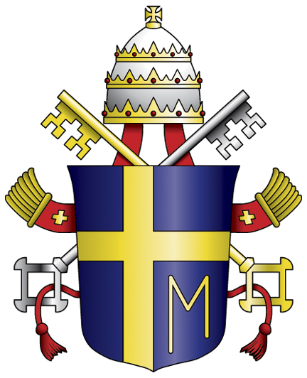

Pope John Paul II Academy | 2023-2024 CALENDAR adopted April 15, 2023
School Calendar Template © calendarlabs.com

