Sea Dragons AUGUST 2024
SUNDAY |  |  | MONDAY | TUESDAY | WEDNESDAY | THURSDAY | FRIDAY | SATURDAY
 |  | 28 | 29 | 30 | 31 | 1 | 2 | 3
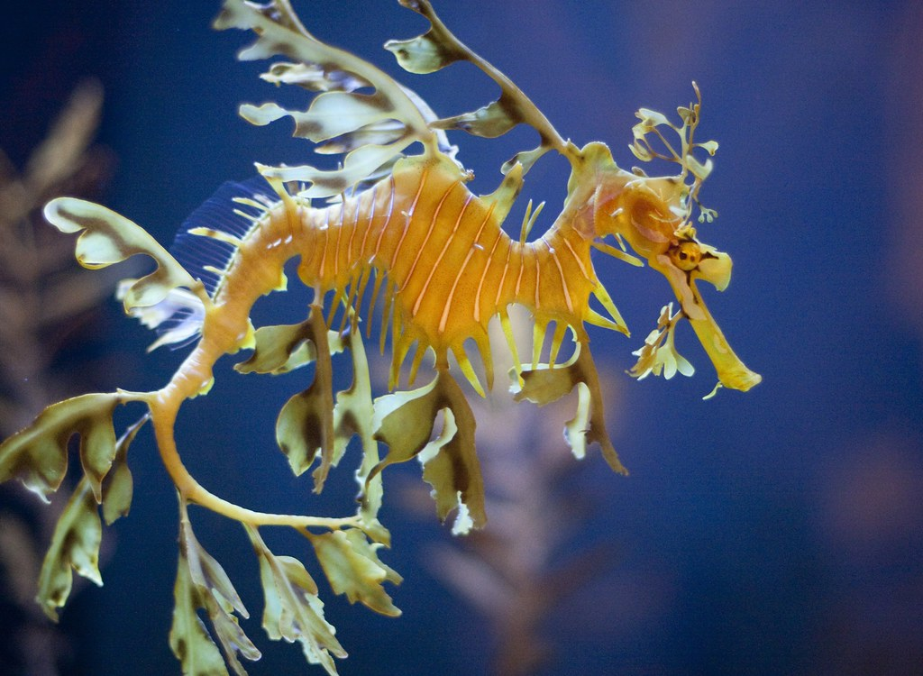  This Photo by Unknown Author is licensed under CC BY-NC-ND |  |  |  |  |  | Central Saanich Park  Crazy Hair Day | Aylard  Farm
 | 4 |  | 5 | 6 | 7 | 8 | 9 | 10
 |  |  | Closed  BC Day | Glen lake Water Park | Royal Bay Beach | Langford Water Park | Esquimalt Lagoon
 | 11 |  | 12 | 13 | 14 | 15 | 16 | 17
 |  |  | Peter Pan Water Park | Witty’s Lagoon | Esquimalt Water Park | Bamberton Beach | Gyro  Park | 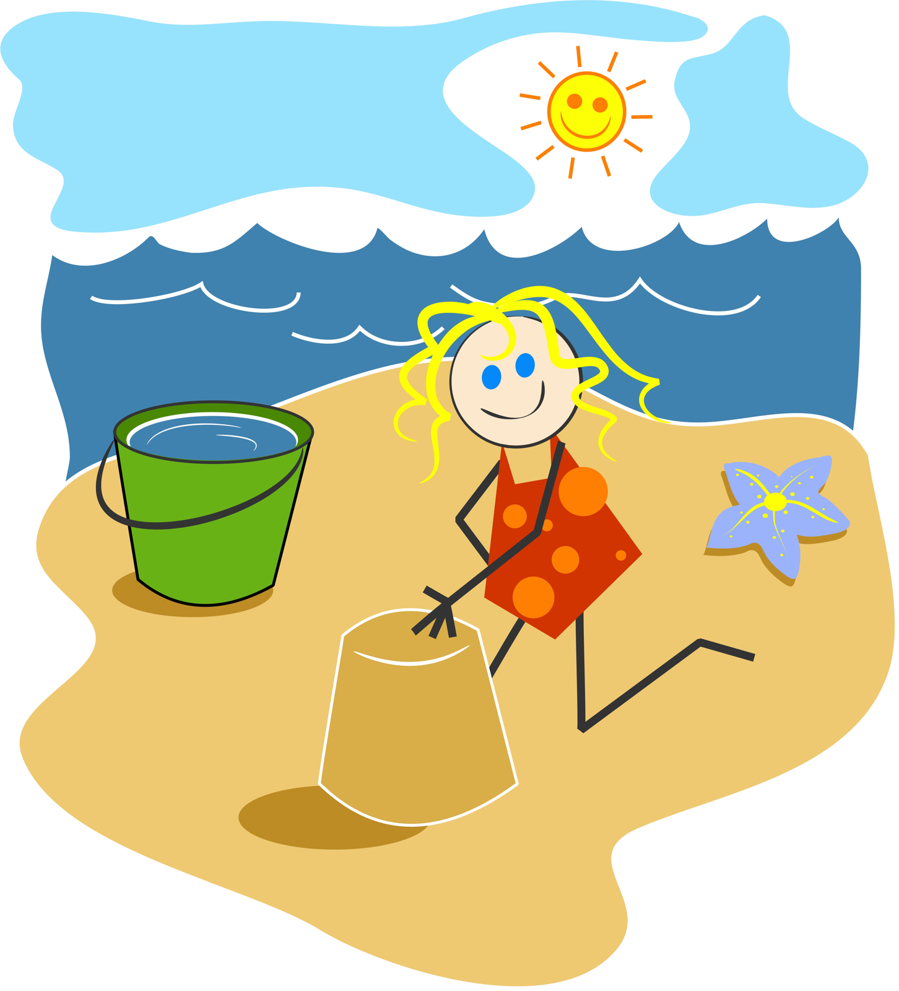  This Photo by Unknown Author is licensed under CC BY
 | 18 |  | 19 | 20 | 21 | 22 | 23 | 24
 |  |  | Cloverdale Water Park | Sooke Water Park | Devonian Beach Trail | Sydney Water Park | Mt Doug  Tinker Town
 | 25 |  | 26 | 27 | 28 | 29 | 30 | 31
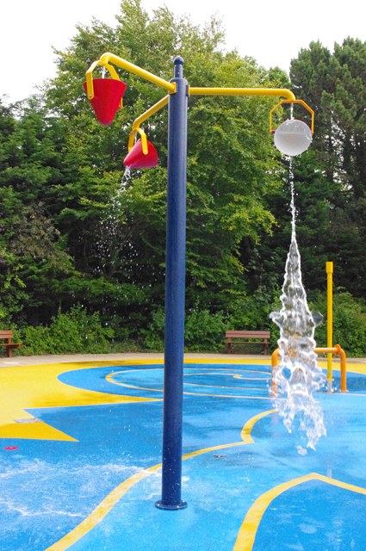  This Photo by Unknown Author is licensed under CC BY-SA |  |  | Beacon Hill Water Park | Whiffin  Spit | Cloverdale Water Park | Beckwith Water Park | Island View Beach  Hotdog Day

