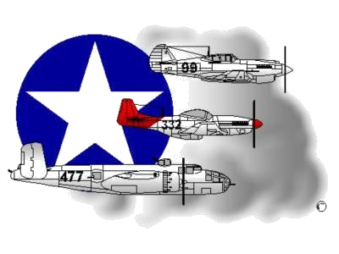
BIOGRAPHY
__________________________________________________________
A DOCUMENTED ORIGINAL TUSKEGEE AIRMAN

Tuskegee Airmen Inc. Public Relations, P.O. Box 830060
Tuskegee, AL 36083

Lieutenant Colonel Donald C. Thomas Jr.

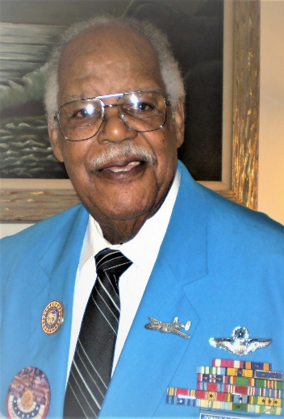
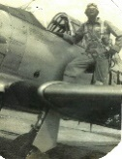
Donald Thomas, Jr. was born in Detroit, Michigan on November 14, 1926 to Donald Sr. and Permelia Thomas. Both parents migrated from Iowa in the 1920s during the automobile boom. His father spent a short time in the Army then worked for the U.S. Postal Service where he retired as a supervisor.

As a youngster, Donald belonged to the YMCA and made paper airplanes like most others. He was always competitive in sports, his studies and with classmates. He couldn’t decide if he wanted to be a doctor or do something else. In 1943, two years into WWII, his father took him to see pilots flying airplanes. He was surprised to see the African-American flyers of the 332nd Fighter Group conducting Gunnery Training at Selfridge Air Base. He became anxious to think he could be something he only dreamed about. Donald graduated high school early at 17 years old. He went to a recruiter and passed the Army Air Corps flying qualification exam. However, he was told he was too young to join the military and must wait for a call. In May of 1944, 6-months prior to his 18th birthday, he was called, inducted and was off to Keesler Field, Mississippi for Basic Training. Thomas was in Class 45-I.
After Basic Training, he had nearly completed the formal part of his flying training when WWII ended and The Tuskegee Institute Program was disbanded. Thomas was given 2-choices: to stay in the military as an enlisted member or separate. Steadfast in his convictions to become an officer and a flyer, Thomas separated and elected to continue his civilian education in November 1945. He went back to school and received a Bachelor’s Degree in Natural Sciences (Biology, Chemistry, Physics, and Science Education) from Wayne State University in 1948 while serving in the inactive reserves. In Apr of 1950, Thomas re-entered the military as a Commissioned Officer and a flyer in the USAF Reserves, but was required to complete the Aviation Cadet Flying Program a 2nd time.
Throughout his career, his flight qualifications included Single and Multi- Engine Propellesr as well as Jet Aircrafts. His planes included the PT-13, T-6, T-28, T-33, T-39, B-25, C-46, C-47, SA-16, C-82, C-119, C-130, F-80, F-84, F-86, DC-9, and the C-141. He served as an Instructor, Evaluator, a Command Pilot; and logged over 6,800 flying hours, of which 2,000 hours were carrier takeoffs and landings over water.
Lt Col Thomas was stationed at Dyess AFB, TX; Bein Hoa Air Base, Vietnam; Davis Monthan AFB, AZ; Norton AFB, CA; Scott AFB, IL; A&T State University, NC; Patrick AFB, FL; USF Keflavik, Iceland; and Ramstein AFB, Germany. Randolph AFB, TX; Perrin AFB, TX; Vance AFB, OK; Westover AFB, MA; London, England, Burtonwood, England; and Selfridge AFB, MI. He served with distinction in both the Air Force Reserves and on Active Duty.
He also served as: a Security Forces Commander in Germany, a Provost Marshal in Iceland, an Instructor at Embry-Riddle University, an Assistant Professor of Aerospace Science at NC A&T State University, a Teacher for the Department of Defense Dependent Schools in Germany and Panama, and a Teacher for Detroit Public Schools. His education included a B.S. in Biology, Chemistry and Physics; B.S. in Science Education; M.A. in Education; Post Masters Fellowships at Howard, Yale, and University of Washington in Physics and Radiation Biology. He also earned a Certification in Guidance and Counseling at NC A&T State. He completed all but his dissertation towards a Doctorate Degree and later was awarded an Honorary Doctorate Degree from Tuskegee University.

His military decorations included: the Joint Services Commendation Medal with an Oak Leaf Cluster, Meritorious Service Medal with an Oak Leaf Cluster, Air Medal with an Oak Leaf Cluster, Distinguished Unit Citation, US Navy Unit Commendation Medal, Air Force Outstanding Unit Award, Meritorious Unit Commendation, Combat Readiness Medal, Armed Forces Expedition Medal, Good Conduct Medal, Republic of Vietnam Service Medal with three Campaign Stars, Long and Short Tour Campaign Medals, American Theater Campaign Medal, World War II Victory Medal, Reserve Officers Medal with a Ten Year Hour Glass, and the Congressional Gold Medal through legislation under President George W. Bush, which officially recognized the original Tuskegee Airmen.

Mr. Thomas was a member of many organizations to include Phi Delta Kappa, Alpha Phi Alpha Fraternity, the American Association for Advancement of Science, National Science Foundation, NAACP, Kiwanis International, Brevard County Police Chief’s Association, National Organization of Black Law Enforcement Executives and a member of the Masonic Lodge. He was a 32nd degree Mason and a Shriner. He served as a President of the Tuskegee Airmen National Historical Museum in Detroit, MI and was a member of the Detroit, MI Chapter of the Tuskegee Airmen Incorporated. (TAI). In his later years, he lived in Virginia and attended the Tidewater Chapter TAI meetings while presenting at gatherings and speaking engagements. The TAI Macon-Thomas West Bloomfied Chapter in Michigan was established and co-named in his honor.
He became a member of the Lonely Eagles at the age of eighty-five in 2011 and his name is honored as an enshrinee into a permanent display at the Air Zoo Michigan Aviation Hall of Fame, class of 2015 in Kalamazoo, Michigan. He was also recently selected to receive the Michigan Military and Veterans Hall of Honor to be presented in the last quarter of 2020 in Lansing, Michigan.
Donald Thomas Jr. retired as a Lieutenant Colonel with more than 37 years of combined military service from the Reserves and Active Duty. His distinguished service and commitment to the military and his country continues to be noted. The legacy of the Tuskegee Airmen as a historical starter for African-American Pilots and so many other minority career public servants must be remembered and celebrated for their sacrifice and historical landmark.

To learn more about Mr. Donald Thomas, Jr., other DOTAs, and other activities and events conducted, please visit the Tidewater Chapter – TAI Website (www.TAI-TidewaterChapter.com) and the National Tuskegee Airmen, Inc. Website at www.TuskegeeAirmen.org.

