Sure-Step Walkways & Docks
Sure-Step decking is a high quality and maintenance-free polypropylene decking system that has been engineered for your outdoor space on and off the water. Sure-Step decking key features are:
- Environmentally friendly
- Made with the best UV protection available
- High impact material exceeds competition
- Affordably priced
- Long lasting and durable
- Maintenance-free
- Easily Installed
- Barefoot friendly
- Slip resistant
- Lightweight
Find a Dealer
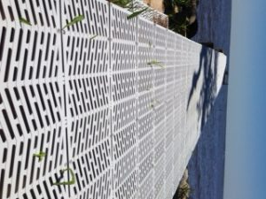<img class="wp-image-541 size-medium" src="https://www.jimdiinc.com/wp-content/uploads/2016/10/photo-3-e1484254341477-225x300.jpg" width="225" height="300" srcset="https://www.jimdiinc.com/wp-content/uploads/2016/10/photo-3-e1484254341477-225x300.jpg 225w, https://www.jimdiinc.com/wp-content/uploads/2016/10/photo-3-e1484254341477.jpg 240w" sizes="(max-width: 225px) 100vw, 225px" />Sure Step
Installation Guide
Warranty
Quality Test Videos

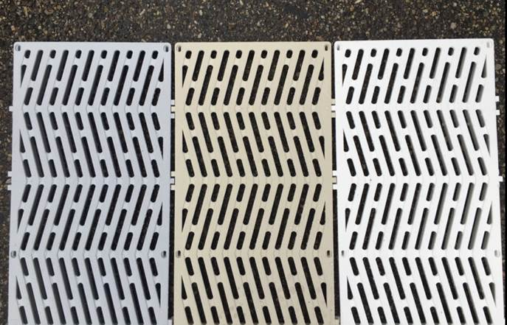<img class="wp-image-225 size-full" src="https://www.jimdiinc.com/wp-content/uploads/2016/10/sure-step-dock-color-options.jpg" alt="sure-step decking colors" width="687" height="441" srcset="https://www.jimdiinc.com/wp-content/uploads/2016/10/sure-step-dock-color-options.jpg 687w, https://www.jimdiinc.com/wp-content/uploads/2016/10/sure-step-dock-color-options-300x193.jpg 300w" sizes="(max-width: 687px) 100vw, 687px" />Mystic White, Harbor Gray, Sandcastle Tan and 3 lengths: 3’, 4’ and 5’
As a walkway and dock system, Sure Step has been a leader since 2001. Its unique design and open web Chevron pattern allows water and sunlight to pass through it in order to help conserve the ecosystem. The surface slots account for 34% of the panel area, allowing for maximum sunlight penetration without compromising strength. The average light availability under dock panel is 53% at 18” and 82% at 60”.
Sure Step is made of 100% virgin material and a has an interlocking system that makes installation a snap! The surface is slip resistant and barefoot friendly. Sure-Step Walkways and docks are available in three colors. (See product list for specifications)
Sure-Step drop-in panels are 1 inch by 47.5 inches by 47.5 inches, 27 pounds in weight, and fastened with fiberglass and stainless steel screws.
- 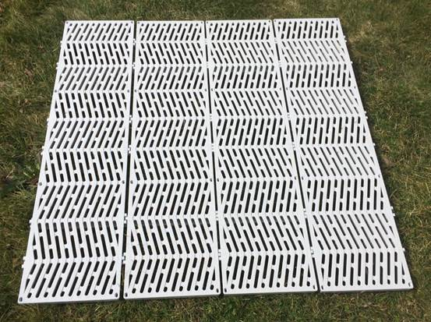<img class="alignright wp-image-227" src="https://www.jimdiinc.com/wp-content/uploads/2016/10/sure-step-drop-in-panel2.jpg" alt="sure-step drop-in top view" width="335" height="250" srcset="https://www.jimdiinc.com/wp-content/uploads/2016/10/sure-step-drop-in-panel2.jpg 553w, https://www.jimdiinc.com/wp-content/uploads/2016/10/sure-step-drop-in-panel2-300x224.jpg 300w" sizes="(max-width: 335px) 100vw, 335px" />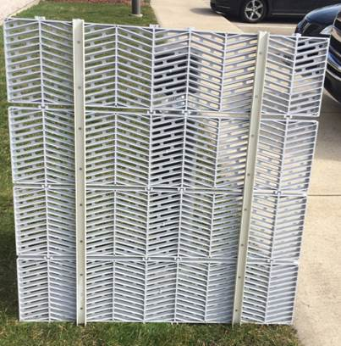<img class="alignright wp-image-226" src="https://www.jimdiinc.com/wp-content/uploads/2016/10/sure-step-drop-in-panel1.jpg" alt="sure-step drop-in bottom view" width="247" height="250" srcset="https://www.jimdiinc.com/wp-content/uploads/2016/10/sure-step-drop-in-panel1.jpg 403w, https://www.jimdiinc.com/wp-content/uploads/2016/10/sure-step-drop-in-panel1-296x300.jpg 296w" sizes="(max-width: 247px) 100vw, 247px" />Size: 1.00” x 47.50” x 47.50”
- Fastened with fiberglass and stainless steel screws
- Weighs 27lbs
the future is important. TREDZ™ is an excellent and environmentally friendly choice, one that will leave a legacy for future generations.
Sure Step Performance Test Report
Sure Step Light Availability Test Report
Sure Step Flexural Properties

