Eco Orca Class JANUARY 2025 Local Heritage, Canada, History
SUNDAY |  |  | MONDAY | TUESDAY | WEDNESDAY | THURSDAY | FRIDAY | SATURDAY
 |  | 29 | 30 | 31 | 1 | 2 | 3 | 4
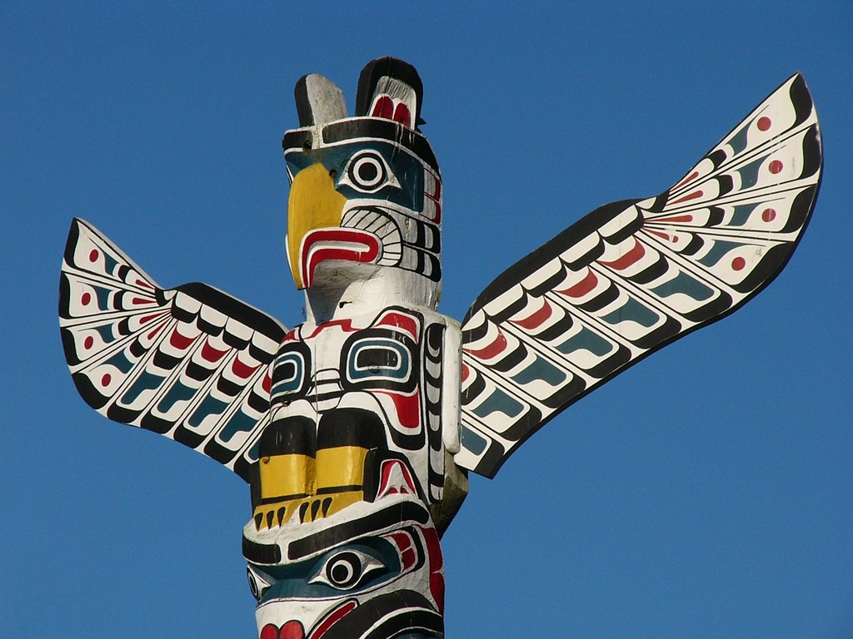  This Photo by Unknown Author is licensed under CC BY-ND |  |  |  |  | Closed  New Year's Day | Closed | Closed | 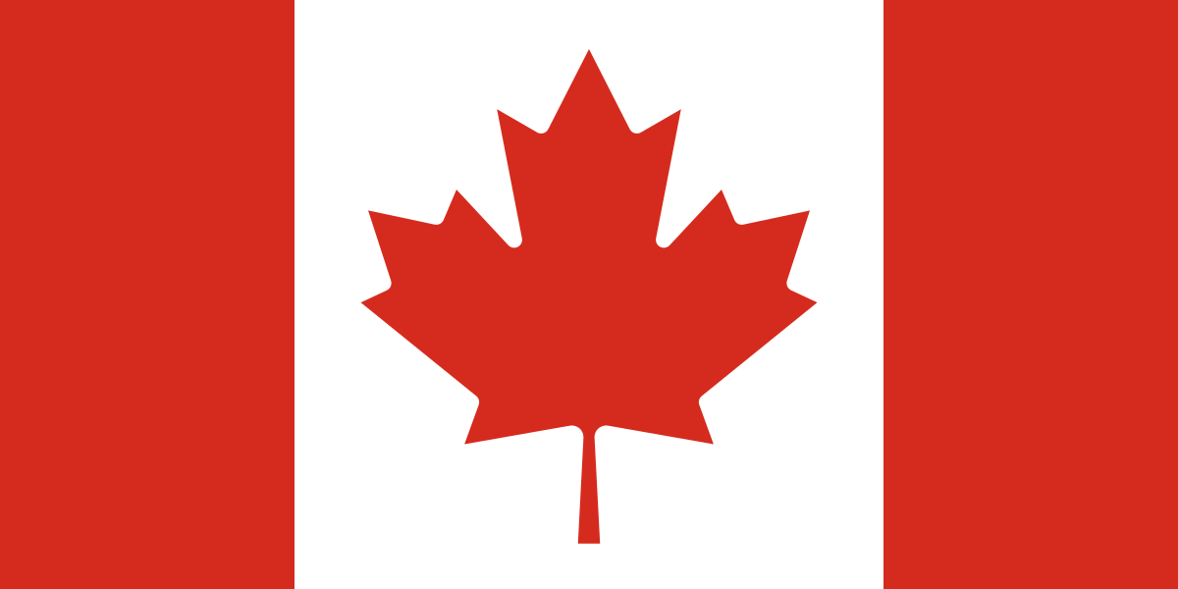  This Photo by Unknown Author is licensed under CC BY-SA
 | 5 |  | 6 | 7 | 8 | 9 | 10 | 11
 |  |  | Tallest Totem Pole | Hatley Castle  $3 | Centennial Park | Songhee’s Waterfront | Whiffin Spit  Lighthouse
 | 12 |  | 13 | 14 | 15 | 16 | 17 | 18
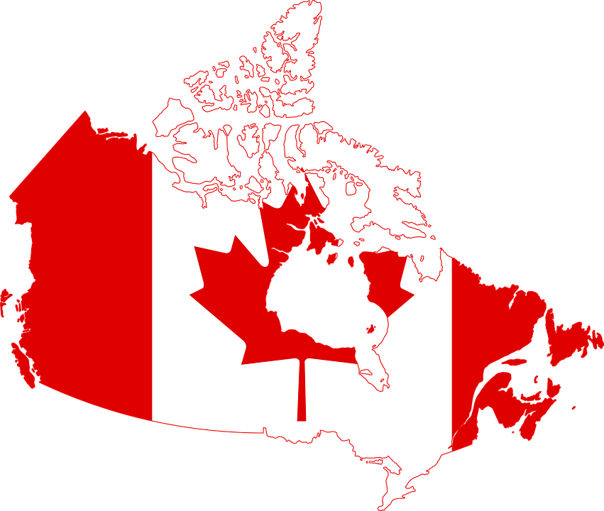 |  |  | BC Museum  $5 | Honey Crisp Park | Gyro Park | Victoria Breakwater  Lighthouse | Chinatown
 | 19 |  | 20 | 21 | 22 | 23 | 24 | 25
 |  |  | Shirley Lighthouse | UVIC Campus  Gyro Park | Sooke Museum $3 | Gorge Park History Walk | Beacon Hill Park History | 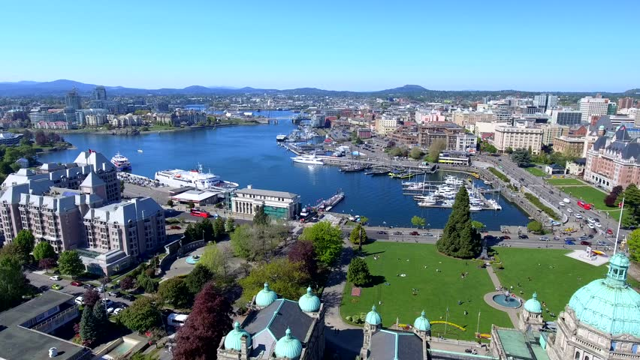
 | 26 |  | 27 | 28 | 29 | 30 | 31 | 1
 |  |  | Sydney Museum $3 | Caleb Pike House $3 | Westhills Park | Fisherman’s Wharf | Aviation Museum $5

