

# Winter 2017-2018 Season

# SUPER 7’s CUP

# 27th January 2018

# 

# The Inaugural Super 7’s Cup saw 16 players take part in the quick fire matches, with the tournament lasting just 3 hours.

# So 7 rounds of matches and for each match playing just 7 ends, with no time limit.

# Round 1 saw Paul Bell take three points on the first end against Toby Northern, but Toby fought back to take the match 8 – 6. Andrew Bellamy-Burt had the biggest win against Cassie Stewart 13 – 1.

# Matt Pinel just won by two points over Richard Williams and Geoffroy Buffetrille beat Jean Stewart 8 – 4 and Keith Pinel lost to Alan Oliveira 6 – 3 who joined the competition at the last minute.

# Round two saw Toby fire 8 out of 9 boules including two carreaux to beat Brian Harris 8 – 4. Ross Payne also made it two wins beating Geoffroy 7 - 5.

# Mo De Gruchy lost by just one point against Richard Williams 7 – 6 as did Keith Pinel against Laurent Pelllaton 6 - 5 with both of those results proving crucial to the finishing positions. Andrew also made it two wins over doubles partner Callum Stewart 8 – 4 and Paul Bell won 13 – 1 against Alex Stewart, the joint top result of the day.

# Round Three saw Geoffroy lose his second match in a row losing to Matt Pinel by one point 6 - 5. Laurent continued to beat Premier League opposition taking out Brian Harris 6 – 4 and new singles player Paul Bell beat experienced Alan Oliveira 7 - 6.

# Andrew beat Toby 7 – 3 and Callum returned to form handing Ross his first defeat 7 - 5.

# Round four saw the pressure start to mount with Andrew beating Matt Pinel by one point 5 - 4, the same was for Callum Stewart over Paul Bell. Ross made it two straight losses against Cassie Stewart. Laurent also handed Toby his second straight loss winning 7 – 2. Geoffroy made it three losses out of four matches with a thrashing from Alan Oliveira 10 - 2. Ross Payne lost 10 – 4 to Cassie Stewart.

# Brian Harris and Richard Williams moved into contention winning their respective matches against Keith 6 – 4 and Alex 6 – 4.

# Round five saw the turning point for Geoffroy who was having an awful competition with just one win out of 4. This time he beat Alex Stewart 8 - 5. But top ranked player Andrew Bellamy-Burt lost 9 – 1 to Richard Williams and Callum Stewart beat Matt Pinel .

# Ross Payne beat Toby 7 – 4 and Paul Bell impressed beating Brian Harris, but by just one point 7 - 6.

# Round six saw Andrew just beat Laurent, by 1 point 7 – 6 and Callum Stewart beat Richard Williams 11 - 3. Brian Harris, Geoffroy Buffetrille and Keith Pinel all gave themselves outside chances with wins.

# The final round saw Alan Oliveira make the top 8 with a win over Callum Stewart 6 – 5 to finish 4th on 5 wins. Callum finished 3rd also win 5 wins but the second highest BHN of 30.

# Andrew Bellamy-Burt topped the rankings winning his final match against Mo De Gruchy 9 – 2 who on fortunately finished last. Andrew ending on 6 wins with just the 9 – 1 loss to Richard Williams.

# Matt Pinel beat Laurent Pellaton 8 – 3 to finish second with 5 wins with the highest BHN of 31. Laurent did make the top 8 though finishing 5th with 4 wins and a BHN of 30.

# The biggest match of the final round was Geoffroy against Brian with a win likely to take them through. Geoffroy won this one comfortably by 8 points to make it three straight wins and finish 8th curtosy of a BHN score of just 22 against Keith Pinel BHN of 20. What a turnaround from Geoffroy.

# Final Rankings on next page.

# Inline image

Quarter Finals

1st Andrew Bellamy-Burt v Geoffroy Buffetrille 8th

2nd Matt Pinel v Cassie Stewart 7th

3rd Callum Stewart v Richard Williams 6th

4th Alan Oliveira v Laurent Pellaton 5th

Well the curse of the top ranked player returned as Geoffroy made it four wins in a row to knockout Andrew winning comfortably 8 - 3.

Matt Pinel though did make it through against Cassie Stewart also with an 8 – 3 score.

Callum was 7 – 5 up with one end to play against Richard, but Richard score two points to tie the match. The extra end went Richards way as the division 2 player took another Premier League scalp to make the semi-finals winning 8 - 7.

Well it hadn’t happened all day, but in the quarter final between Alan and Laurent it did as Laurent another division 2 player beat Alan 9 – 0.

So the semi-finals saw two Division 2 players take on two Premier League players.

2nd Matt Pinel v Richard Williams 6th

8th Geoffroy Buffetrille v Laurent Pellaton 5th

This is where the quality and experience really shows and despite excellent tournaments for Richard and Laurent big game players Geoffroy and Matt took the wins to make the final.

Matt won easily 8 – 1 as Richard faulted at the crucial moment. Geoffroy won the closer of the two semi-finals 6 – 3.

It was a comfortable ride for Laurent in the 3rd/4th place play off as he took 3rd place and Bronze medal winning 9 – 1 against Richard, well done Laurent.

Matt Pinel had already beaten Geoffroy in round three, but only by one point.

Matt took two points on the first end, but Geoffroy came back with some excellent placing to take the first trophy of the year winning by a relatively big margin 8 - 4.

So despite only winning 4 out of 7 matches Geoffroy went on to win another tournament and on his birthday as well, well done Geoffroy. (Picture below holding the trophy!)

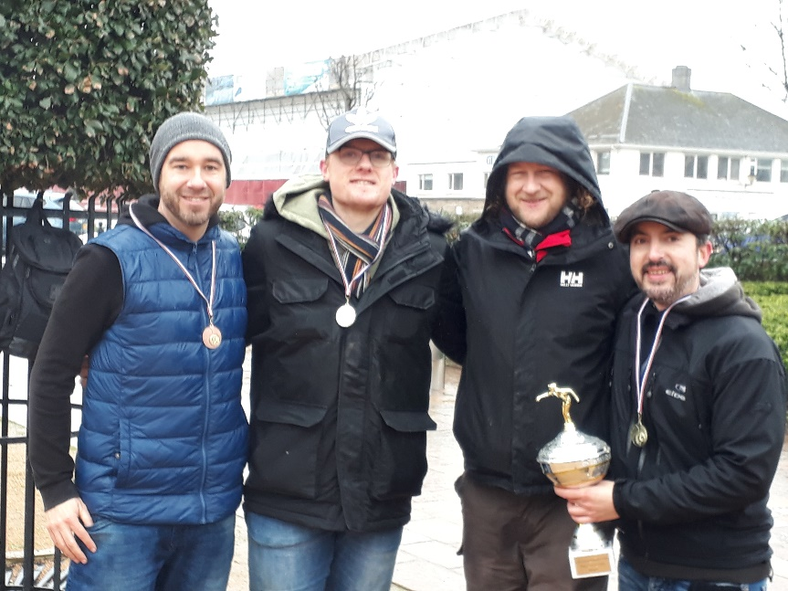

***NEXT WEEK***

**Doubles League**

**WEBSITE** [**www.liberationpetanque.co.uk**](http://www.liberationpetanque.co.uk)

**EMAIL** [**liberationpc@gmail.com**](mailto:liberationpc@gmail.com)

**Kind Regards**

**Report Editor**

**Toby Northern**

**Liberation Petanque Club**

# SPONSORED BY

# http://nebula.wsimg.com/135a1bd6338e1b589a50cdec98bd84d1?AccessKeyId=C6E923731F1A482DD910&disposition=0&alloworigin=1