December

2017

TRUE LIES

The Stuart Rod & Reel Club Newsletter

*The Stuart Rod and Reel Club is dedicated to improving local fishing through by increasing angler knowledge, encouraging conservation and maximizing the fun involved in light tackle fishing in the Stuart Florida area. We hold monthly meetings on the second Thursday of each month, year-round. Please join us or contact any board member for more information on how you can become a member of the Stuart Rod and Reel Club.*

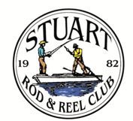

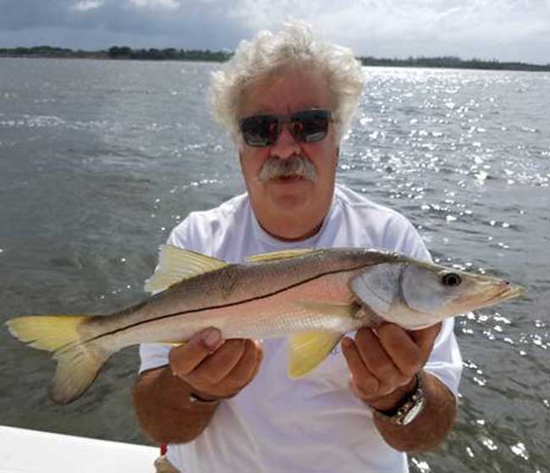

*New Member John caught this snook on a party cloudy day. With the sunshine, you can see the beautiful colors of this open water fish.*

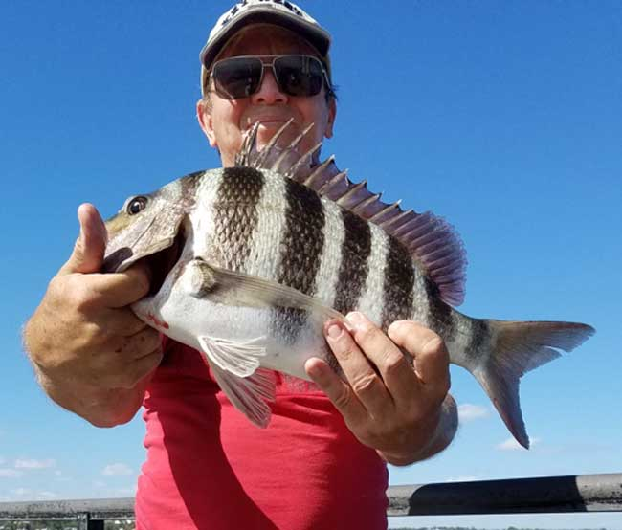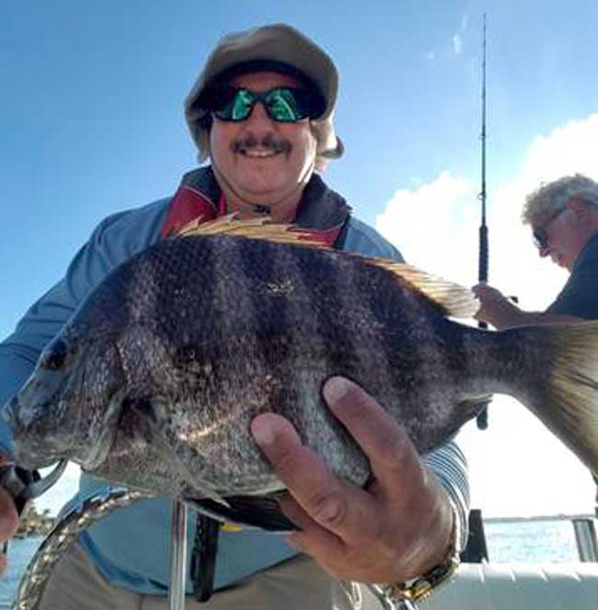 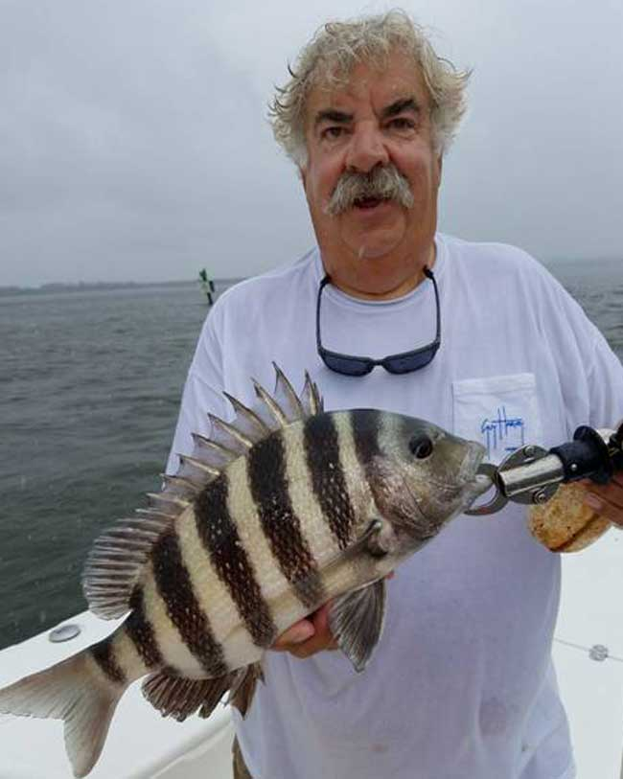

You know that is winter in Florida when the Sheepshead, Pompano and Cobia show up. So far, the Spanish Mackerel are a little late and we hope that the dirty water does not move their breeding grounds.

Above Left: Eric Rosenberg. Above Right: Keith Palant. Above Center: John XXXXXXX

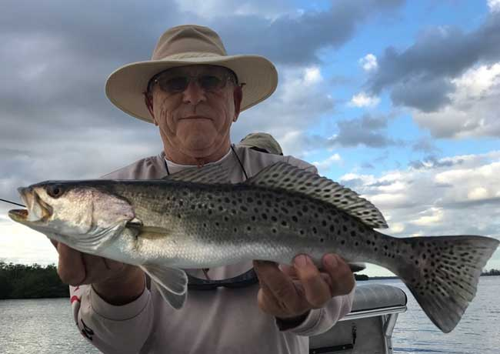

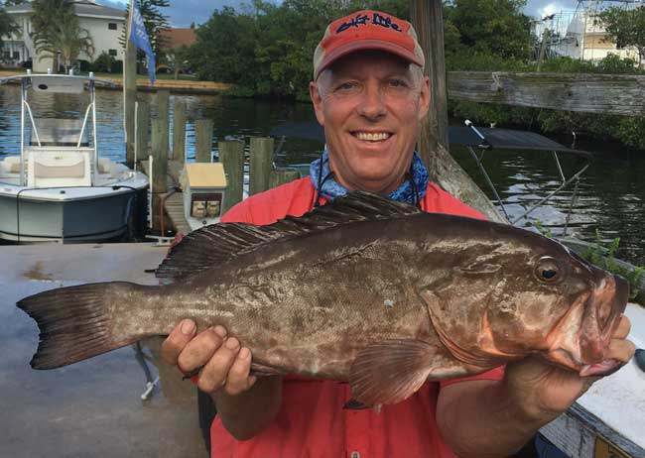

*Bill Lalone brought this fine Red Grouper back from the Bahamas in a fresh and whole condition. It is rare to see a grouper like this in our area any longer.*

*Jerry Hoge landed this beautiful trout while fishing with Jim Bohrer and Rose Rooney.*

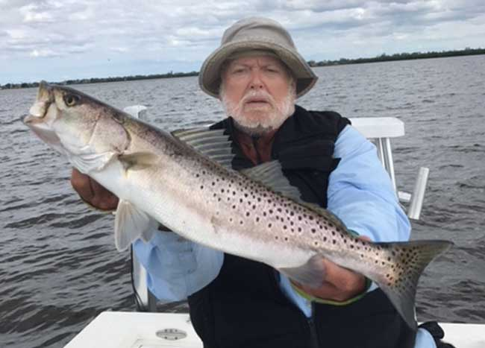

*Jim Bohrer with a magnificent gator trout caught near Round Island. Even though fishing has been a little spotty, there are some large ones ready and willing to strike*

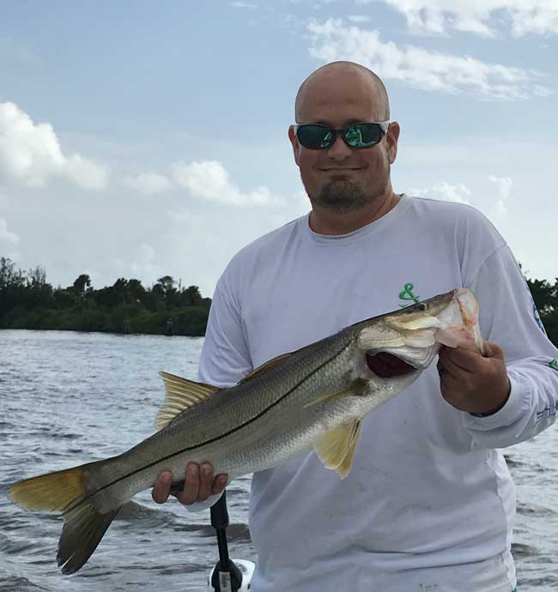

*Justin Steckley caught and released this nice 27 inch Snook.*

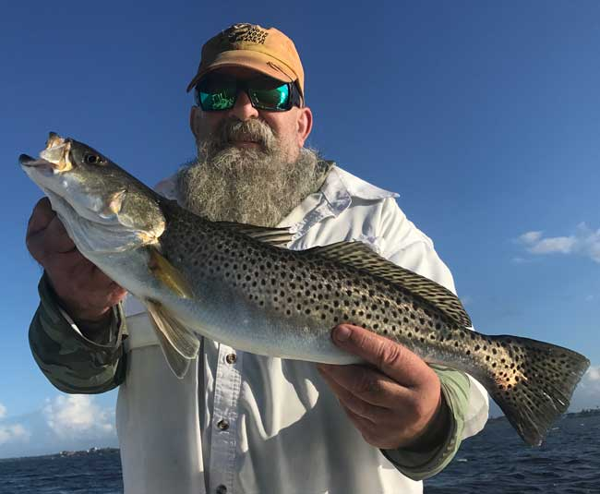

*Jim Bohrer invited Woody Woodard out to fish the Indian River Lagoon. Woody is one of the most helpful countermen at the Snook Nook in Jensen Beach. Although they had a relatively slow day, Woody caught this fine trout on a beautiful Fall day.*

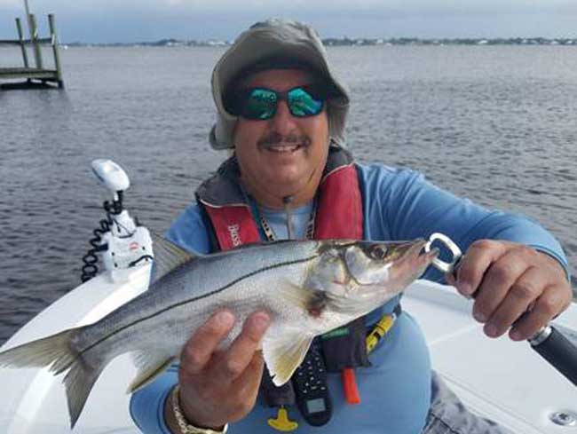

*Keith Palant landed this Fat Snook on a cloudy day. One of the four main species of snook, this one is characterized by a deeper body profile. The world record is 7 pounds, 4 ounces but most are 12 to 16 inches lon*g.

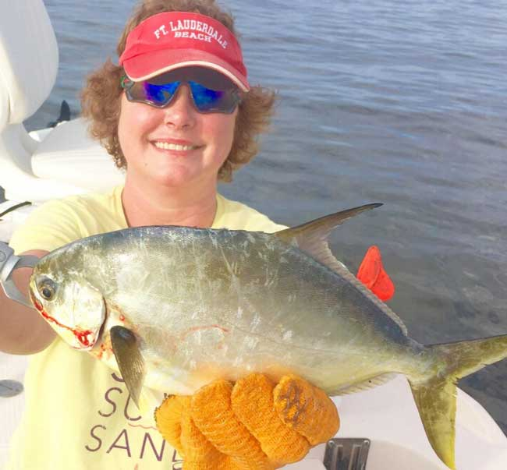

*Shelly Bowdish caught this fine pompano while fishing with her Dad in Pine Island, FL. She used a live shrimp on a popping cork rig. The fish was swimming near Marker 9 at Jug Creek Shoal in the Pine Island Sound.*

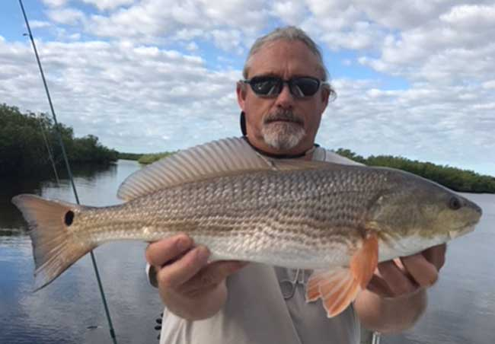

*Jay Honan caught this fine redfish along the shoreline near Round Island. Jim Bohrer was fishing with Jay that day.*

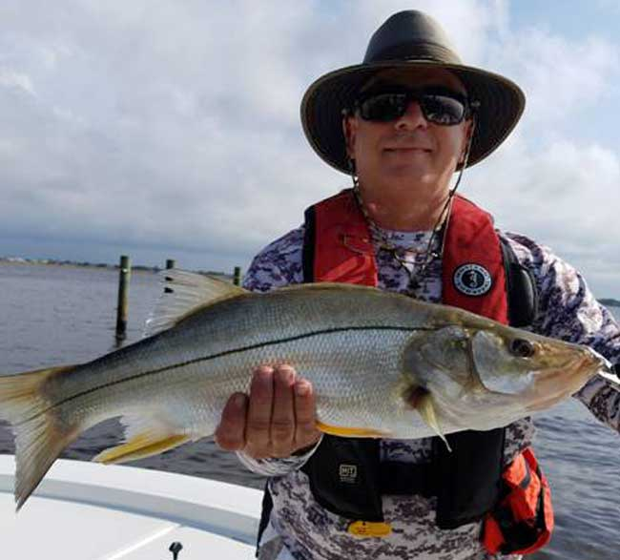

*Jorge (George) Perez with a lovely snook, caught and released to fight another day.*

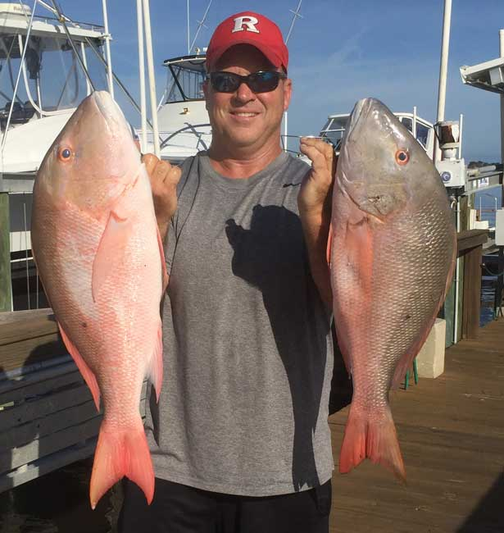

*Members Phillip Quick and Jim Tuten, along with friend Tom Janic went on a multi-day charter trip out of Key West. Near the Marquesas islands, they hit paydirt with a large number of Mutton Snapper and Yellowtail Snapper. In addition, a few grouper joined in for an exciting catch. Here, Tom shows off two prize muttons.*

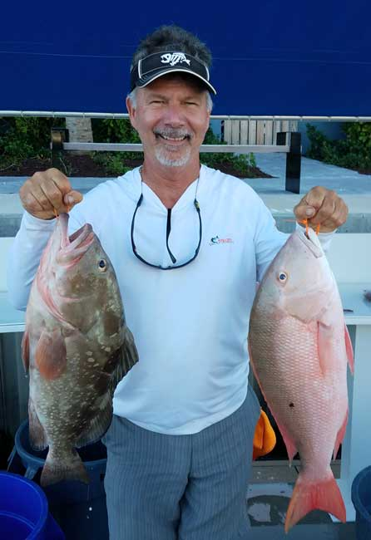

**Support our Advertising Sponsors**

We are very fortunate to have many local businesses that advertise on our web site and provide additional sponsorship support to the Club. These businesses provide a wide range of products and services for the entire community. Whether you are looking for lodging, restaurants, fishing supplies, boat repair and restoration, guide services, legal services, or roof repair our sponsors deserve your consideration. You can learn more about these businesses by visiting our website at [www.stuartrodandreel.com](http://www.stuartrodandreel.com). Click on the advertiser’s tab and you will find a brief description of our sponsors with contact information and links to their websites. Make our advertising sponsors your priority when shopping. Please let them know that you learned about them through the Stuart Rod and Reel Club and that you appreciate their support.

|  |  |
| --- | --- |
| **Bait & Tackle**   * Crowder Rods * D.O.A. Lures * Fish Heads of Stuart * Snook Nook * Treasure Coast Rod and Reel * White's Tackle * T & A Jigs, Inc. | **Area Lodging**   * Marriott - Hutchison Island Resort |
| **Area Dining**   * Big Apple Pizza * Crawdaddy’s * Dixie Grill * Manatee Island Bar & Grill * Manero’s Restaurant * Polka European Deli * Rancho Chico * Shrimper’s | **Guide & Charter Services**   * Cajun Fishing Adventures Louisiana * Catch 22 Charters Florida * The Fish Intimidator Louisiana |
| **Marine Products & Services**   * C&H Trailer * Manatee Marina * Marine Customs Unlimited * Marine Parts Outlet * Master Repair * Metco Marine Electronics * Outboards Only * Sailfish Marina * Stuart Propeller * Treasure Coast Battery & Alternator | **General Business**   * Capps Roofing * Inn of the Dog * Plaza 95 Marathon, Dairy Queen and Highway Café   **Professional**   * Crary Buchanan Attorneys |

***MEMBER’S INFORMATION***

**MONTHLY MEMBERSHIP MEETINGS WITH SPEAKERS:** The monthly membership meeting is the second Thursday of the month. Our home port is The Quality Inn/Flanigan’s Bar & Grill located at 950 SE Federal Hwy. (US 1) Stuart, FL. We have the privilege of listening to many fishing industry and conservation leaders in the Southeastern Florida region. These experts include tackle manufacturers, tournament winning Captains and guides, television and print journalists, and academic researchers. We have a guest speaker from this pool at each monthly meeting. Speakers will address topics of interests such as how to fish for the upcoming outing’s targeted species and our diverse estuary system. This is a great way to gain additional local knowledge of this fishery. Dinner begins at 6PM with Meeting at 7 PM.

**MONTHLY OUTINGS:** The Club sponsors a fishing outing each month. All outings are based on an Honor System. You don’t have to keep your catch or take a picture of it either. Outings are scheduled for the weekend following the general membership meeting. Outings are usually three day events where anglers select to fish Friday, Saturday or Sunday. Most outings are scheduled from first safe light till 1PM. The targeted fish and scoring change from month to month with interesting twists such as more points for one species than another. The intent is to have fun! The winner of each monthly outing receives a Club logo embroidered fishing shirt. As part of the outing we have several lunches at restaurants along with club and family cook-outs. Additionally, the Board is encouraging members to partake of the lunch regardless of the day fished. These are no-cost events. With two away outings and the remainder based at Sandsprit Park, there is opportunity to participate without travelling around the state. Frank Miller as the Angling Committee Chairman will also consider your ideas about other outings in other parts of the state. This year’s outing schedule was developed to increase participation, emphasizing the fun of fishing. You are able to view the schedule in every edition of True Lies.

**NEWSLETTER:** We publish a newsletter, True Lies, each month. It is circulated by e-mail. We are constantly looking for your fishing reports, pictures, recipes, and any other Club related information for inclusion. Submitting information is easy. You can send an e-mail to Jim Bohrer (halieutics@gmail.com).

**WEB SITE:** The Club’s web site (www.stuartrodandreel.com) is a wealth of information. You can find the latest weather and tides, fishing tips and information on our advertisers/sponsors.

**RAFFLE:** An activity at our membership meetings that generates a great amount of interest is the “Raffle”. Tickets are $1 each or 6 for $5. Raffle prizes vary monthly but usually include a fishing rod, reel or combination. Other prizes have been tackle bags, boxes, pliers, lures and boating accessories. Your purchase of raffle tickets gives you a good chance of winning and helps support the activities of your club.

**MEMBER DISCOUNTS:** Your Club membership can help you to save some money. White’s Tackle offers a 10% store discount on all purchases. Be sure to mention that you are a current member of the Stuart Rod and Reel Club and that you appreciate the support that they give the club.

to

Year End News

We will have a full recap of the Christmas Party in the January 2018 Newsletter. The December general membership meeting will be held at the Christmas Party. There will be no Flanigan’s meeting in December.

We will also publish a new tournament schedule for the 2018 Calendar Year in the January Issue

**2018 Annual Dues**

Fully paid memberships begin the first day of January, and end on the thirty first day of December of each calendar year. An individual membership is one adult 18 years of age or older. Family memberships consist of the member, their spouse or significant other and their children under the age of 18.

**Individual membership** for a Full Year is $80.00

**Family membership** for a Full Year is $95.00

**Send your checks payable to:**

Stuart Rod and Reel Club, Inc.

c/o Pete Noll, Treasurer

1888 S. W. Mooring Dr.

Palm City, FL 34990

***Membership entitles a single person (or family as applicable) to participate in all outings and to enjoy a meal at every local outing. Members also receive an included meal (with soft drinks) at Shrimper’s and Manatee Island Grill on the appropriate dates. We hold monthly meetings with interesting speakers and share information on where and when to fish in our area.***

**2017 SRRC Fish**

**of the Month Contests**

The Fish of the Month Contest will run from the day after the monthly membership meeting and end at 12 Noon the day of the following meeting. All fish need to be legal size except for Snook that must be 24-inch minimum. Natural bait (live or dead), artificial lures and flies are allowed. The member catching the most fish will be the monthly winner. The monthly winner will receive a monogrammed club hat.

|  |  |
| --- | --- |
| Date | Species |
| Jan 13 thru  Feb 09 | Snapper, Bluefish |
| Feb. 10 thru Mar. 09 | Most Pompano |
| Mar. 10 thru April 13 | Most Snook |
| April 14 thru May 21 | Largest Trout |
| May 12 thru June 18 | Most Snook |
| June 19 thru July 13 | Most Redfish |
| July 14 thru Aug 10 | Most Trout |
| Aug. 11 thru Sept 14 | Most Tarpon Caught and Released |
| Sept. 15 thru Oct 12 | Largest Snapper |
| Oct. 13 thru Nov 9 | Largest Redfish |
| Nov 10 thru Dec 13 | Most Black Drum |

The Winner of the Year Overall will be the person catching the most total species during the calendar year. The overall prize is a $50 gift certificate to White’s Tackle in Stuart.