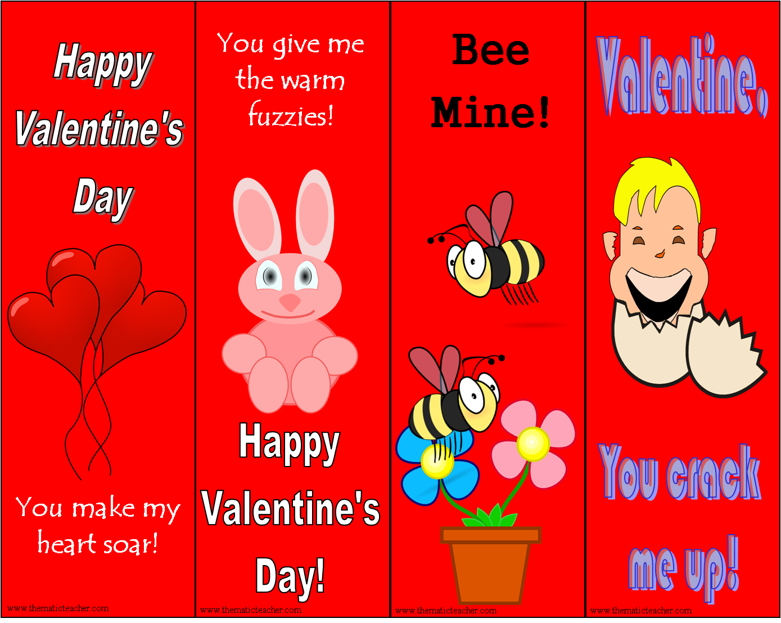
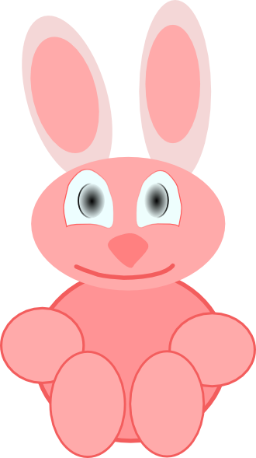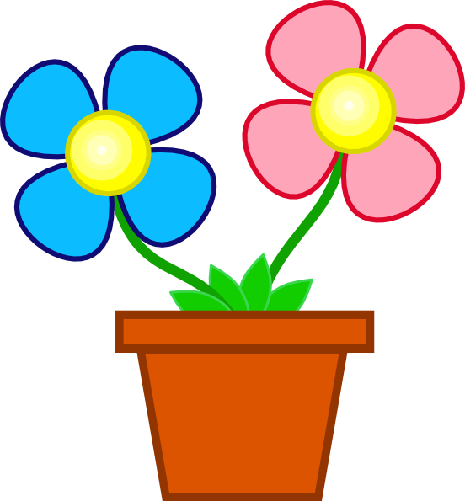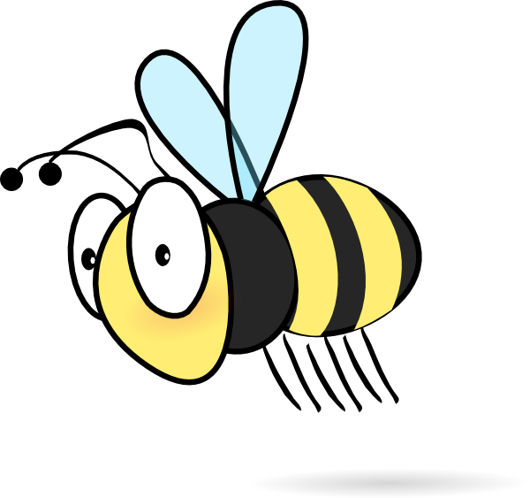
Dear Student,

Today is a great day to tell you how much I
appreciate your sense of humor. Thank you for all the fun you bring to our class. You make it a better place!

Love,
Your Teacher
Dear Student,

Valentine’s Day is the perfect day to thank you for all the support you give me. It warms my heart to see your eyes focused on me and know that you are truly listening. I am blessed to have such a
conscientious
student.

Love,
Your Teacher
Dear Student,

I want to tell you how proud I am of you. You have been working so hard and I have seen a LOT of progress. Keep up the good work. It is really making a big difference!

Love,
Your Teacher
Dear Student,

I’ve been wanting to tell you just how wonderful I have seen you be with the other students. You are kind and helpful and always try to include others. Thank you for
being yourself.

Love,
Your Teacher

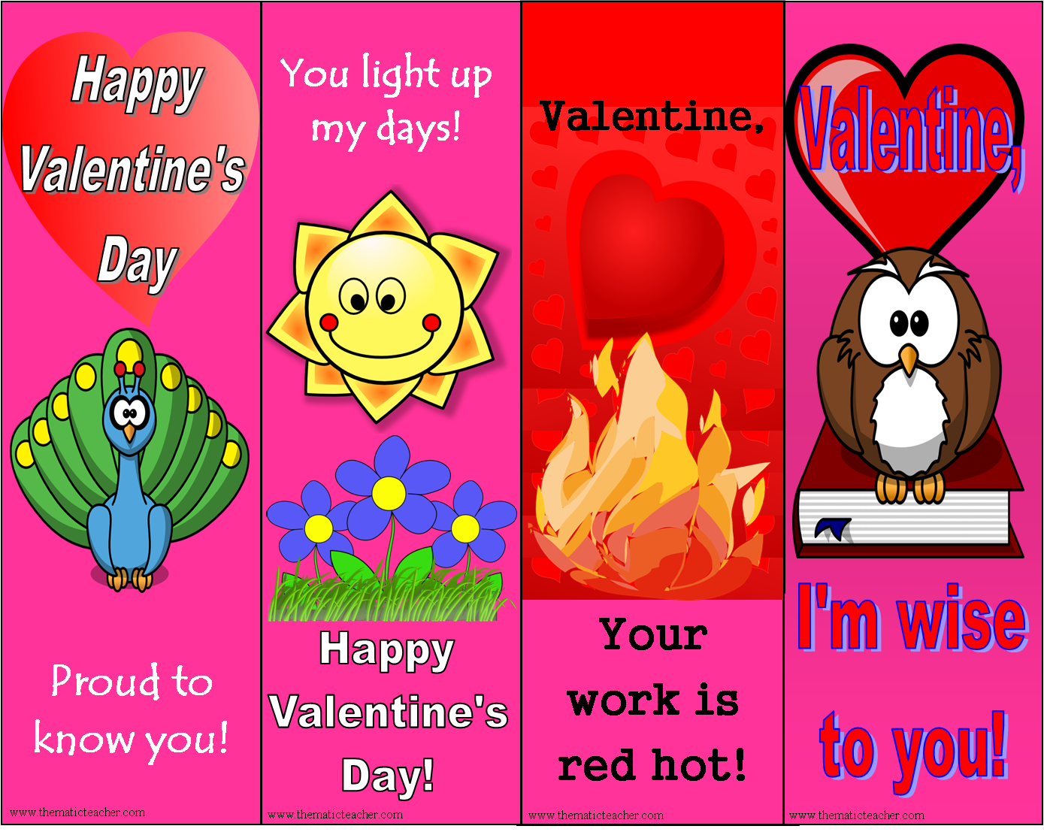

Dear Student,

I have noticed a big change in the way you do things. Your work has
improved and your attitude is so helpful to our class. Thank you for your hard work.

Love,
Your Teacher
Dear Student,

Correcting papers can be very tiring work sometimes, but I know that whenever I get to look at something you have done, it is going to be smoking’ hot! Thanks for
helping to make my work more fun.

Love,
Your Teacher
Dear Student,

Your cheerful
attitude and
smiling face make my school days bright ad happy. I am so thankful to have the chance to work with someone as energetic and positive as you. Thank you for
being here!

Love,
Your Teacher
Dear Student,

I am so proud of you. You work hard, even when the work is hard! You hang in there through thick and thin. You are an inspiration to me and I am lucky to know you.

Love,
Your Teacher

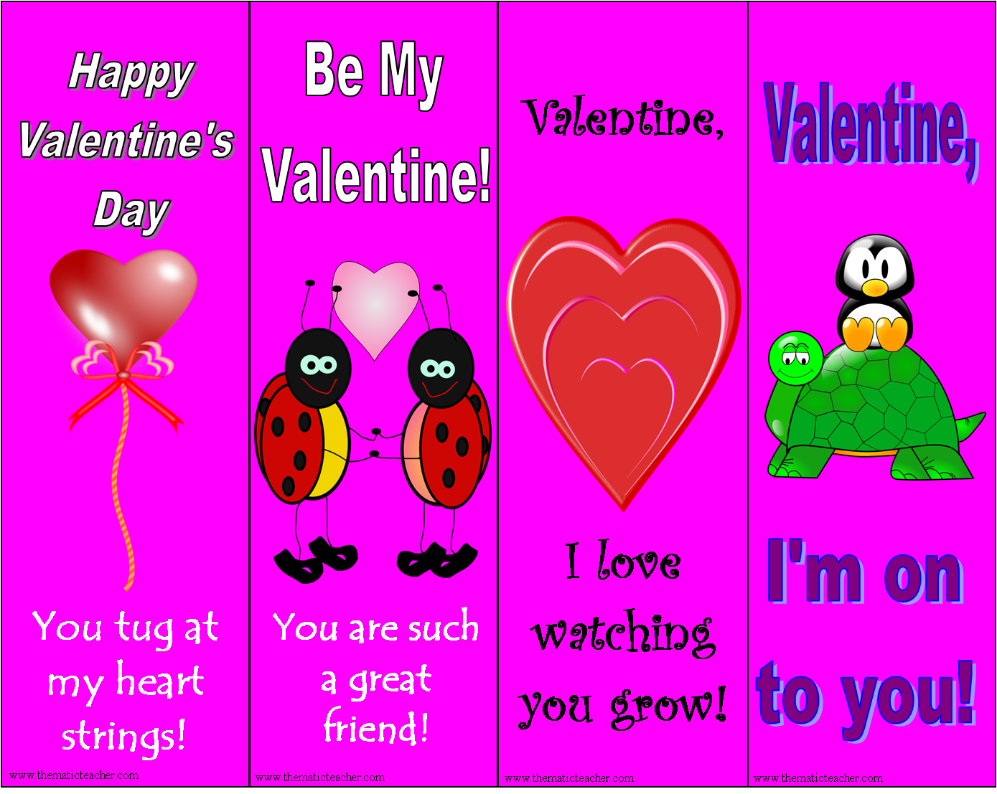
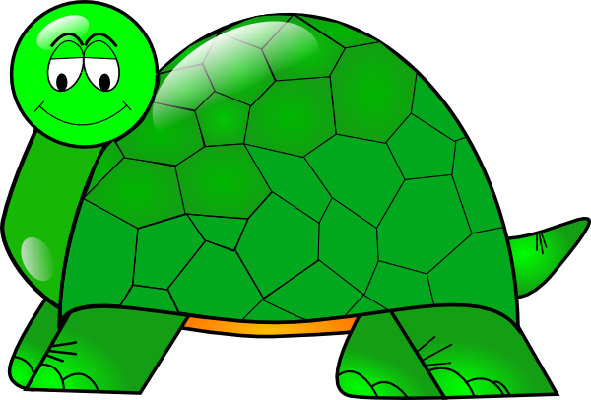
Dear Student,

I can’t believe the changes you have made in the way you do things. I have seen a big improvement in your work and your attitude. Thanks for all the effort you have put into making things better!

Love,
Your Teacher
Dear Student,

Being a teacher can be hard work, but when it comes to watching the amazing growth you have shown, there is nothing better in all the world! Thank you for all the effort you have made. I LOVE it!

Love,
Your Teacher
Dear Student,

I want to thank you for being such a good friend to so many people. You are always there whenever anyone needs help and you are
always ready to stick up for
others. Our class is a better place because of you.

Love,
Your Teacher
Dear Student,

It is a great thing to watch someone try to do something very hard to do without giving up or complaining. You inspire me with your “Can do” attitude and I am so glad to have the chance to work with you.

Love,
Your Teacher

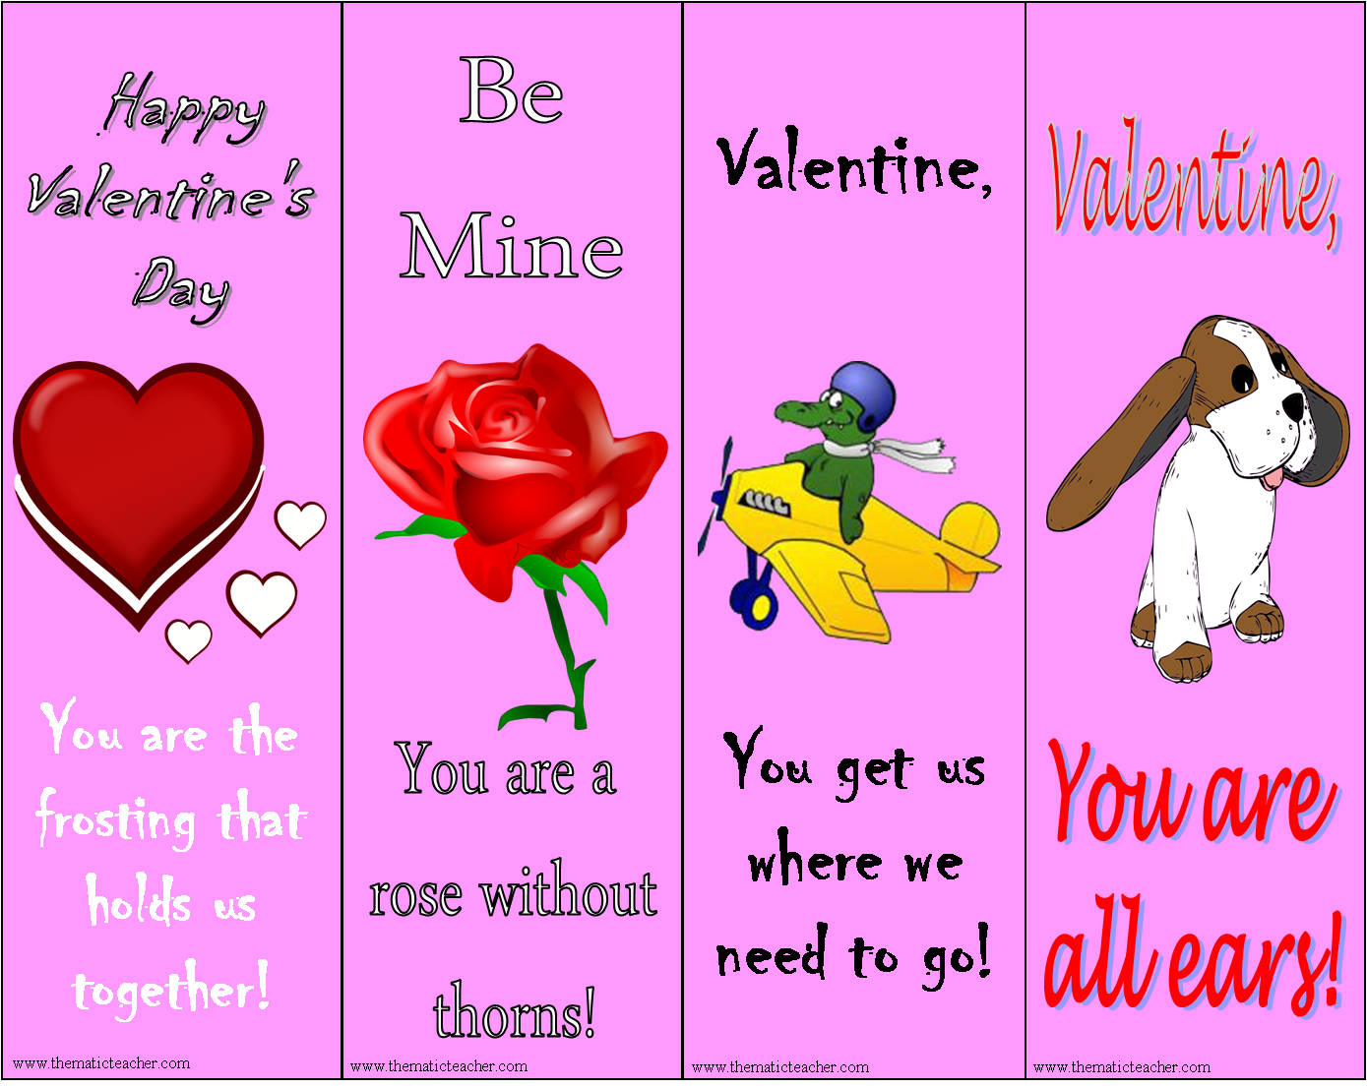
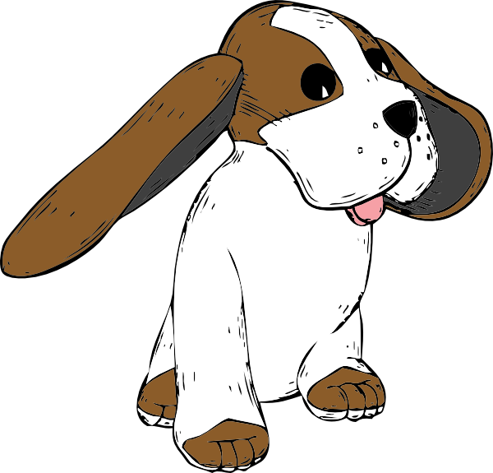
Dear Student,

Thank you so much for the way you are always
listening and how I can count on you to follow all my directions. What a great gift you are. It is such a help to know you always know what I said, even when I can’t remember!

Love,
Your Teacher
Dear Student,

Thank you for leading our class safely around the school. You pay good attention to where we are
going and how everyone is
behaving. I am proud of our class when you are the line leader!

Love,
Your Teacher
Dear Student,

Everything you do is kind and thoughtful to
others. Thank you for caring for those who are hurt, repeating directions to those who don’t listen, and paying attention to those who are left out.

Love,
Your Teacher
Dear Student,

It is amazing to see how you bring people together. It is a great gift to be able to help others work out their problems and you use that gift so well. We are all very
fortunate to have you in our class.

Love,
Your Teacher

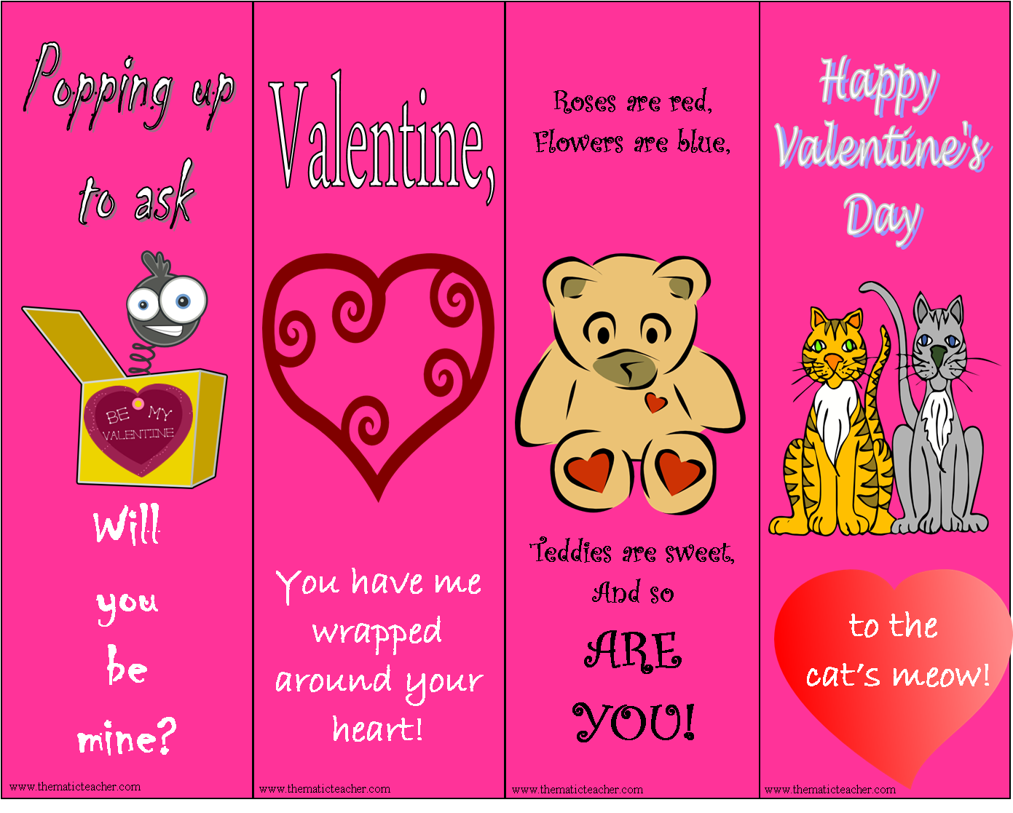
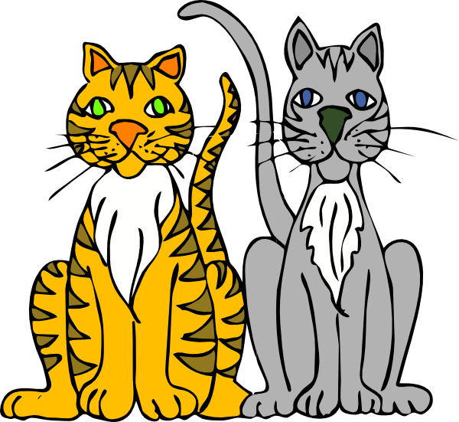
Dear Student,

You are really something! It is so fun to watch how you solve problems and try new things. Thank you for
being so curious and interested in all the world.

Love,
Your Teacher
Dear Student,

I am so glad to know such a sweet person. Thank you for being so nice to others and helping in so many ways around our school. We are much better
because of you.

Love,
Your Teacher
Dear Student,

I really enjoy coming to school every day knowing I will get to work with you. You are a pleasure to teach and fun to be around. Thanks for all you do.

Love,
Your Teacher
Dear Student,

I really enjoy the way you pop up with all kinds of funny and crazy ideas. It helps me look at things from a different point of view and makes school a lot more fun. Thanks for helping us keep our thinking fresh!

Love,
Your Teacher



Dear Student,

I want to thank you for the way you are always ready to give help. No matter what the problem is, you are willing to jump in and save the day. Thank you for looking out for all of us!

Love,
Your Teacher
Dear Student,

It is so terrific to know that I only have to ask you once to do some thing. Thank you for being a model at following
directions. I don’t know what I’d do without you!

Love,
Your Teacher
Dear Student,

What an amazing athlete you are. I know you work hard at sports and it shows in what you do. Thank you for helping the other students develop their skills.

Love,
Your Teacher
Dear Student,

You are a person with a great heart. You put all of yourself in everything you do and as a result you accomplish great things. You inspire me to try new things, too!

Love,
Your Teacher

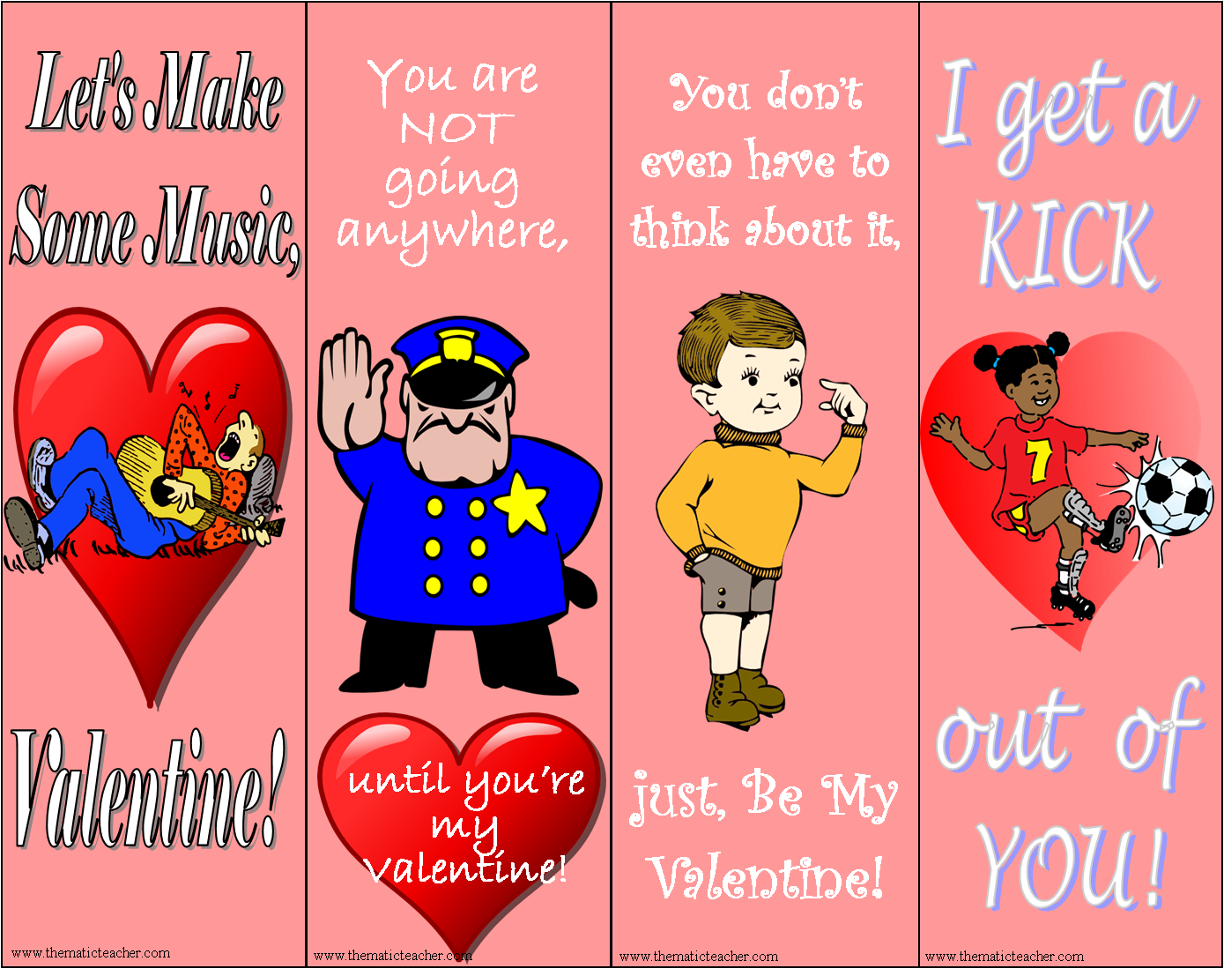
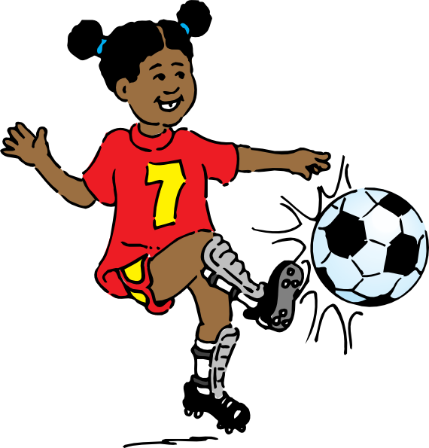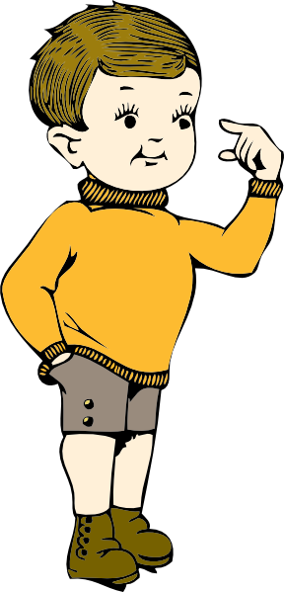
Dear Student,

I really enjoy watching you play at recess and PE. You are quite an athlete and it is a pleasure to see how you run, kick, jump and leap. Thanks for
keeping us active!

Love,
Your Teacher
Dear Student,

I always love watching you think through things. You think deeply and often make connections that I haven’t
noticed. Thanks for helping me
see new things!

Love,
Your Teacher
Dear Student,

It is always
interesting to watch you stop and think before you answer or try something. I can tell you put a lot of thought into all that you do. Thanks for taking the time to
consider things carefully!

Love,
Your Teacher
Dear Student,

What a great
musician you are. I enjoy the music you make and am always amazed at how competent you are. Music plays a very
special role in our lives. Thanks for sharing it
with us!

Love,
Your Teacher


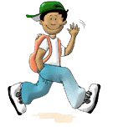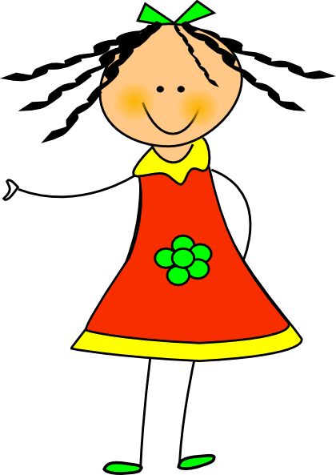
Dear Student,

I have noticed that you are really good at putting a lot of little parts
together to come up with a whole new idea. I have learned a lot from you. Thanks!

Love,
Your Teacher
Dear Student,

Thank you so much for always being so patient. You are never in a hurry to say what you think and are always willing to wait until others have had their turn. That is a very special
talent. You are
a good example.

Love,
Your Teacher
Dear Student,

I love watching you run on the playground. You are fast, graceful, and careful. Thank you so much for not
running into other people as you travel like a speeding bullet. You are amazing to watch.

Love,
Your Teacher
Dear Student,

I can’t believe what a fantastic memory you have. How do you do it? I wish I could
remember like you. I really
appreciate the help you give me when I forget
the little details
that are very
important. Thank you for your help.

Love,
Your Teacher

Valentine Bookmarks: Tips and Suggestions
Copyright © 2010 by Sandie Flynn All rights reserved. www.thematicteacher.com
Permission to reproduce these classroom materials is given to all educators for use with their own students or clients in a single classroom. They may change the publication to make it more suitable for their own personal use.

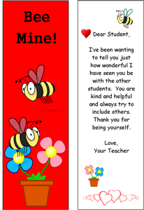
There are 32 different Valentine bookmarks you can print for the students in your class. Each one presents a Valentine card on the front with a printed message on the back. The messages are based on different personality types commonly found in most classrooms. There should be an appropriate message for most of the kids in your class. If not, you can easily replace the text with your own message, as long as you have access to Microsoft™ Word. There are several different ways to print the cards, depending on how much time you want to spend. Here are some alternatives for you to choose from:

- Print only the even pages. This will give you the bookmark with nothing on the back.
- Print odd and even pages back to back, as is. This will give you generic bookmarks, with a personal message BUT you will need to read the message before you decide who to give it to to make sure the message fits the student!
- Change the teacher’s name from “Your Teacher” to your own name. Then print both sides back to back. This will still give you generic messages that you will have to monitor, but will personalize it from you.
- Change the teacher’s name and type in the name of the student best suited for the message. This will give you a personalized message for each student in your class and you will KNOW the message fits the student.
- Write your own message instead of using the message already printed. You can’t get much more personalized than this!

Choose the method that best suits your needs. They will print best on letter sized photo paper, cover stock. Most inkjet printers allow you to set the print level to draft or fast normal which prints fairly nicely for most classroom needs. If you laminate them they will look good and last a long time. A personal message of appreciation from a teacher to a student often goes a long way to helping form and keep a positive, effective relationship.

I hope you will find these helpful and that you will have a Wonderful Valentine’s Day!

www.thematicteacher.com
Permission to reproduce these classroom materials is given to all educators for use with their own students or clients in a single classroom. They may change the publication to make it more suitable for their own personal use and may share with their colleagues, but not for commercial gain.

Credits: The clip art on these cards came from www.clker.com, a wonderful collection of public domain clip art.

