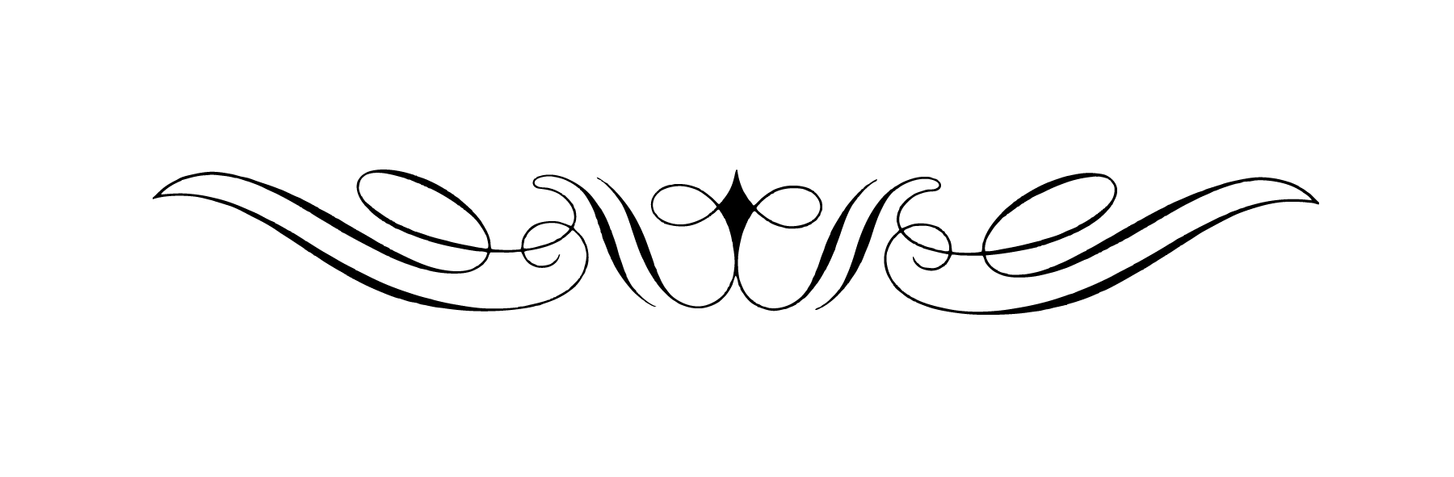
2018 SDRA Finals Awards Bids
- Individuals and/or Businesses can submit a bid for the following:
  - Saddles Only
  - Buckles Only
  - Saddle and Buckle Combination
- Buckle Bid Requirements
  - Projected order of minimum of 65 buckles
  - Buckles to include winner’s name
- Saddle Bid Requirements
  - Projected order of minimum of 19 saddles
  - Saddles to be order after finals to winner’s specifications
- Bids must be submitted by 8:00pm MT February 1, 2018
- Bids can be submitted electronically at andersonsdra@gmail.com or by mail at SDRA, 14150 232nd Ave, Isabel, SD 57633
- Bids will be voted on by SDRA Board of Directors at February board meeting
- Bid(s) will be selected in the best interest of the SDRA
- Any questions please contact Merretta Anderson 605-466-2341

