8/25/2017 Wonder Woman

Gal Gadot is primarily known for her role as Wonder Woman in the "DC Extended Universe" series of movies.

Israeli actress Gal Gadot was born in Petah Tikva, Israel, in 1985. Petah Tikva was founded in 1878 and was known as a "mother" of privately owned settlements in Israel.

"Wonder Woman" Gal Gadot was pregnant while shooting for the movie was being completed in early 2017. She gave birth to her daughter Maya on 3/20/2017.

Below are the significant things that have taken place on March 20 during the past 4 years.

3/20/2013 - President Obama enters Jerusalem, Israel, on a secretive Peace Agreement mission.

3/20/2014 - Asteroid 163 Erigone eclipses the King star Regulus, sign of Israel's Messiah King, for about 20 minutes as viewed from New York City at 2:06 AM EDT

3/20/2015 - A very rare total solar eclipse ends precisely at the North Pole at 153 degrees local meridian, signifying the 153 fish of John chapter 21.

3/20/2016 - President Obama enters Havana, Cuba, signifying Satan entering heaven. The name Havana means "heaven".

3/20/2017 - Wonder Woman Gal Gadot gives birth to a daughter, Maya. The name Maya means "mother".

The Wonder Women of 2017 and Jerusalem

What's special about the Israeli "Wonder Woman" giving birth on 3/20/2017?

According to YaHuWaH Elohim's instructions, a woman will remain 80 days in her purifying after giving birth to a female child (Leviticus 12:5). After giving birth on 3/20/2017 to Maya, "Wonder Woman" Gal Gadot would have been purified on 6/7/2017.

3/20/2017 + 80 inclusive days = 6/7/2017

6/7/2017 was the 50th anniversary of the taking of Jerusalem in the Six Days War on 6/7/1967.

Also note that human gestation is normally 40 weeks. 7 days x 40 weeks = 280 days.

280 days gestation + 80 days cleansing for the birth of a daughter = 360 days ( 1 prophetic year)

From the date of conception to the date of the purifying of a woman after giving birth to a maid child is exactly 1 prophetic year.

Note that on 9/23/2017 there will be a sign in the heavens of a Woman giving birth to a man child. There are 40 days indicated for the purifying of a woman after the birth of a male child in Leviticus 12.

The maid child is Jerusalem and the Man Child is Messiah. They will wed.

The Flood Coming Upon Corpus Christi

The name Corpus Christi means "body of Christ".

I had been unemployed for about 6 months since being discharged from the U.S. Air Force in July 1967. My future wife had set our wedding date at 2/9/1968, so in January, 1968, we decided that I needed to get a job. I sent out resumes and received offers of employment from two TV stations. One station was in Muncie, Indiana. The other station was in Corpus Christi, Texas. I thought about which place would be best. One night I had a full color dream of warm blue ocean waves and decided that Corpus Christi would be a nicer place to go than cold Muncie.

My future wife and I weren't Christians at that time, although we both grew up in godly homes. The evening of our wedding we left for Corpus Christi, 1800 miles away. We had no idea that 10 years later we would again leave for "Corpus Christi", but this time spiritually. We were saved in 1978 and spiritually became a part of the body of Christ, Corpus Christi. I believe that we were chosen and guided from our early lives to live in Corpus Christi physically and then 10 years later, spiritually. Our first child was born there.

Fast forward to 2017.

Hurricane Harvey began to physically flood the Corpus Christi area on 8/25-26/2017 as a sign to the body of Christ. Exactly 80 inclusive days after 8/26/2017, on 11/13/2017, there are signs that some sort of flood event will occur as indicated in the graphic below.

Note that 80 is a number associated with double testing, 2 x 40. Moses was 80 years of age when he returned from the desert to pronounce plagues on Pharaoh and Egypt.

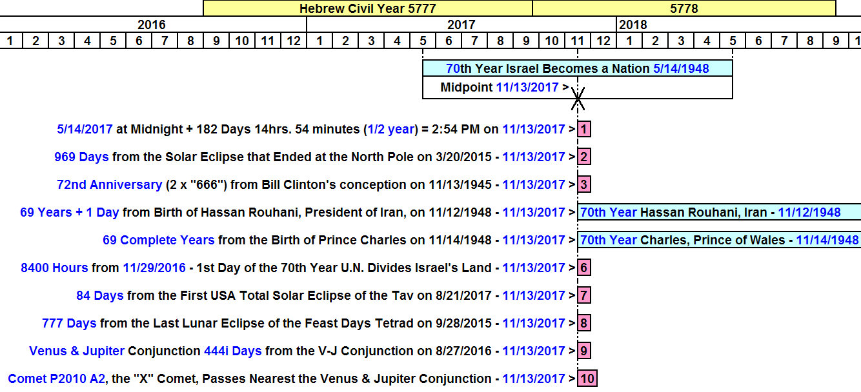

Many of the items listed on the graphic above are treated in previous emails and in various pages and articles on the JoyBySurprise.com website.

