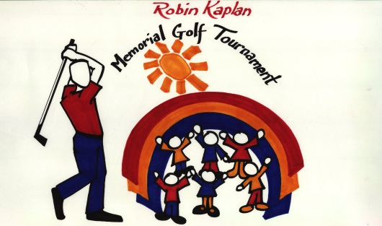

16th Annual Robin Kaplan

Memorial Golf Tournament
to benefit Crohn’s & Colitis Foundation
Camp Oasis Program

Wednesday, July 31, 2019 Mohegan Sun Country Club, Baltic, CT

Thursday, August 1, 2019 Mohegan Sun Country Club, Baltic, CT

DONATION CONTRACT

Donor Information Name:
Address:

City, State, Zip:
Daytime Phone:

Item Information Item Donated:
Description:

Estimated Value:
Expiration Date:
Exchange Privileges:
Legal Restrictions:
Delivery or Pickup Instructions:

Items will be allocated to use during the tournament, or at the live or silent auction, at the discretion of the Executive Committee
RKMGT’s IRS Tax Exempt number is # 74-3169269

Please submit all donations by July 12, 2019 to:

Robin Kaplan Memorial Golf Tournament
P.O. Box 1577
Westborough, MA 01581

For more information visit: www.rkmgt.com

