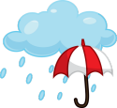
The Spring Open @ Carrboro was canceled due to rain.

