TWENTY EIGHTH SUNDAY
IN ORDINARY TIME
OCTOBER 12 & 13, 2019
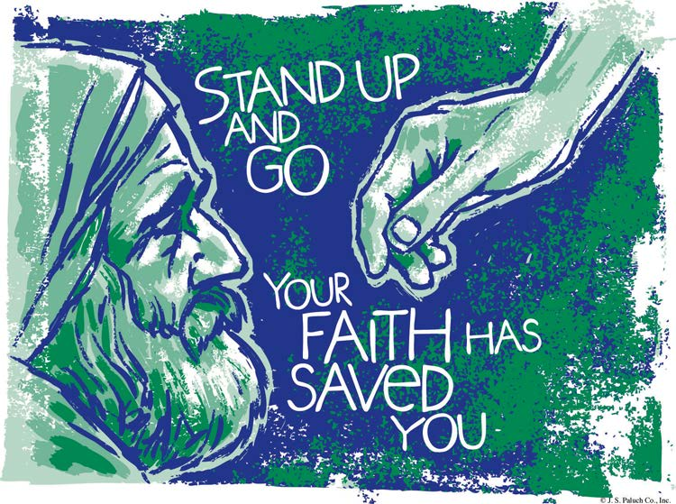
HEALING AND SALVATION

The readings today speak of healing and salvation. In Second Kings, Naaman, a Commander of the Army of the King of Syria, develops leprosy. He goes to a stranger, a prophet from Israel, when no one else can cure his disease. Much to his surprise, after a simple bath in the river, he is cured. In Luke’s Gospel, Jesus cures ten lepers and sends them to the Priest. Only one, a Samaritan, returns to thank Jesus for his cure and only he hears the words. “Your faith has saved you.” The Psalm and Timothy remind us that salvation involves justice, kindness, and faithfulness and forever links us with Jesus. In a world as broken as ours, both healing and salvation are necessary.

NATURAL LAW AND SOCIETY
By Dennis Tavares
Our human nature determines what is good or bad for us; so our nature shows us the natural law we should live by. Both our human nature and the natural law come from God. Also, the purpose of God’s Revelation, particularly the Ten Commandments, is to lead us to Heaven by showing us what actions are in accord with our nature. We live according to God’s design by developing a virtuous character, so we can avoid a sinful or misdirected life. We are meant to think about goodness, which flows from God, who is Goodness itself. Part of this contemplation of Goodness involves us in proper relationships with others. Thus a proper society is one in which government and civil life is directed to relief and prevention of the disorders that hinder our pursuit of goodness and God; a world that should be.

PRAY FOR OUR FAMILY AND FRIENDS THAT ARE IN THE MILITARY SERVICE
Rebeca Sánchez, José Araiza Jr., Edgar Toscano, Marina González, Alondra Jara, Sonia Jara, Jason Lorenz, Matt Mills y Jared Schroeder.

PASTORAL RUMINATIONS
By Fr. Andre Querijero

Over the past week, my reflections and writings surrounded my extreme sadness and pain over losing a loved one, coming from a position of vulnerability. Spectators may frown, and say it's a sign of weakness, or attention-seeking; but I say, should a priest be not an exemplar of “invincibility and passivity” in the midst of loss and death? Should I be apologetic for being “human” and “vulnerable”?
While ministering to the bereaved families of active parishioners who had passed on, I have seen people who are desperate for a shoulder to cry on or, even a sounding board compassionate enough to hear them out. Yet still there are others who just go through the motions of having their dying family members receive the Catholic sacraments and eventually, the funeral services. The essence of what others see as "motions" is the inter-connectivity within the church as a community or entire families of men, women and children willing to grieve, pray and be a healing presence to them.
Once I witnessed a man who for many years had shunned coming to church, completely turned off by the love and affection even strangers showered him with. He tried to defensively fence himself off, but miserably failed. The tragedy of this attitude is that we can be so prideful that we neither want God nor others to salve our wounds of self-sufficiency, indifference and isolation.
This is precisely the “miracle” of being a member of a family, a community of believers in the Resurrection. Even in the here and now, we experience a foretaste of heaven… a “Communion of Saints.” There is much more beyond the grave. “O death, where is your power… where is your sting?!” (1 Cor. 1:55). Victory and healing occur in the union of prayers, genuine condolences and loving remembrances in the celebration of the Holy Eucharist not only for the deceased but more so for the family in grief.
Consoling people who find themselves in different circumstances of loss has become second nature to me. There is an organic, symbiotic relationship between the pastor and his flock; and, as I realize now as a diocesan priest being alone in the rectory without other brother-priests to turn to for consolation, it is interdependent. Maybe it is time for me to experience being on the receiving end of empathy and caring. The bigger and humbling role that should not be neglected, however, is for a secular priest to find support in the community of faith that he serves.
The church is more than a religious institution or a depository of truth, but first and foremost a community of men and women who seek to relate in agape love for one another just as Christ Himself taught us. I pray that we, Catholics, would find refuge in our community of brothers and sisters in our journey towards healing, wholeness, and sanctity in the ordinary events of parish life.

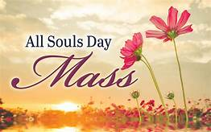
NOVEMBER 1ST, ALL SAINTS DAY AND ALSO FIRST FRIDAY,
THERE WILL BE A SPECIAL MASS AT 6PM.

PLEASE BE REMINDED THAT NOVEMBER 1ST IS A
HOLY DAY OF OBLIGATION.

STARTING MONDAY, OCTOBER 28TH, YOU MAY BRING PHOTOS OF YOUR DECEASED LOVED ONES TO THE RECTORY, WHICH WILL BE PLACED ON A TABLE AT THE ALTAR FOR ALL SOUL’S DAY.

KINDLY WRITE LEGIBLY THE DECEASED’S NAME ON THE FRONT, AND WRITE YOUR NAME AND PHONE NUMBER ON THE BACK.

FOR MORE INFORMATION, PLEASE CALL THE OFFICE AT 964-0229.

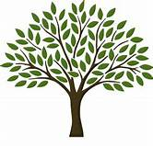
OLGC’S MEMORIAL TREE
In the vestibule of the Church, on the southern wall,
is a beautiful Memorial Tree.
Its bright leaves represent permanent memorials to the
departed of our Parish.
For the sum of $200.00, you can give to the Parish Secretary, the correct spelling and dates of the departed and in due time the leaf is printed and attached to the tree: a permanent reminder of a loved
one who is gone.
For more information, call the Parish Office at 964-0229.

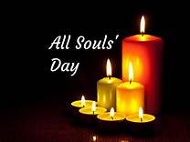
FIRST ANNUAL ALL SOULS DAY
CANDLE LIGHTING

When: 2:00pm November 2, 2019
Where: Rose Memorial Park Cemetery, Fort Bragg.

All are welcome to decorate a luminary (lantern) and place on the grave of a loved one or take home.

Supplies will be provided.

Courtesy of: Chapel By the Sea Funeral Home
445 East Fir Street Fort Bragg, CA 95437
707-964-5675.
MASS INTENTIONS OCTOBER 14 - 20, 2019
Monday (14)  Tuesday (15)  Wednesday (16)  Thursday (17)  Friday (18)  Saturday (19)  Sunday (20) | 12:05pm  12:05pm  12:05pm  12:05pm  12:05pm  5:00pm  6:30pm  8:00am  10:00am | Angelina Alcalá †  Souls in Purgatory  Frank & Angie Espinoza †  Vanessa Jones †  Catherine Moe †  Fred & Clara White †  Alberto Flores Solorzano †  Conley Family †  Yoke Iskandar †  Fitero Ileana †  Moy Villalpando †  Mauricio Escobedo †  Alicia Rentería  (b-day)  Gina & Gabriello Giusti †  Angelo & Baulah Mazzetta †

PLEASE PRAY FOR OUR SICK PARISHIONERS
Antonia Rentería, Pauline Ortiz, Ana María López, María Cristina Reyes, Karma Mendez, Juan Hernández, Frank Richards, Lisa Wright, Ricardo Contreras, Florencia Chávez, Refugio Yáñez, Tarcicio García, Sofía García, María de Jesús Mendoza, Antonio Cazares, Ana García, Ryan Moore, Marianne Brannan, Lilia Parrish, Nancy Smith, Julián Palomar, Jennifer Vera, John Braet, Kim Koskinen, Margaret Valencia, Matthew Marcoulier, Dennis Tavares, Jose Freitas, Alfredo Sousa, Juana Arreguín, Aron Yasskin, Victoria Walzer, Fidela Yáñez Jara, Erika Ramos, Bill Gibson, Carla Tomas, Erasmo Yáñez, Memo Soria, Patricia Vargas, Fidela Yáñez, Elvia Flores, Yonel Ruíz, Angie Freitas, Russel Bryant, Derrick Heater, Luis Angel, Juan Barrera-Terán, Gabriel Hurtado, Gerald Butler, Helen Reynolds, Toni Clark, Ann Gallagher, Brianna Lopez, Margaret Milliken, Gina Pivirotto, Nick Quin, Mary Servis, Denis Sousa, Victor Venegas, Matty Walker, Charles Lorenz, Rebecca Lorenz, Ofelia Ibarra, Leonardo Naal, Gina Leal.

WEEKLY COLLECTION
OCTOBER 5 & 6, 2019……..$2,029.50
LIABILITY INSURANCE…..$793.00

THIS WEEKEND’S SECOND COLLECTION:
MAINTENANCE FUND
NEXT WEEKEND’S SECOND COLLECTION:
WORLD MISSION SUNDAY

THANK YOU
FOR YOUR SUPPORT & CHRISTIAN GENEROSITY

A CALL TO ACTION

WE ARE UPDATING OUR PARISH
REGISTRATION LIST.
PLEASE TAKE A FORM AND GIVE US YOUR CURRENT INFORMATION.
YOU CAN PUT IT IN THE COLLECTION BASKET, RETURN IT TO THE OFFICE, CALL US AT 707-964-0229
OR EMAIL US AT olgcinfb@gmail.com.

UNITED CHRISTIAN WOMEN’S POTLUCK SALAD LUNCHEON

YOU ARE INVITED TO ATTEND THIS LOVELY LUNCHEON.
WHICH WILL TAKE PLACE AT THE
FIRST PRESBYTERIAN CHURCH,
367 SANDERSON WAY, FORT BRAGG, CA
ON THURSDAY, OCTOBER 17, 2019
AT NOON.
PLEASE BRING YOUR FRIENDS TO SHARE IN THIS DAY OF CHRISTIAN FELLOWSHIP.
PRESBYTERIAN FELLOWSHIP WILL PROVIDE DRINKS AND DESSERTS.
PLEASE CALL THE CHURCH AT 964-2316 FOR YOUR RESERVATION .

