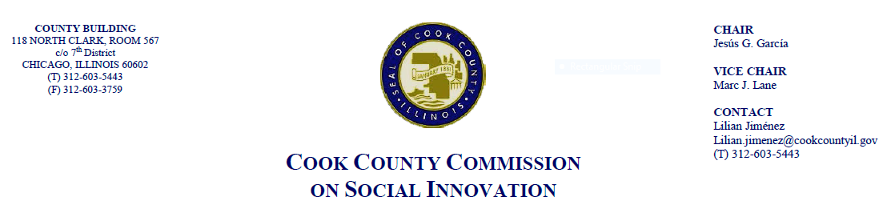April 19, 2018, 4 P.M.
118 N. Clark, Rm. 569
MINUTES

- Call to Order

The Cook County Commission on Social Innovation convened via an in-person meeting to discuss committee updates and hear from a guest speaker. The meeting was chaired by Vice Chair Marc J. Lane. The meeting was open to the public and took place from 4:06 p.m. to 4:50 p.m.

Commission Members Present:
- Commissioner Garcia
- Victor Dickson
- Maria Kim
- Wendy Raymer
- Marc Loveless
- Pamela F. Rodriguez
- Valerie Leonard
- Howard Males
- Carrie Thomas
- Mike Hobbs
- John Yonan
- Morgan Malone
- Ana Guajardo
- Mark McHugh

Commission Staff Present:
1. Alma Anaya
2. Victoria Moreno

Meeting Notes and Decisions Made:
- Approval of Minutes
- Comm. Rodriguez moved to approve the Commission’s minutes from January 18, 2018. Comm. Males seconded the motion and the motion passed unanimously by a voice vote
- Comm. McHugh moved to approve the Commission’s minutes from February 15, 2018. Comm. Yonan seconded the motion and the motion passed unanimously by a voice vote
- Comm. Hobbs moved to approve the Commission’s minutes from March 15, 2018 Comm. Dickson seconded the motion and the motion passed unanimously by a voice vote

- Updates
- Rodger Cooley from the Good Food Policy Action Council provided an update on the proposed Good Food Purchasing Policy. He explained that we had received feedback from the Cook County Procurement Office and are working on revisions. The next steps will involve task force and leadership of different departments and agencies and coalition to ensure different measurements and goals are maintained. Annual report will have to go back to Health Committee
- Several commissioners indicated they were pleased with the proposal’s focus on equity and that it highlights social disparities
- Comm. Garcia explained that Cook County would be the first in the nation to take this on
- Comm. Garcia addressed upcoming transition with him leaving his role at the County and intends on staying engaged moving forward. Commissioner Garcia introduced Alma Anaya as Commissioner-elect and wants them to know she would like to be involved with Social Innovation

- Guest Speaker: Niketa Brar of Chicago United for Equity on the topic of Racial Equity Impact Assessment tools
- Ms. Brar provided an overview of racial equity assessments and the ways in which they can create structural reforms and understand who is not being served well under existing systems. Such assessments are currently being utilized by over 150 jurisdictions throughout the country
- Racial equity assessments help us think about the impact of a policy on different groups of people
- Ms. Brar explained there is no correct way to do an REA. She presented three approaches to establishing an REA system: 1) Slow and steady; 2) Legislation; 3) Structural Reform
- The slow and steady option is a multi-process option process that would require base-building, conducting training, training staff, and codifying into legislation
- The legislation process accelerates racial equity justice. It requires strong public awareness and creates a new point of decision making. This is stronger the more well-defined the assessment is
- The structural reform option establishes more long-term movements for equity. An example of this is how Boston established a Chief Equity Officer in its school system. Furthermore, the Boston Office of Equity and Inclusion addresses the disparate impact on immigrants and low-income people

Post-Presentation Discussion
- Comm. Leonard mentioned that advocates have been telling CPS and CPD about disparities for years, and wonders how much does it take for people to be listened to. Ms. Brar believes that honest dialogues needs to take place where privileges and influences are identified and various resources and skills are utilized. Furthermore, it is important to not be scared to talk about race and address potential negative impacts of a decision
- In response to Comm. Guajardo’s question of how communities are identified for equity work by Chicago United for Equity, Ms. Brar mentioned that at least ten community members must bring forth an issue to the organization
- Ms. Brar agreed with Comm. Dickson on the importance of a local equity office and encouraged the formation of an Office for Equity and Inclusion here in Cook County
- Comm. Loveless supported the idea and reflected on how the Detroit Ombudsman Office came from the Kerner Report and how such entities are necessary for a livable society
- Comm. Leonard also cautioned of the risks involved and how many discrimination issues may be uncovered in Chicago through this type of work

- Other Business
- Commissioners did not discuss additional business

- Public Speakers
- Mr. Thom Alcazar, CEO of eatsgroceries.com presented about his venture which seeks to address the issue of food deserts and would provide opportunities to formerly incarcerated individuals
- Mr. Mark Armstrong spoke about lack of diversity on government meetings but commended this body for its diversity
- Mr. Christopher Lafayelle spoke about lack of opportunities for formerly incarcerated individuals within social enterprises. Praised work of Commission
- Mr. George Blakemore spoke about racial disparities in Chicago
- Ms. Queen Sister spoke on behalf of DuSable’s Daughters and how African Americans in Chicago seem to have been forgotten by local government while immigrants are priority

- Adjourn
- Chairman Garcia moved to adjourn. Meeting adjourned at 4:50 p.m.

