**ISSUE**

**PEP TALK**

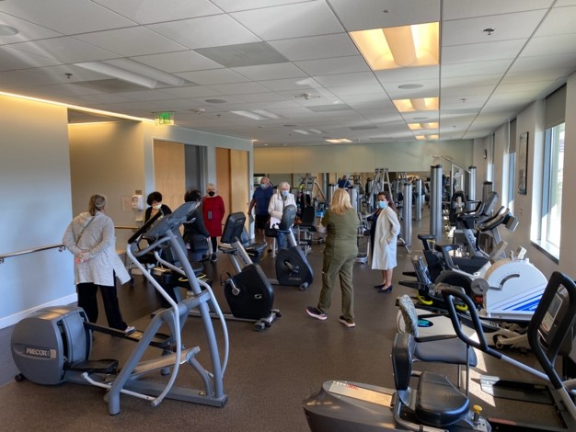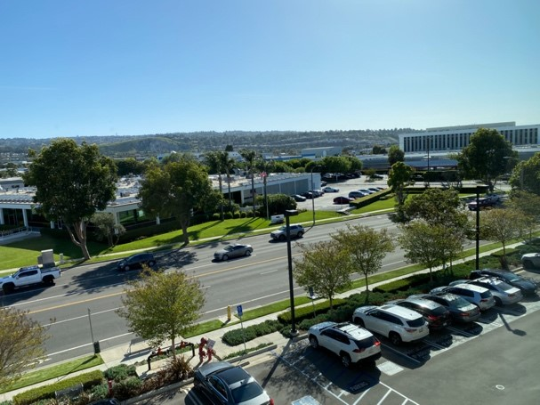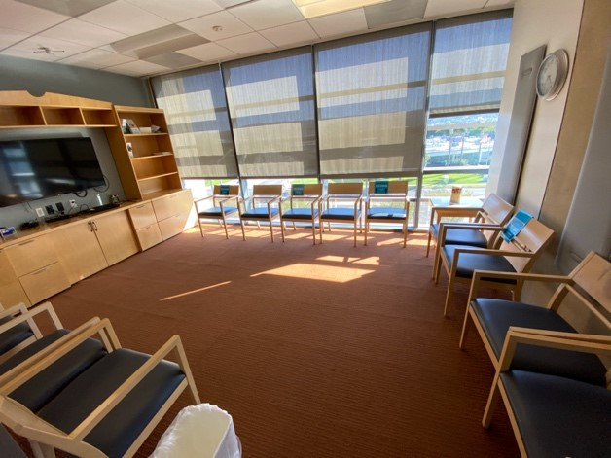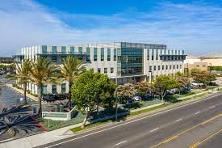

**Old times are back again!** The new gym at Torrance Memorial Medical Center feels like our old gym at LCM except it’s much better in so many ways. Jackie has been supplying cookies and coffee and we have had a nice turnout for the gym.

The variety of equipment at **TMMC** helps you to strengthen your entire body. Joanne is there to help us learn about the workout equipment as well as personally working with you to set up your goals.

There is oxygen available if you don’t bring your own and it has a great view while you are working out or having a cup of coffee!

Parking is great and the facility is nearly new and easy to find, 2841 Lomita Blvd.

**We meet every Tuesday and Thursday from 4:00- 5:30**

.

***~NEW PEP GYM IS OFF TO STRONG START~***

193

***P****ULMONARY* ***E****DUCATION*

***P****ROGRAM*

**MAY  
2022**

Changes to PEP

As mentioned in last months **PEP Talk newsletter**, your PEP Board of directors is happy to announce some wonderful changes.

* Jackie Tosalini RT is your new PEP Chairwoman
* May 3 Exercise gym began at TMMC Specialty Center #335 on Tues and Thurs. For details see flier sent out end of April
* June 16 Quarterly luncheons at Mimi’s, with Picnic in Park in September
* July 12 Harbor Cruise Field trip. See article in newsletter
* We look forward to these new changes, and hope you enjoy them

~Mark Your Calendar~

September 15th- Annual PEP Picnic at Victor Park

December 15th- Annual Christmas Party

**~June Babies~**

1-Leland Dolley

5-Gregory Cookson

5-Shirley Tracy

6-Connie French

6-Eddie Sekine

9-Albert Pearson

11-Carolyn Mulhall

12-Carole Hoshiko

17-Keith Hartmann

18-Irene Bardwill

22-Beth Leibowitz

24-Diane Lange

26-Kelvin Rising

28-Sue Coppock

30-Joann Cannon

30-Sally Downie

Board Membership

During the past few months three of our Board members passed away. They have been a big part of the Board of Directors with 5-10 years of loving service.

Bebe Bonnell facilitated many of our trips. She, and her team, did a lot of prep work to be sure that the trip was comfortable, safe, and enjoyed by all who adventured with the group. Bebe enjoyed the planning as well as the trip, and was eager to find new adventures for PEP

Karen Thompson provided our luncheon seasonal decorations prior to our Covid lockdown. She also published our colorful newsy PEP Talk newsletter. Karen always had a smile, and a loving positive note for everyone.

Nancy Kimball is remembered as the Badge lady. She and her caregiver Joanne had your badge and lanyard ready – with a friendly hello and smile. Although she had many ailments, she was quick to laugh and be positive.

Each of these women will be missed. They leave a big hole in the PEP Board of Directors, with current members doubling and tripling up as they prepare for PEP activities.

We need your help. All actives are planned, organized and facilitated by 9 enthused members. If you want to give back a little to the Pulmonary Rehab, if you are sitting around wondering how to connect with more people, if you have a talent or skill that you are willing to share with others, we may be your answer. If this may appeal to you, please contact a Board member or email <peppioneer@gmail.com>

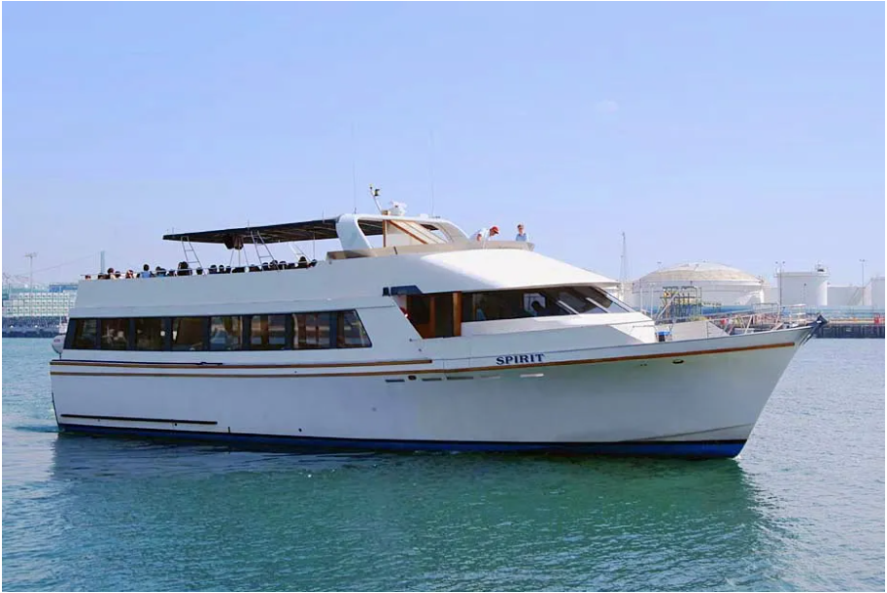

**PEP PIONEERS is a non-profit corporation comprised of graduates of the Pulmonary Rehabilitation Program at Providence Little Company of Mary Hospital. We are dependent on private donations and fundraisers to finance events and purchase equipment that benefit all of its members.**

**Tax Deductible donations may be made to:**

**PEP PIONEERS**

**Pulmonary Rehabilitation**

**20929 Hawthorne Blvd.**

**Torrance, CA 90503**

**310-303-7079**

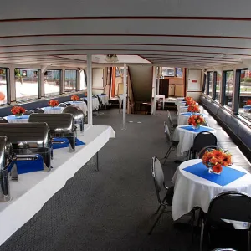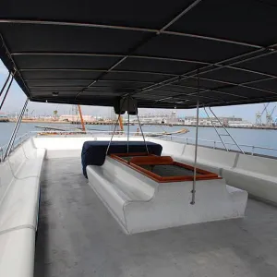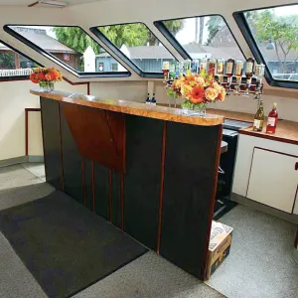

**Before you know it, the LA Harbor cruise will be here—July 12 from 11:30 -2:00 pm. $25 per person which includes a hot lunch, drinks, free Margaritas and more!**

**The 90 ft vessel, Spirit, will provide us with a great tour of the busiest port in the USA. There is inside dinning and viewing and outside viewing on the top deck.**

**This is a can’t miss event at a great price!**

You can pay Jackie at the new gym (which is another excuse to go there) or mail in your payment payable to PEP Pioneers, 1223 East Acacia, El Segundo, CA 90245, or come to the June 16 PEP Luncheon a Mimi’s Restaurant. Three ways to pay.

**~Los Angeles Harbor Cruise~**